[复旦大学附属华山医院北院刘杨、上海市第一妇幼保健院妇科殷怡华论文图像重复泛滥成灾，作者团队如何自证清白？](https://mp.weixin.qq.com/s?__biz=Mzk3NTEwMTE3OA==&mid=2247485468&idx=1&sn=3268aa924b6a84c22ba3a4cb0c71ebd6&chksm=c55bc6eab3526efead410f18a5ca93f411a6dad8ae225dc5c575e24571ba6badf201bd33cae8&scene=126&sessionid=1743849226)

[学术荟萃](javascript:void(0);)2025-04-05 18:19:00山东

**Part.1**



**论文简介**

**标题：Inhibitory effects of Arhgap6 on cervical carcinoma cells**

**日期：**2015年12月1日

**单位与作者：**复旦大学附属华山医院北院Junping Li、Yang Liu(通讯作者 音译 刘杨)

上海市第一妇幼保健院妇科Yihua Yin(通讯作者 音译 殷怡华)

**期刊：*Experimental and Therapeutic Medicine***

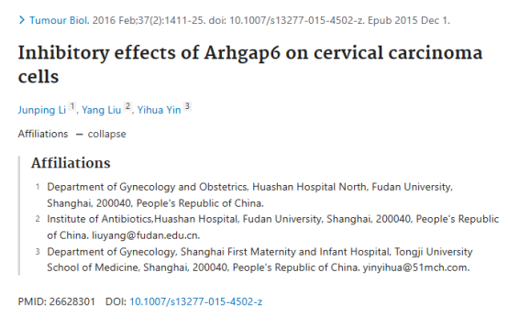

**Part.2**



**图像重复问题**

**#1 图6b面板重叠，图8a,c面板重叠。**

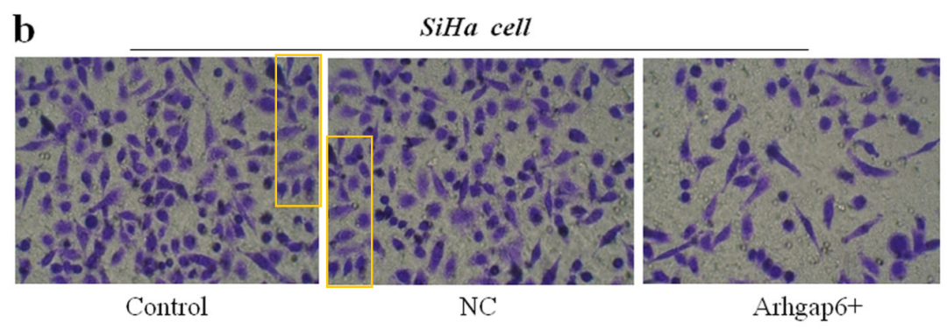

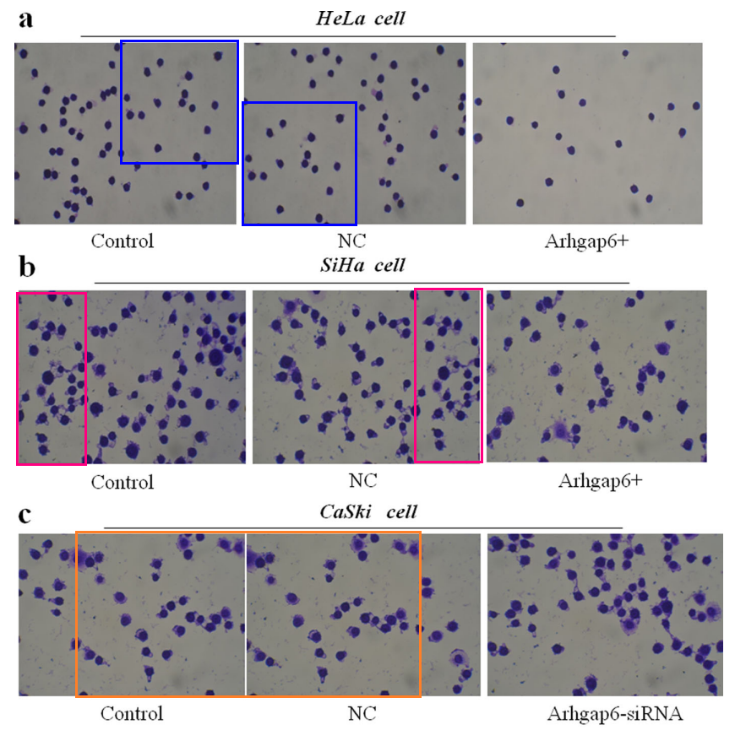

**#2 图2e与Zhang et al 2017的5C出现重复。**

[left] Fig 2e.

[right] Fig 5C from "FAM46C is critical for the anti-proliferation and pro-apoptotic effects of norcantharidin in hepatocellular carcinoma cells" (Zhang et al 2017).

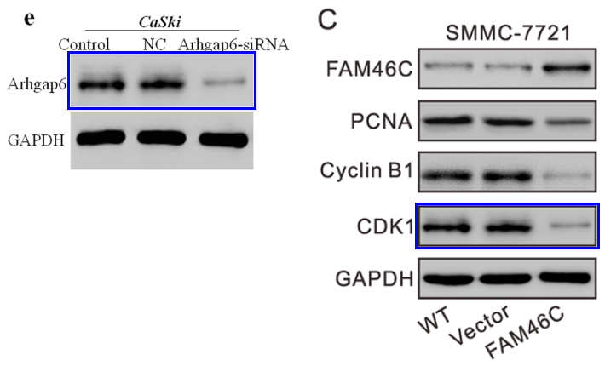

**#3 图9e与Huang et al 2016的图5C出现重复。**

[left] Fig 5C from "Effects of UCP4 on the Proliferation and Apoptosis of Chondrocytes: Its Possible Involvement and Regulation in Osteoarthritis" (Huang et al 2016).

[right} Fig 9e.

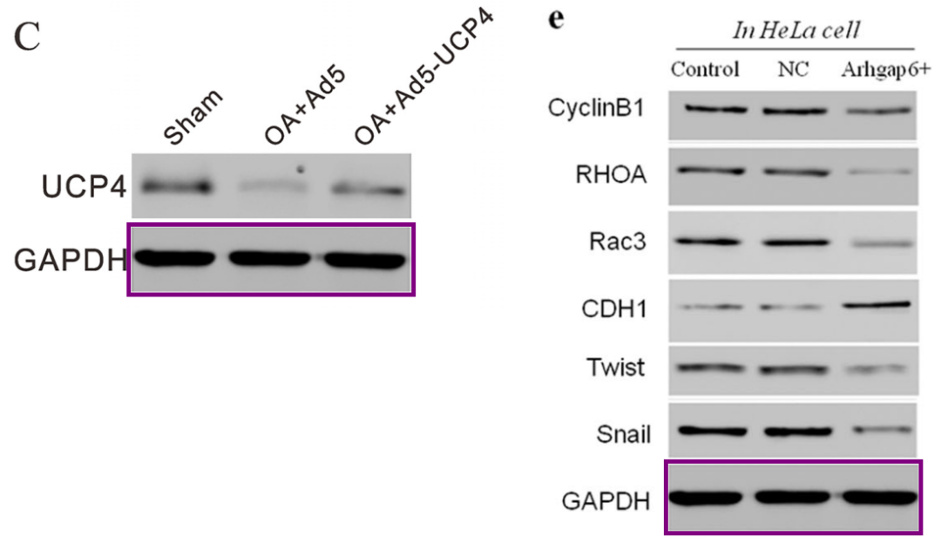

**#4 图9f与Diao et al 2017的图2D、Xu et al 2016的图5D、Ding et al 2016的5C出现重复。**

[left] Fig 9f.

[right] Fig 2D from "IQGAP1-siRNA inhibits proliferation and metastasis of U251 and U373 glioma cell lines" (Diao et al 2017).

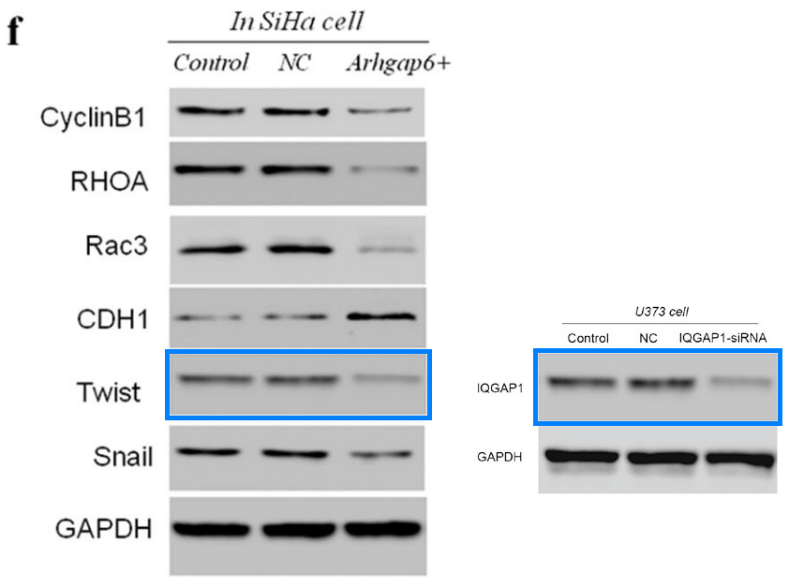

[left] Fig 5D from "RNA interference against TRIM29 inhibits migration and invasion of colorectal cancer cells" (Xu et al 2016).

[right] Fig 5C from "Silencing of SOX12 by shRNA suppresses migration, invasion and proliferation of breast cancer cells" (Ding et al 2016).

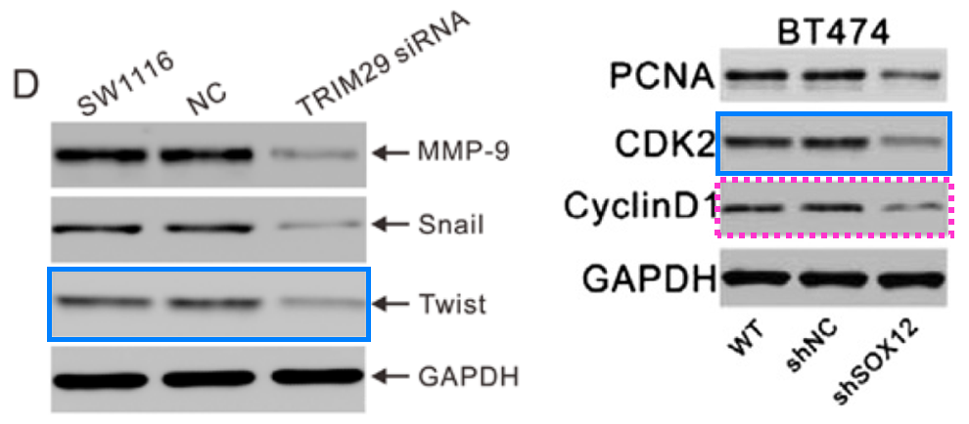

**#5 图2e与Qin et al 2016的图6A出现重复。**

[left] Fig 2e again.



Another sighting! [left] Fig 6A from "Silencing of WWP2 inhibits adhesion, invasion, and migration in liver cancer cells" (Qin et al 2016).

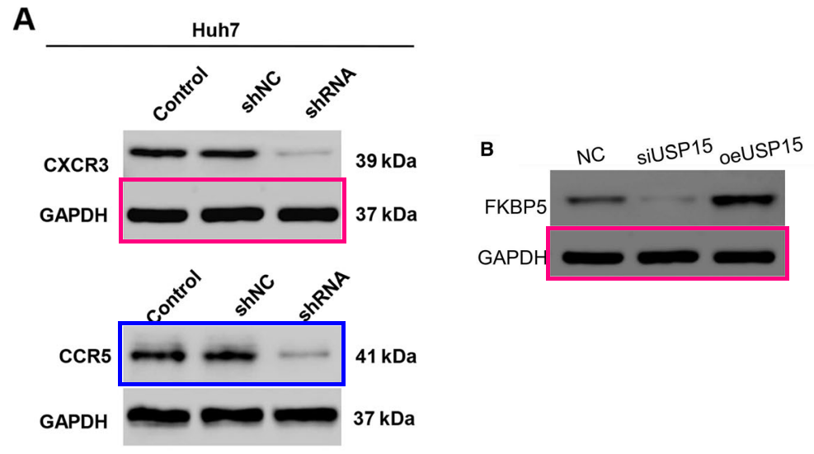

**#6 图8C与Zhou et al 2019的图3C出现重复。**

Fig 8c.

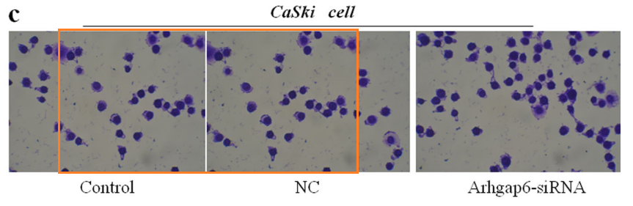

Fig 3C from "Fibronectin promotes cervical cancer tumorigenesis through activating FAK signaling pathway"(Zhou et al 2019).

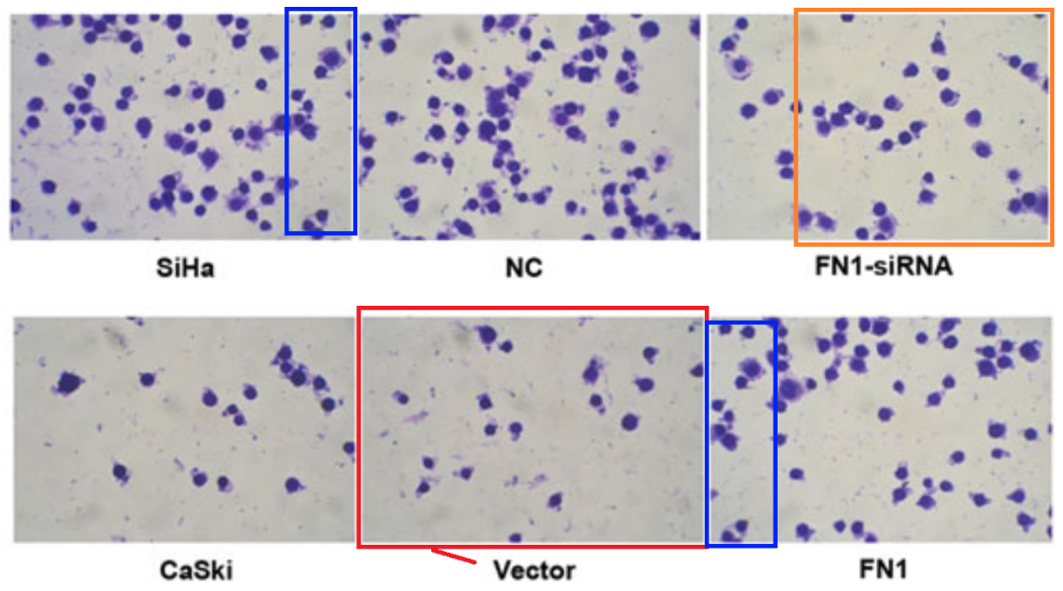

**#7 图6b与Wan et al 2021的图5B、5C出现重复。**

Fig 6b again.

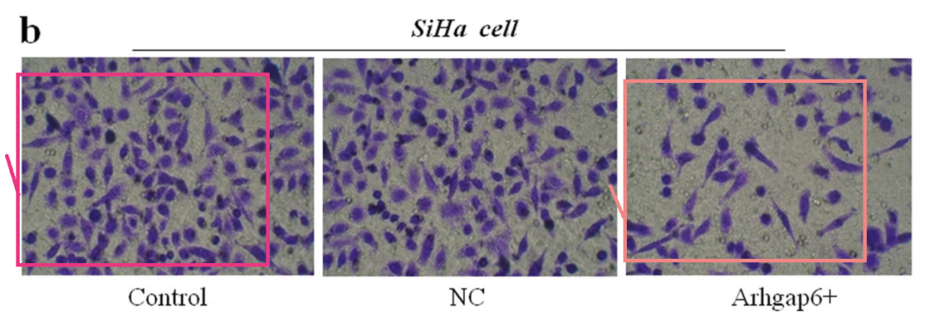

Fig 5B and 5C (H1581 panels) from "LncRNA WT1-AS downregulates lncRNA UCA1 to suppress non-small cell lung cancer and predicts poor survival" (Wan et al 2021).

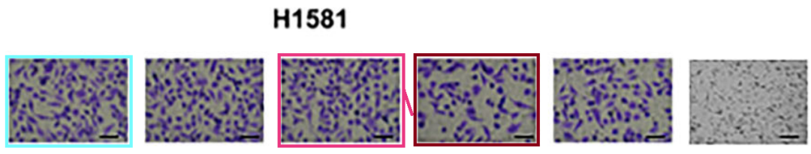

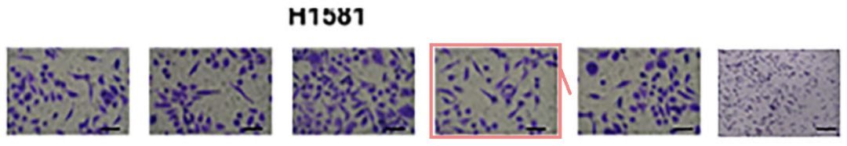

**#8 图9f与Hu et al 2016的图4A出现重复。**

[left] Fig 4A, BT474 bands from "RNA Interference of IQ Motif Containing GTPase-Activating Protein 3 (IQGAP3) Inhibits Cell Proliferation and Invasion in Breast Carcinoma Cells" (Hu et al 2016).

[right] Fig 9f again.

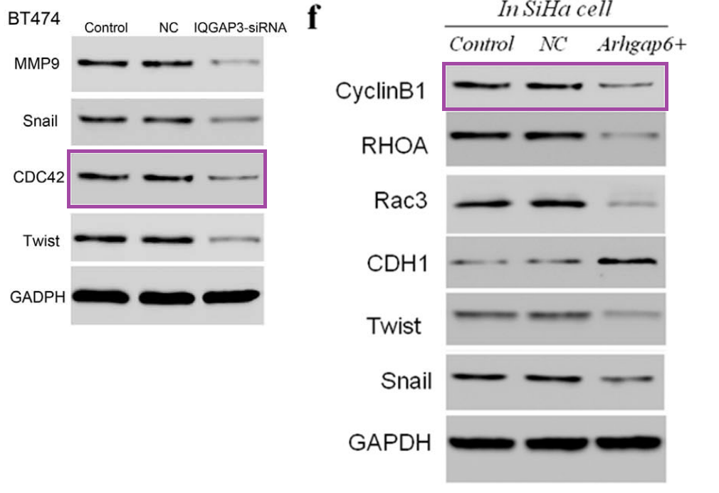

**#9 图6d与其他三篇论文出现重复。**

Clockwise from upper left:

* Fig 4A,C,E from "ARHGAP1 overexpression inhibits proliferation, migration and invasion of C-33A and SiHa cell lines" (Li et al 2017).
* Fig 2D from "Long Non-Coding RNA-NEAT1 Promotes Cell Migration and Invasion via Regulating miR-124/NF-κB Pathway in Cervical Cancer" (Shen et al 2020).
* Fig 3E from "Everolimus inhibits breast cancer cell growth through PI3K/AKT/mTOR signaling pathway" (Du et al 2018).
* Fig 6d.

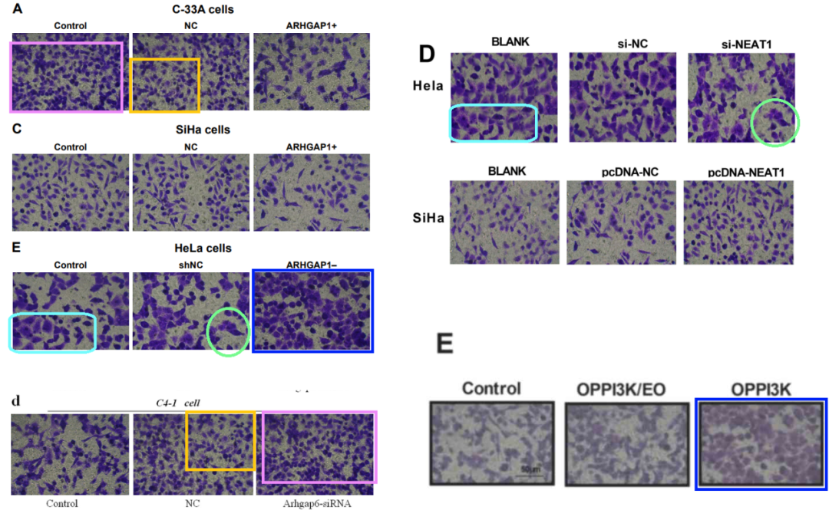

**#10 图7d与其他三篇论文出现重复。**

Clockwise from upper left:

* Fig 5A,C,E from "ARHGAP1 overexpression inhibits proliferation, migration and invasion of C-33A and SiHa cell lines" (Li et al 2017).
* Fig 2C from "Long Non-Coding RNA-NEAT1 Promotes Cell Migration and Invasion via Regulating miR-124/NF-κB Pathway in Cervical Cancer" (Shen et al 2020).
* Fig 3E,F from "Everolimus inhibits breast cancer cell growth through PI3K/AKT/mTOR signaling pathway" (Du et al 2018).
* Fig 7d.



**#11 图2f与 Wu et al 2021 的图5e出现重复。**

[left] Fig 2f.

[right] Fig 5e from "TRIM65 Promotes Invasion of Endometrial Stromal Cells by Activating ERK1/2/C-myc Signaling via Ubiquitination of DUSP6" (Wu et al 2021).

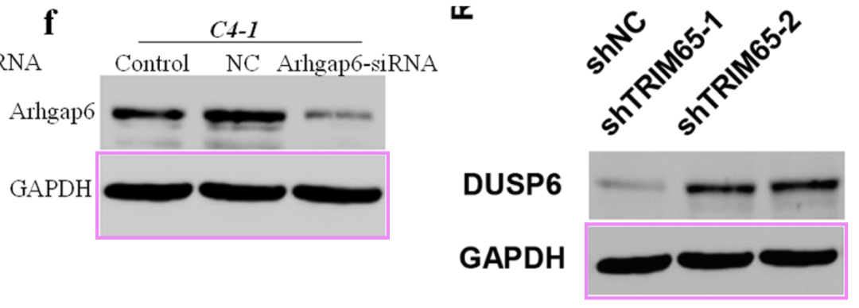

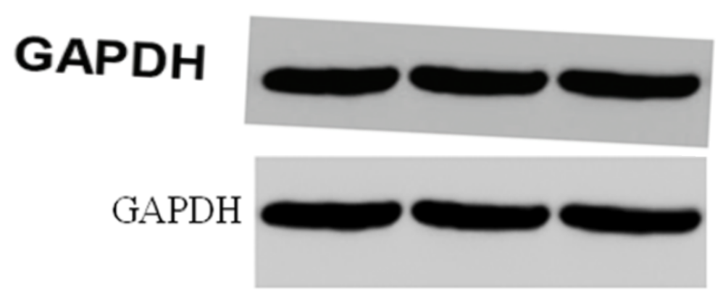







**#12 图9e 与 Xu et al 2016 的图5C出现重复。**

[left] Fig 5C from "RNA interference against TRIM29 inhibits migration and invasion of colorectal cancer cells" (Xu et al 2016).[right] Fig 9e again.

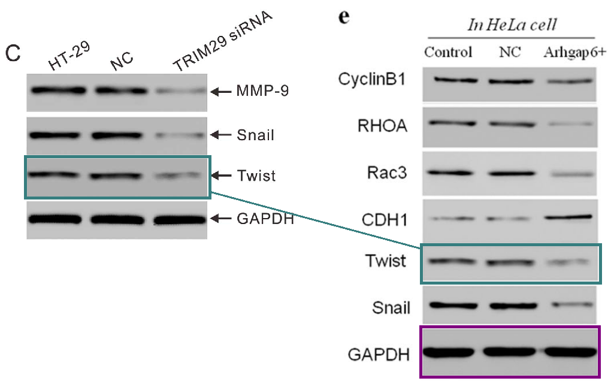

**参考信息：**

https://pubpeer.com/publications/B69C2B3943CD9ED5D88418F886F1C7#

https://pubmed.ncbi.nlm.nih.gov/26628301/