[敲响警钟！疑似论文工厂？山东大学第二医院消化内科主任郭建强的论文图像重复频发](https://mp.weixin.qq.com/s?__biz=Mzk3NTEwMTE3OA==&mid=2247485462&idx=1&sn=ec58c3ec3161d2eaa385225ccdda4236&chksm=c5c360bfe1fa850ec8f097d023caecb4c140baa14b2adb4963d50d7e1bf1bba82c3fa2cf0725&scene=126&sessionid=1743786433)

[学术荟萃](javascript:void(0);)2025-04-04 09:30:26山东

**Part.1**



**论文简介**

**标题：LncRNA SNHG5 affects cell proliferation, metastasis and migration of colorectal cancer through regulating miR-132-3p/CREB5**

**日期：**2018年11月5日

**单位与作者：**山东大学第二医院消化内科Mingbao Zhang、Jianqiang Guo(通讯作者 音译 郭建强)

**期刊：*Cancer Biology & Therapy***

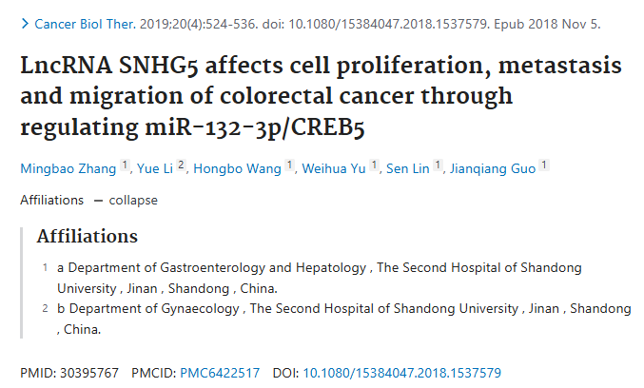

**Part.2**



**图像重复问题**

**#1 图3似乎有一个重叠的图像。**

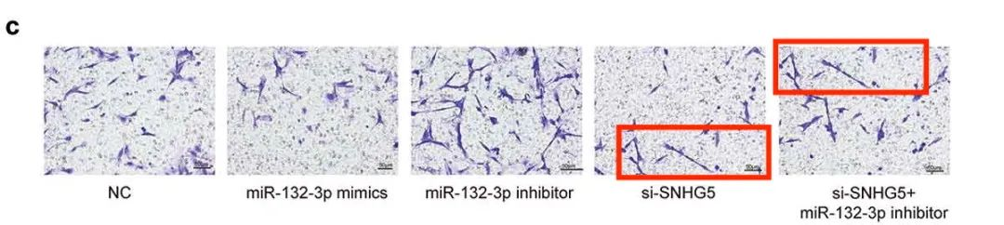

**#2 图4a疑似出现在另外三篇论文中，而其中一篇论文又和其他文章存在相似。**

Fig 4a:

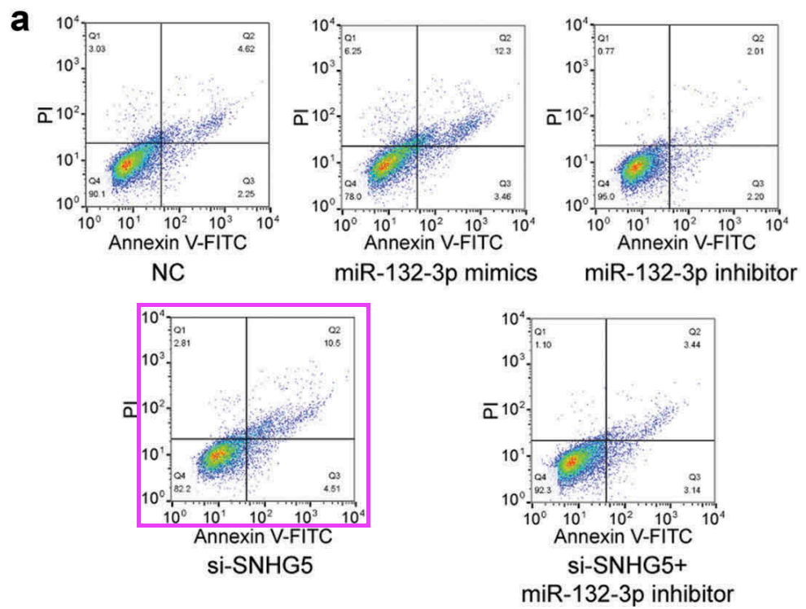

Clockwise from upper left:

* Fig 6A from "MiR-130b promotes the progression of oesophageal squamous cell carcinoma by targeting SASH1" (Zhu et al 2019).
* Fig 3D from "MiR-139-5p, miR-940 and miR-193a-5p inhibit the growth of hepatocellular carcinoma by targeting SPOCK1" (Li et al 2019).
* Fig 2G from "circZMYM2 Competed Endogenously with miR-335-5p to Regulate JMJD2C in Pancreatic Cancer" (An et al 2018) [retracted].
* Fig 3A from "MicroR‐542‐3p can mediate ILK and further inhibit cell proliferation, migration and invasion in osteosarcoma cells" (Cai et al 2019).

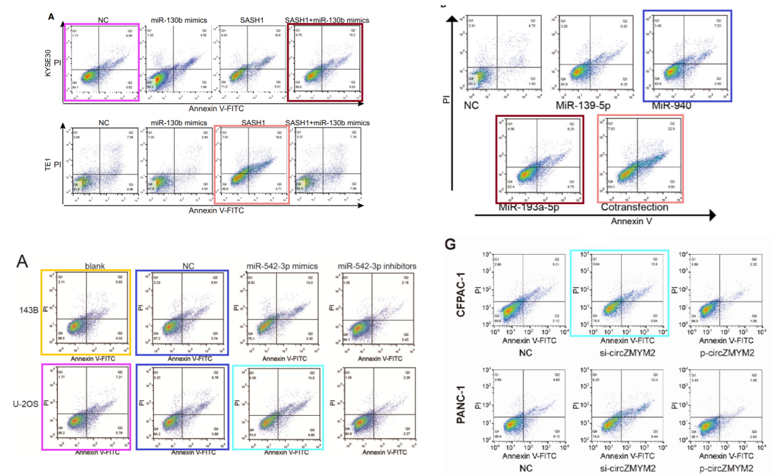

**#3 图5A与Xu et al 2018的1C出现重复。**

[left] Fig 5A.

[right] Fig 1C from "The effects of lncRNA MALAT1 on proliferation, invasion and migration in colorectal cancer through regulating SOX9" (Xu et al 2018).

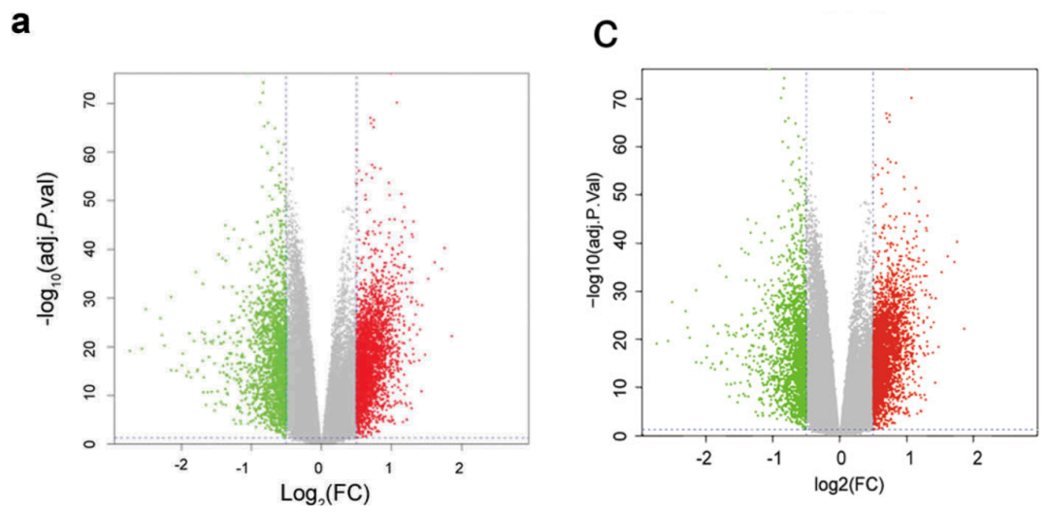

**参考信息：**

https://pubmed.ncbi.nlm.nih.gov/30395767/

https://pubpeer.com/publications/39321946A60249478A5893B5F8E6ED#3