[湖北中医药大学知名附属医院论文图片重复](https://mp.weixin.qq.com/s?__biz=Mzg5MTg0MDc4NQ==&mid=2247493242&idx=1&sn=f49a9ba565576d143b27bd43d09e5124&chksm=ce75cecff57f226ad78d88033d6f69bbb331f18a6cfbaff232f7b7ea85bcfc473b5101eeb2eb&scene=126&sessionid=1743785759)

原创  Figure[图片重复](javascript:void(0);)2025-03-16 08:46:00广东

**pH-triggered sustained release of arsenic trioxide by polyacrylic acid capped mesoporous silica nanoparticles for solid tumor treatment in vitro and in vivo**

Journal of Biomaterials Applications (2016) - 2 Comments  
doi: 10.1177/0885328216637211  issn: 0885-3282  issn: 1530-8022  pubmed: 27059495

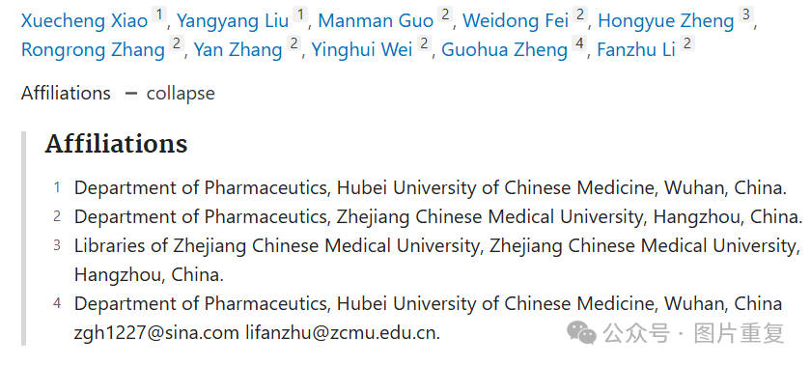

#1 ***Paguma larvata*** comment accepted March 2024

there is a duplication or repetition in the TEM image section. please comment with that

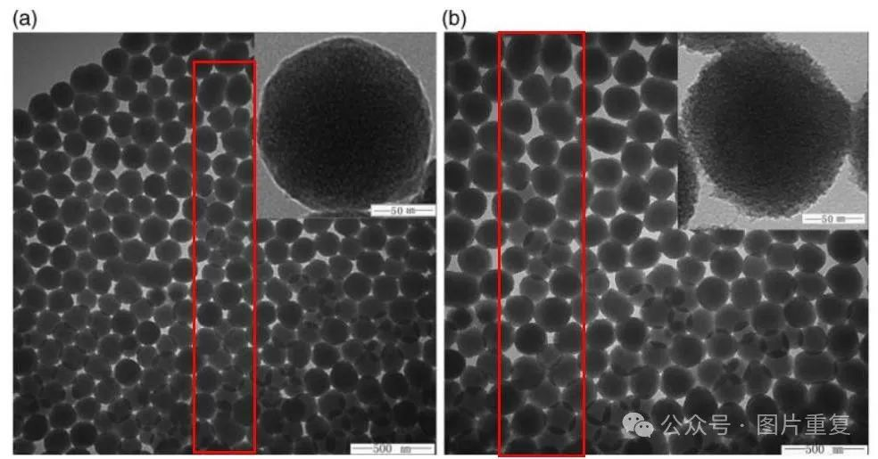

#2 ***Lachnum pteridophyllum*** comment accepted March 2024

The identical images were also identified in multiple instances within the article titled

'Preparation and in vitro/in vivo evaluation of arsenic trioxide-loaded pH-responsive mesoporous silica nanoparticles,' published in the

Chinese Traditional and Herbal Drugs

