[20 处引用被撤或遭质疑！温州医科大学附属第二医院妇产科的论文引风波，以色列理工学院生物学院、哈佛大学医学院等机构卷入](https://mp.weixin.qq.com/s?__biz=Mzk3NTEwMTE3OA==&mid=2247485443&idx=1&sn=a7921959be47f4235bc96da329e0336b&chksm=c54518ab9e1fbe1210c62e85f2843a7af53463b30606a3cedec4a48550a8f8c0d0e571f0d250&scene=126&sessionid=1743699818)

[学术荟萃](javascript:void(0);)2025-04-03 23:59:00山东

**Part.1**



**论文简介**

**标题：Long non-coding RNAs as a determinant of cancer drug resistance: Towards the overcoming of chemoresistance via modulation of lncRNAs**

**日期：**2020年2月25日

**单位与作者：**

温州医科大学附属第二医院妇产科Wenxiao Jiang、Xueqiong Zhu(通讯作者 音译 朱雪琼)

蚌埠医科大学检验医学院Jun Xia

哈佛大学医学院Beth Israel Deaconess医学中心Zhi-wei Wang

以色列理工学院生物学院 Fred Wyszkowski癌症研究实验室Yehuda G. Assaraf

**期刊：*Drug Resistance Updates***

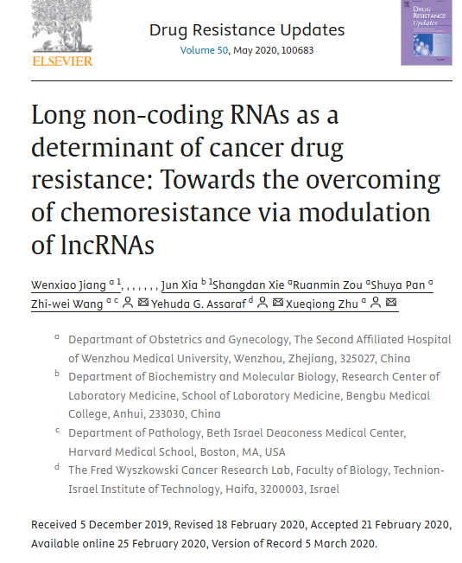

**Part.2**



**图像重复问题**

**#1 文章存在20个受质疑或被撤回的引用，这些引用的可靠性受到质疑。**

DOI: 10.1007/s13277-015-3998-6 **[retracted]**

Details: Overexpression of long non-coding RNA HOTAIR leads to chemoresistance by activating theWnt/beta-catenin pathway in human ovarian cancer. Tumour Biol., 37 (2) (2016), pp. 2057-2065.

DOI: 10.1080/15384101.2017.1301334 **[retracted]**

Details: LncRNA CCAT1 modulates the sensitivity of paclitaxel in nasopharynx cancers cells via miR-181a/CPEB2 axis. Cell Cycle, 16 (8) (2017), pp. 795-801.

DOI:10.3892/ijo.2018.4412 **[retracted]**

Details: Exosome-mediated transfer of lncRNA RP11838N2.4 promotes erlotinib resistance in non-small cell lung cancer. Int. J. Oncol., 53 (2) (2018), pp. 527-538.

DOI:10.2147/ott.s220998 **[retracted]**

Details:LncRNA FTX promotes proliferation and invasion of gastric Cancer via miR-144/ZFX Axis. Oncol. Ther., 12 (2019), pp. 11701-11713.

DOI:10.1038/s41419-018-0706-7 **[retracted]**

Details: Aberrant mannosylation profile and FTX/miR-342/ALG3-axis contribute to development of drug resistance in acute myeloid leukemia. Cell Death Dis., 9 (6) (2018), p. 688.

DOI:10.1016/j.biopha.2017.02.011 **[retracted]**

Details: The effects of the long non-coding RNA MALAT-1 regulated autophagy-related signaling pathway on chemotherapy resistance in diffuse large B-cell lymphoma. Biomed. Pharmacother., 89 (2017), pp. 939-948.

DOI:10.3892/ijo.2018.4467 **[retracted]**

Details: Exosome-mediated transfer of lncRNASNHG14 promotes trastuzumab chemoresistance in breast cancer. Int. J. Oncol., 53 (3) (2018), pp. 1013-1026.

DOI:10.1186/s13046-018-0845-9 **[retracted]**

Details: Exosome-mediated transfer of lncRNA PART1 induces gefitinib resistance in esophageal squamous cell carcinoma via functioning as a competing endogenous RNA. J. Exp. Clin. Cancer Res., 37 (1) (2018), p. 171.

DOI:10.1007/s10529-017-2392-4 **[retracted]**

Details: Autophagy regulated by lncRNA HOTAIR contributes to the cisplatin-induced resistance in endometrial cancer cells. Biotechnol. Lett., 39 (10) (2017), pp. 1477-1484.

DOI:10.1186/s13046-018-0875-3  **[retracted]**

Details: SP1-induced lncRNA AGAP2-AS1 expression promotes chemoresistance of breast cancer by epigenetic regulation of MyD88. J. Exp. Clin. Cancer Res., 37 (1) (2018), p. 202.

DOI:10.1007/s00280-016-3178-4 **[retracted]**

Details: Linc-ROR confers gemcitabine resistance to pancreatic cancer cells via inducing autophagy and modulating the miR-124/PTBP1/PKM2 axis. Cancer Chemother. Pharmacol., 78 (6) (2016), pp. 1199-1207.

DOI:10.1016/j.canlet.2018.06.039  **[retracted]**

Details:Downregulation of lncRNA GAS5 confers tamoxifen resistance by activating miR-222 in breast cancer. Cancer Lett., 434 (2018), pp. 1-10 Pubpeer thread

DOI:10.1186/s12943-018-0931-9 **[retracted]**

Details:Activation of LncRNA TINCR by H3K27 acetylation promotes Trastuzumab resistance and epithelial-mesenchymal transition by targeting MicroRNA-125b in breast cancer. Mol. Cancer, 18 (1) (2019), p. 3.

DOI:10.1080/15384101.2019.1652035 **[retracted]**

Details:Downregulation of long noncoding RNA CRNDE suppresses drug resistance of liver cancer cells by increasing microRNA-33a expression and decreasing HMGA2 expression. Cell Cycle, 18 (19) (2019), pp. 2524-2537.

DOI:10.26355/eurrev_201906_18188 **[retracted]**

Details:Long noncoding LUCAT1 promotes cisplatin resistance of non-small cell lung cancer by promoting IGF-2. Eur. Rev. Med. Pharmacol. Sci., 23 (12) (2019), pp. 5229-5234.

DOI:10.1159/000495168 **[retracted]**

Details: Knockdown of long non-coding RNA XIST inhibited doxorubicin resistance in colorectal Cancer by upregulation of miR-124 and downregulation of SGK1. Cell. Physiol. Biochem., 51 (1) (2018), pp. 113-128.

DOI:10.18632/oncotarget.13708

Details:Correlation of long non-coding RNA H19 expression with cisplatin-resistance and clinical outcome in lung adenocarcinoma. Oncotarget, 8 (2) (2017), pp. 2558-2567.

DOI:10.1186/s12967-015-0442-z

Details:The long non-coding RNA HOTTIP promotes progression and gemcitabine resistance by regulating HOXA13 in pancreatic cancer. J. Transl. Med., 13 (2015), p. 84.

DOI:10.1007/s00280-016-3194-4

Details:Long noncoding RNA GAS5 inhibits malignant proliferation and chemotherapy resistance to doxorubicin in bladder transitional cell carcinoma. Cancer Chemother. Pharmacol., 79 (1) (2017), pp. 49-55.

DOI:10.26355/eurrev_202104_25517  **[retracted]**

Details: BCAR4 increase cisplatin resistance and predicted poor survival in gastric cancer patients. Eur. Rev. Med. Pharmacol. Sci., 21 (18) (2017), pp. 4064-4070.

Detected using **Problematic Paper Screener.**

**参考信息：**

https://pubpeer.com/publications/DA3C76EA7417F3528592796C642E0A#1

https://www.sciencedirect.com/science/article/abs/pii/S1368764620300108?via%3Dihub