[Imagetwin查重发现，新乡市中心医院神经内科论文与多篇论文共享流式细胞术数据，待深度核查](https://mp.weixin.qq.com/s?__biz=Mzk0NjYzMDcyNQ==&mid=2247513690&idx=2&sn=6a4614888c4f222dabe725a8c041dae6&chksm=c25104b7058525da43cb47241c4504d788d80c1515489b925474731cb4e7501cff6245f7e913&scene=126&sessionid=1743699067)

[图片查重指南针](javascript:void(0);)2025-03-26 13:49:57中国台湾

[](http://mp.weixin.qq.com/s?__biz=Mzk0NjYzMDcyNQ==&mid=2247494760&idx=1&sn=9f28762dc91428c028f15e4f752f2e88&chksm=c3019542f4761c5449a4b653c431eba3a2d17317fed2115923f1044eabc511f4a936059ae166&scene=21#wechat_redirect)

***01***

**论文信息**

2017年10月6日，新乡市中心医院神经内科在OncoTargets and Therapy发表题为“let-7d suppresses proliferation and invasion and promotes apoptosis of meningioma by targeting AEG-1”的论文。

通讯作者：新乡市中心医院神经内科Jianmin Zhao

第一作者：新乡市中心医院神经内科Hui Li

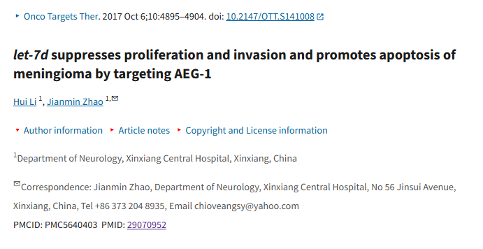

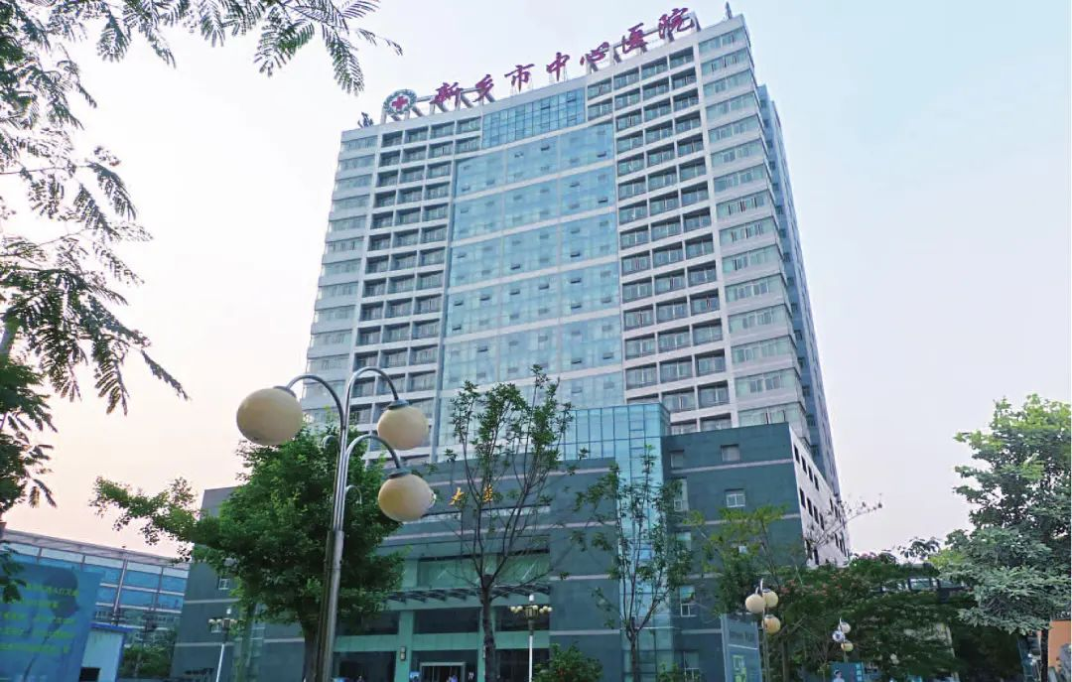

***02***

**质疑信息**

**质疑一：图2C：图像的某些部分似乎已被克隆。**

Figure 2C: There are parts of the image which appear to have been cloned. I've added the coloured rectangles to show where I mean. Would the authors please check and comment? Are there any better quality images available?

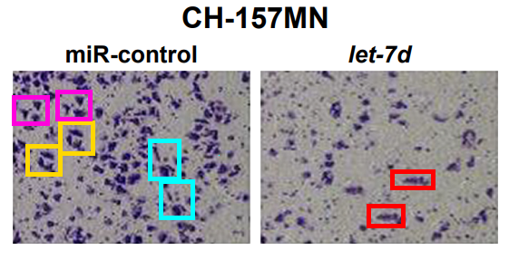

Imagetwin全网查(如需要查重服务，请联系文末客服微信)

**质疑二：这篇论文是共享相同流式细胞仪数据的多篇论文之一。我在下面添加了一个图表来说明我的意思。这些图的形式多种多样，在某些情况下，可能对相同的数据进行了不同的门控分析，因此并非所有标有彩色矩形的图乍一看都很相似，也许有些部分是事后在 photoshop（或类似软件）中克隆的。我添加了一些彩色矩形，以显示曲线图比预期更相似的地方，为了确认，我建议仔细对比高质量图像，以识别数据点的独特排列。ImageTwin.ai对识别这些点有很大帮助。**

This paper is one of a number of papers that share the same flow cytometry data. I've added a diagram below to show what I mean. The plots have various forms, in some cases it seems possible that the same data was analysed with different gating, so not all the plots marked with coloured rectangles appear similar at first glance, perhaps some parts were cloned in photoshop (or similar) after the fact. I've added some coloured rectangles to show where the plots are more similar than expected, for confirmation I recommend carefully comparing high quality images against each other to identify the unique constellations of data points. ImageTwin.ai is a great help in identifying these.

Would the authors please check and comment?

List of papers in the diagram:

10.3892/ol.2016.4827

10.1155/2017/8317913

10.2147/OTT.S124595

10.1177/1010428317711315

10.2147/OTT.S141008

10.1186/s13578-017-0178-y

10.1186/s40709-019-0102-1

10.2147/OTT.S172152

10.1007/s12032-015-0695-7

10.3349/ymj.2017.58.6.1092

10.1242/bio.024133

10.3892/br.2018.1084

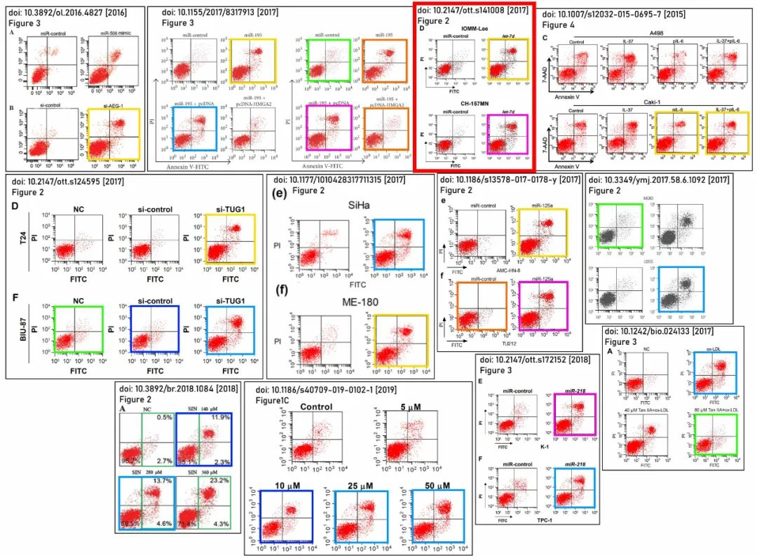

**参考信息：**

https://pubpeer.com/publications/CE3164D47F70CCA1BDE2B881325340#1

https://pmc.ncbi.nlm.nih.gov/articles/PMC5640403/#

**论文图片Imagetwin查重服务**

**请添加查重部客服微信：figfig04**



*#*

***往期精选***

城门失火，殃及池鱼| 涨知识，非洲大草原上的蚂蚁如何打败狮子：物种入侵的危害

**近日Onco Targets and Therapy接连撤稿数篇，本周涉四川省人民医院李刚教授文章，与两篇论文图片重复**

猎杀狼保护牲畜？可能会适得其反

DOVE期下期刊近期撤稿和质疑高发，重点警惕，南京医科大学附属第一医院顾艳宏等人文章因多处图片重复被质疑

[**Science最新封面研究！人类使用的植物都分布在哪里？**](http://mp.weixin.qq.com/s?__biz=Mzk0NjYzMDcyNQ==&mid=2247484011&idx=1&sn=c66c081849cf2df587aa956f14f783dc&chksm=c3027b41f475f2579f223d5f58c14d6000fc335b1147f43d6c7f76d056e1f6c4819a8373d34f&scene=21#wechat_redirect)

**校园霸凌导致逃避心理VS被打败的老鼠会绕道走！最新Nature重磅成果——专门的下丘脑催产素回路控制厌恶性社交学习**

[世界领先！柳叶刀-复旦大学舒易来教授团队成果，恢复先天性耳聋儿童听力的临床试验取得成功](http://mp.weixin.qq.com/s?__biz=Mzk0NjYzMDcyNQ==&mid=2247484011&idx=1&sn=c66c081849cf2df587aa956f14f783dc&chksm=c3027b41f475f2579f223d5f58c14d6000fc335b1147f43d6c7f76d056e1f6c4819a8373d34f&scene=21#wechat_redirect)

**和早期发表论文图片重复，北京大学人民医院郭卫教授的文章因图片重复被质疑**

[**普通的水也能引发核反应？Science Report新发现！**](http://mp.weixin.qq.com/s?__biz=Mzk0NjYzMDcyNQ==&mid=2247483830&idx=2&sn=537cebf16ad583dbd66f7b3189a53c16&chksm=c302789cf475f18a890d93724d2ac5f2d46b927242fdac92456d4d405e42fa839840ee8375e7&scene=21#wechat_redirect)

[**科研心法| 字字触动科研人的灵魂**](http://mp.weixin.qq.com/s?__biz=Mzk0NjYzMDcyNQ==&mid=2247483653&idx=1&sn=f7be4bed0253bd20d69b549bc1371b98&chksm=c302782ff475f139ced644ce446311f6444100157db60ffcbb33a81d844cd3bbd068315d108b&scene=21#wechat_redirect)

[**疑似数据在不同论文重复使用！国家卫健委直属北京医院国家老年病学中心内分泌科郭立新教授等发表的文章被质疑**](http://mp.weixin.qq.com/s?__biz=Mzk0NjYzMDcyNQ==&mid=2247483830&idx=3&sn=19dfc430973d4390f940258997ec5da2&chksm=c302789cf475f18a0ccf7c722741814d9b477fdfa256bfdc97a50cb3538c2a58fe48583ef55a&scene=21#wechat_redirect)

[**一图两用，双双撤稿，深圳大学第一附属医院放射科两篇论文近日被撤稿**](http://mp.weixin.qq.com/s?__biz=Mzk0NjYzMDcyNQ==&mid=2247483765&idx=1&sn=02944f4bc5de4cf631b484fe00fa5440&chksm=c302785ff475f1496244384c1ec34dd2fb9907d59cde4156637810f48dde2b40c908b01dfb88&scene=21#wechat_redirect)

[**通讯作者邮箱有误，论文工厂参与操作图片！聊城市人民医院肿瘤科马丹论文被撤稿**](http://mp.weixin.qq.com/s?__biz=Mzk0NjYzMDcyNQ==&mid=2247483765&idx=2&sn=eff726b58cf0ff803a53cf1b8591f8b6&chksm=c302785ff475f14901bcbb18a9f8134d1bb1fe2cc40ab8c3e418f3f56e4494b8334209ef741c&scene=21#wechat_redirect)

[**第三方参与操纵发表迹象，青岛大学附属医院/四川大学华西口腔医院/复旦大学附属妇产科医院三家单位的论文本周被撤稿**](http://mp.weixin.qq.com/s?__biz=Mzk0NjYzMDcyNQ==&mid=2247483690&idx=1&sn=bc06edadea5ca7926a7155565664a660&chksm=c3027800f475f1161978def48dc683f7964c6f493b03398c7f22a6c6cb9aadd51d0cca34f636&scene=21#wechat_redirect)

[**盗用他人多年前发表图片，上海中医药大学附属第七人民医院被撤稿**](http://mp.weixin.qq.com/s?__biz=Mzk0NjYzMDcyNQ==&mid=2247483690&idx=2&sn=a13ff72bf531150f978d559e5964edd5&chksm=c3027800f475f116462ad6cc0fcea63b0ee700741bedf113c3dbf81250d7a65ae5767ccfa0ce&scene=21#wechat_redirect)