[南方医科大学附属深圳医院知名团队论文图片重复](https://mp.weixin.qq.com/s?__biz=Mzg5MTg0MDc4NQ==&mid=2247493258&idx=1&sn=083ba6aca651ccc123f90b8049353636&chksm=cebc981299247a2c5cd2522815e52215f3e0bfa67dc11fe223e653976e23bc3354351f6d0070&scene=126&sessionid=1743612023)

原创  F[图片重复](javascript:void(0);)2025-03-17 20:43:20广东

**Bcl-2 Proteins Regulate Mitophagy in Lipopolysaccharide-Induced Acute Lung Injury via PINK1/Parkin Signaling Pathway**

**Oxidative Medicine and Cellular Longevity (2020)**

**PMID:**32148654

**DOI:**10.1155/2020/6579696

**AUTHORS**

**Zhihao Zhang1,Zhugui Chen2,Ruimeng Liu1,Qingchun Liang3,Zhiyong Peng1,Shuang Yin1,Jing Tang2,Ting Gong1,Youtan Liu1**

**AFFILIATIONS**

1Department of Anesthesiology, Shenzhen Hospital, Southern Medical University, No. 1333, Xinhu Road, Baoan District, Shenzhen, Guangdong Province, 518110, China.

2Department of Anesthesiology, Affiliated Hospital of Guangdong Medical University, Renmindadao Road, Xiashan District, Zhanjiang, Guangdong Province, 524002, China.

3Department of Anesthesiology, The Third Affiliated Hospital of Southern Medical University, Guangzhou 510000, China.

#### Author response 4 hours ago

**#1Amathusia Phidippus 5 day ago**

 The control group images in Figure 1(d) and Figure 4(i) appear strikingly similar.

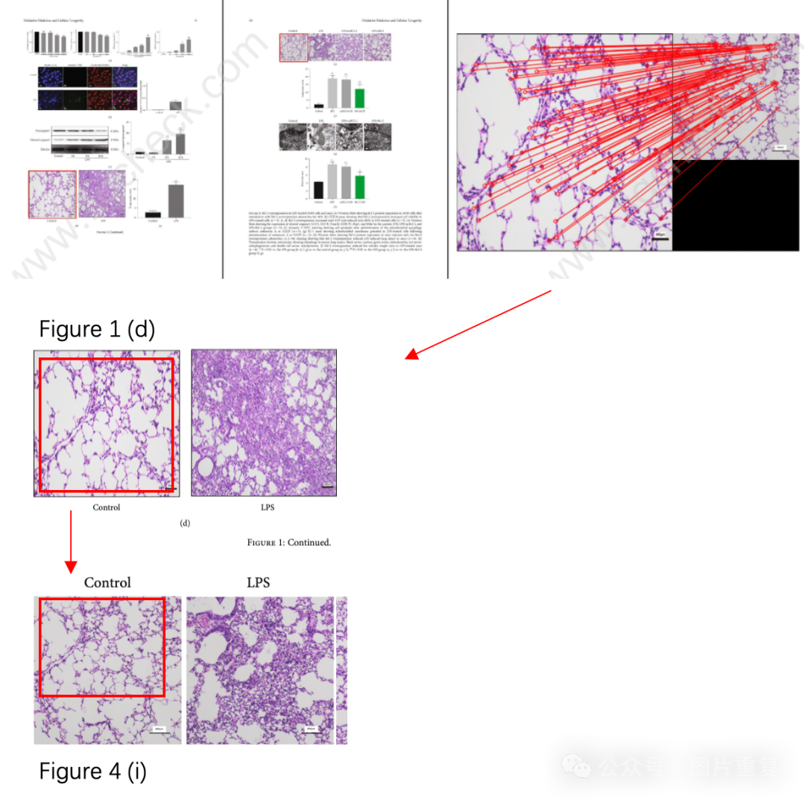

**#2Youtan Liu (author) 1 day ago**

Thank you very much for your valuable comments. In our study, we extracted lung tissue sections from the control group mice and performed H&E staining. The sections were then photographed and the images were stored in a designated folder. When we needed to use images from the control group, we randomly selected them from the folder and marked them to avoid duplication. We considered that the two images in question are sections from different layers of the same lung tissue, which is why they appear similar. The apparent repetition is due to the random selection process, but they are not the same image. Both images are from the same control group, and we believe that this has no impact on the rigor of our study. It is simply the result of random sampling.Here are the original data for the two images in this study: Figure 1 D: We used a photograph magnified 200 times.  Figure 4 I: We used a photograph magnified 100 times.  From this, it can be seen that the two images are from different sources!

Once again, thank you very much for your valuable comments! Best regards.

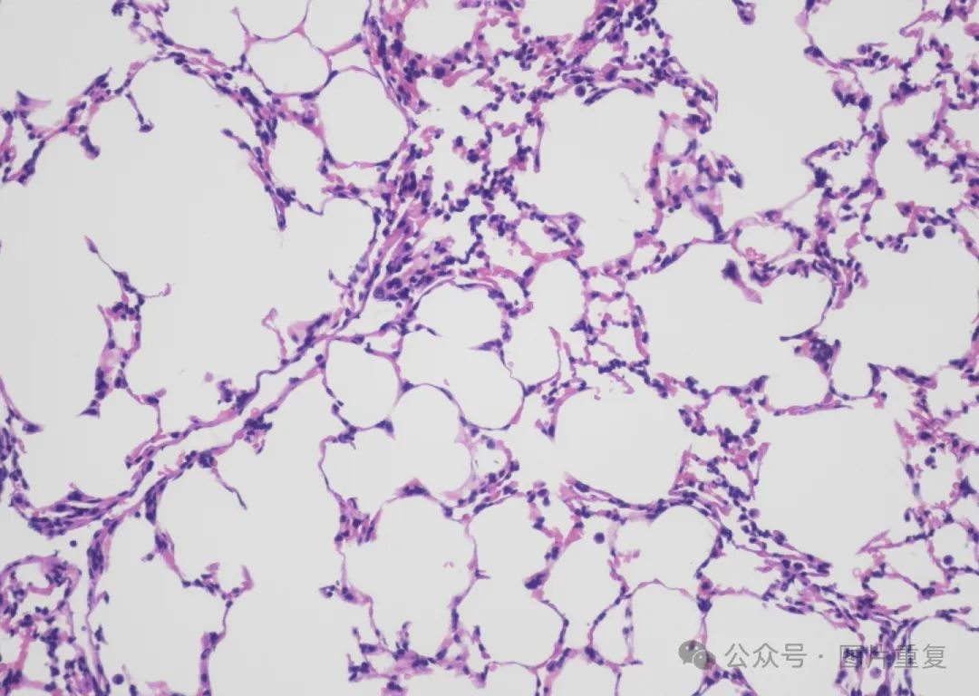

**#3Youtan Liu (author)**

**4 hours ago**

This is the basic information of the two original images. Apparently, these are two different photographs. When publishing the article, we randomly selected images and marked the used ones to avoid duplication. Both of these different photographs are from the control group. The two images convey the same meaning. We believe that this does not affect the rigor of the experiment. Figure1D： gure4I： Thank you once again for your valuable comments. Best wishes!

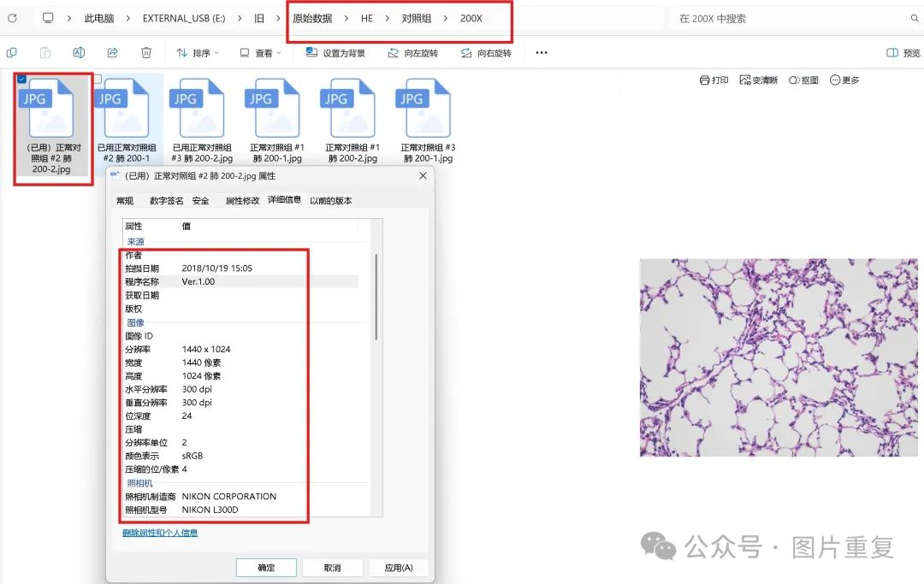

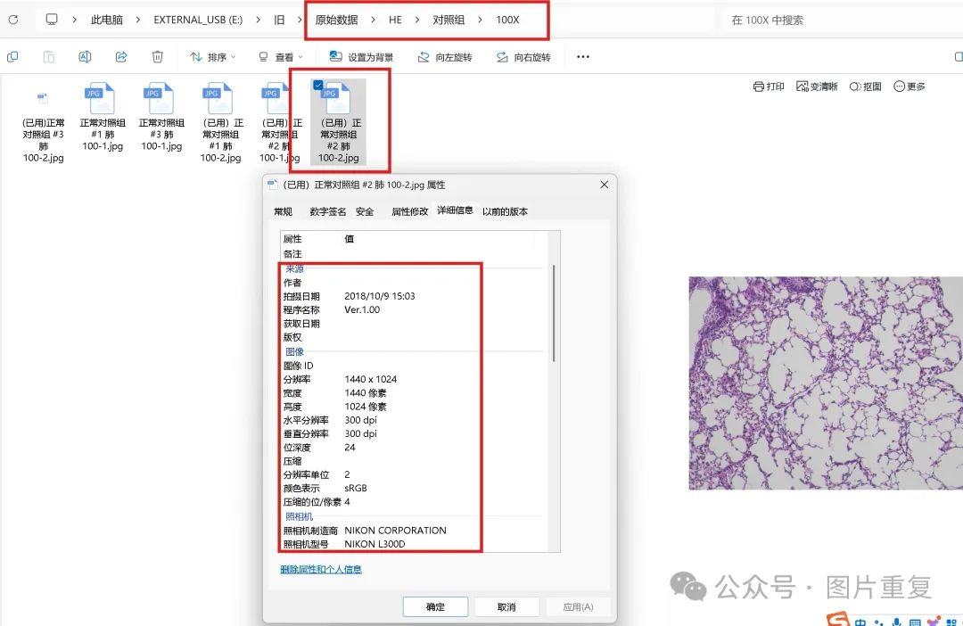

[#图片重复](https://mp.weixin.qq.com/mp/appmsgalbum?__biz=Mzg5MTg0MDc4NQ==&action=getalbum&album_id=2546994047780667392#wechat_redirect)[#南方医科大学](https://mp.weixin.qq.com/mp/appmsgalbum?__biz=Mzg5MTg0MDc4NQ==&action=getalbum&album_id=3902767546918715396#wechat_redirect)