[与9篇论文图像面板重叠，吉林大学中日联谊医院韩涛的论文被撤稿.PMID: 29179483](https://mp.weixin.qq.com/s?__biz=MzkzNjYxMTEzMA==&mid=2247530946&idx=1&sn=24d714700411a41ce1eda3bbab46e1da&chksm=c3afb427dfdf1c195900ad5cbca6a87bcc45707effd452082c009726901c1ac2e21198ab0c90&scene=126&sessionid=1743523802)

DataTwin[DataTwin](javascript:void(0);)2025-03-24 07:53:29浙江

**点击上方蓝字**关注我们







**论文信息**

2017年10月4日，吉林大学中日联谊医院在Oncotarget期刊上在线发表题为**"MicroRNA-216a inhibits the metastasis of gastric cancer cells by targeting JAK2/STAT3-mediated EMT process"**(MicroRNA-216a 通过靶向 JAK2/STAT3 介导的 EMT 过程抑制胃癌细胞的转移)论文。

第一作者：吉林大学中日联谊医院 Youmao Tao

通讯作者：吉林大学中日联谊医院 Tao Han（音译 韩涛）

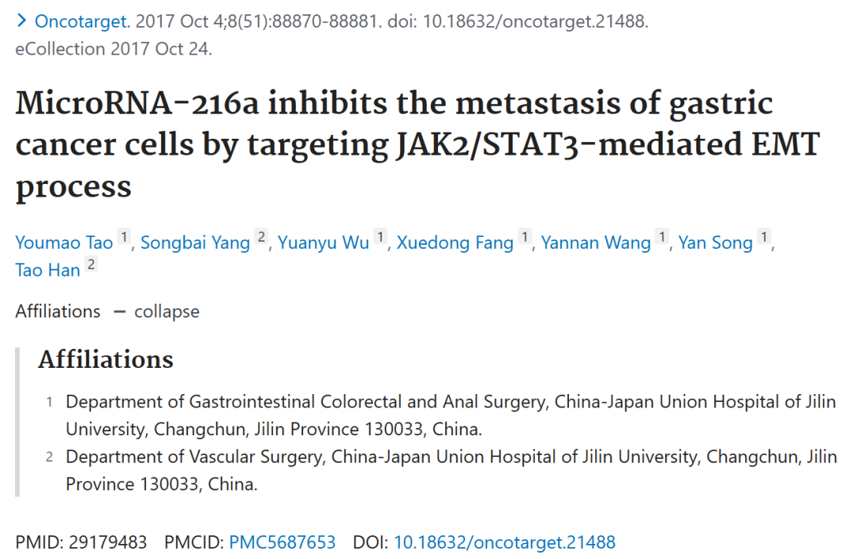





**质疑信息**

**#1**Unexpected similarities among scratch-assay migration images from three papers:

[above] Fig 5a from "EZH2-mediated epigenetic suppression of long noncoding RNA SPRY4-IT1 promote s NSCLC cell proliferation and metastasis by affecting the epithelial–mesenchymal transition" (Sun et al 2014a).

[middle] Fig 4A/B from "Downregulation of BRAF activated non-coding RNA is associated with poor prognosis for non-small cell lung cancer and promotes metastasis by affecting epithelial-mesenchymal transition" (Sun et al 2014b).

[lower] Fig 2B,E.

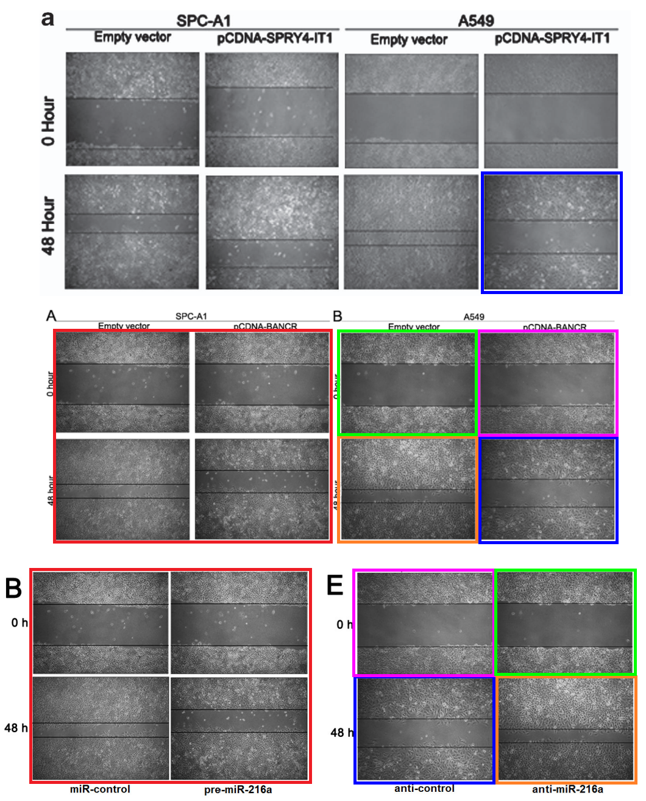

DataTwin图片查重

**#2**[above] Fig 2C/F.

[below] Figs 2C, 3C from "miR-944 inhibits metastasis of gastric cancer by preventing the epithelial-mesenchymal transition via MACC1/Met/AKT signaling" (Pan et al 2017).

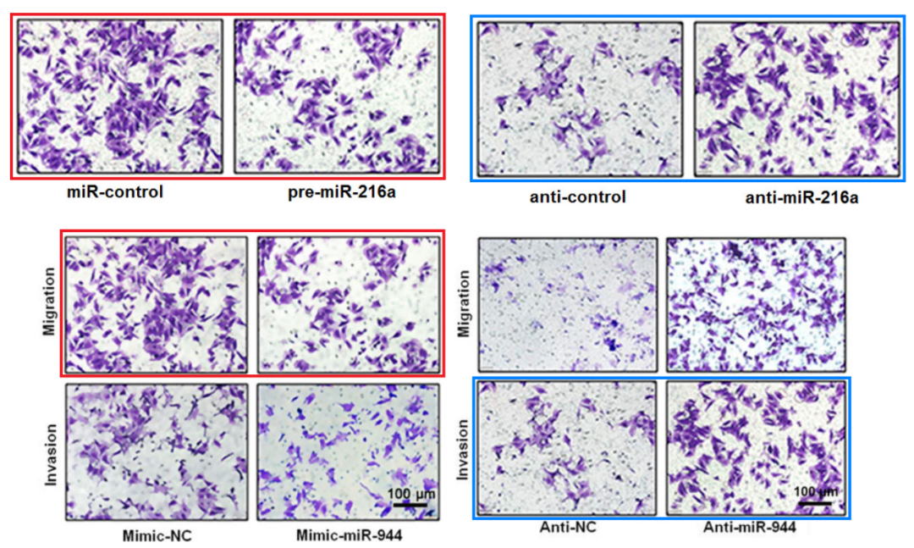

DataTwin图片查重

**#3**[left] Fig 7C.

[right] Fig 3D from Pan et al (2017).

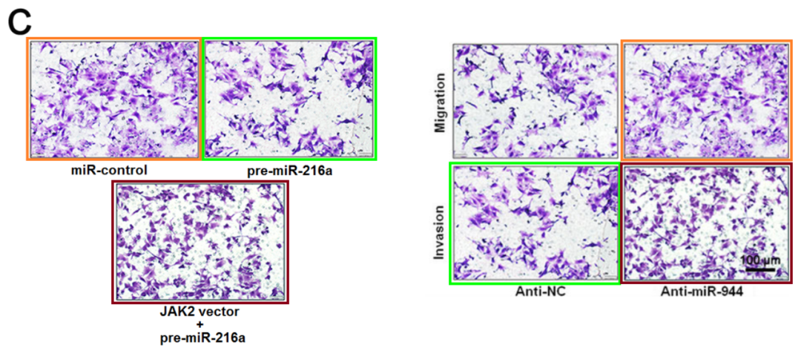

DataTwin图片查重

**#4**[left] Fig 7B.

[right] Fig 4E from "SUMOylation of Grb2 enhances the ERK activity by increasing its binding with Sos1" (Qu et al 2014).

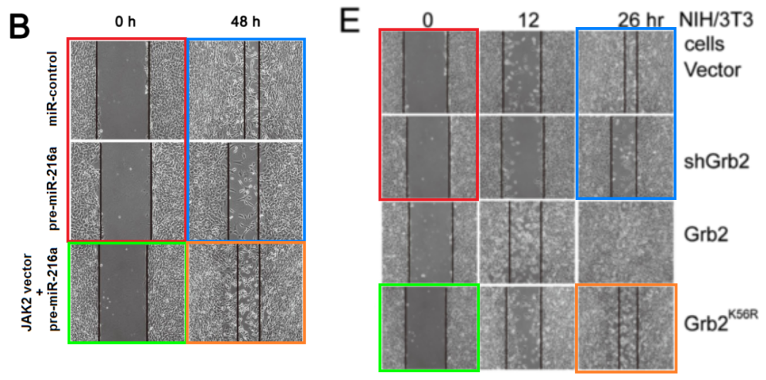

DataTwin图片查重

**#5**[left] Fig 6.

[right] Fig 8 from "microRNA-526b servers as a prognostic factor and exhibits tumor suppressive property by targeting Sirtuin 7 in hepatocellular carcinoma" (Liu et al 2017).

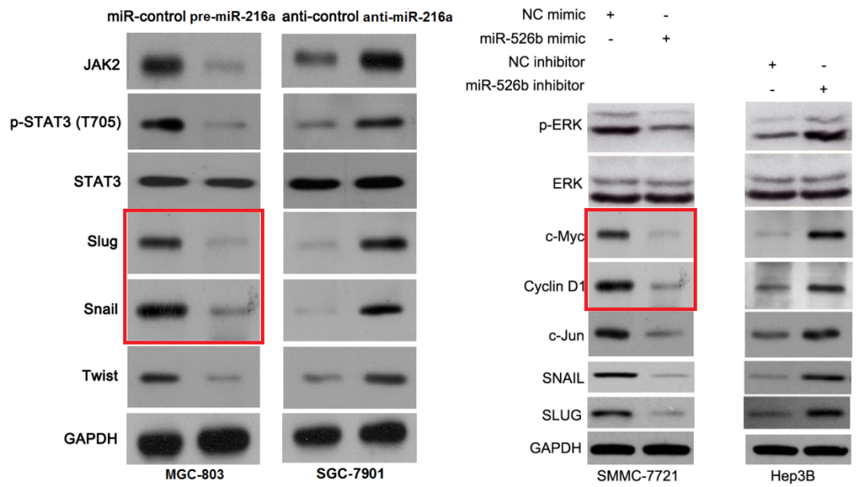

DataTwin图片查重

[left] Figs 9A,C from "LncRNA CHRF-induced miR-489 loss promotes metastasis of colorectal cancer via TWIST1/EMT signaling pathway" (Tao et al 2017).

[right] Fig 6 again.

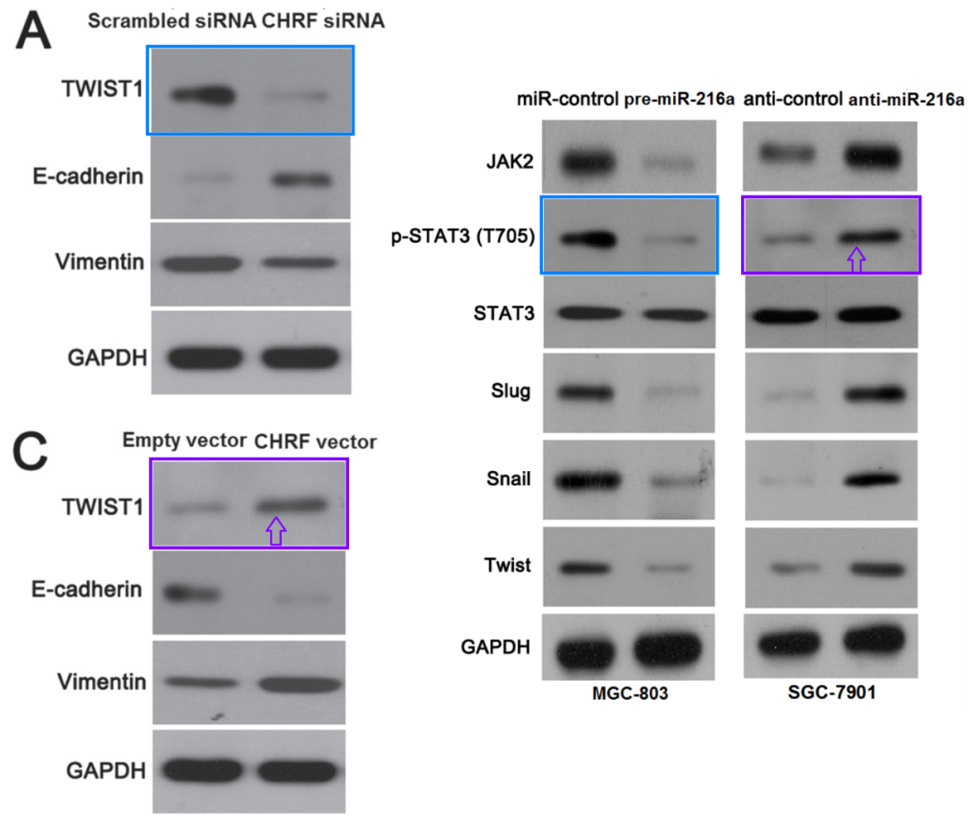

DataTwin图片查重

**#6**[left] Fig 6a from "MicroRNA-27b exerts an oncogenic function by targeting Fbxw7 in human hepatocellular carcinoma" (Sun et al 2016).

[right] Fig 5C.

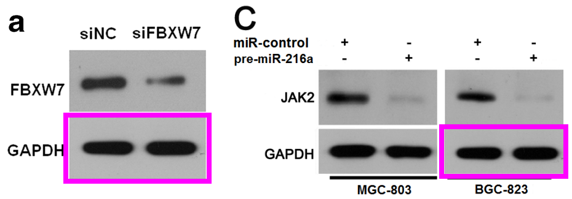

DataTwin图片查重

**#7**[left] Fig 6B/D from "Acylglycerol kinase promotes cell proliferation and tumorigenicity in breast cancer via suppression of the FOXO1 transcription factor" (Wang et al 2014).

[right] Fig 7A.

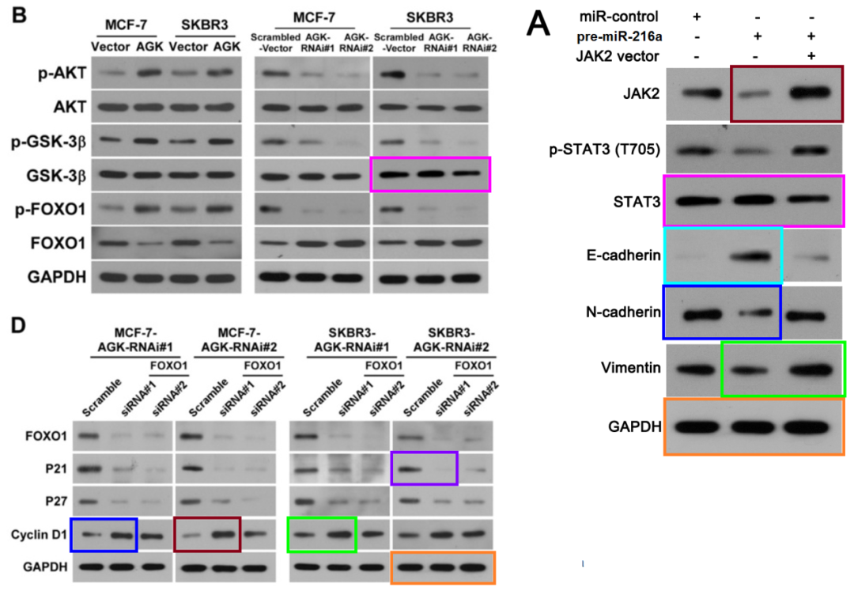

DataTwin图片查重

**#8**[left] Figs 2B/E, 6B from "MicroRNA-448 suppresses metastasis of pancreatic ductal adenocarcinoma through targeting JAK1/STAT3 pathway" (Yu et al 2017)

[middle] Figs 7B, 8B.

[right] Fig 4E/F from "SUMOylation of Grb2 enhances the ERK activity by increasing its binding with Sos1" (Qu et al 2014).

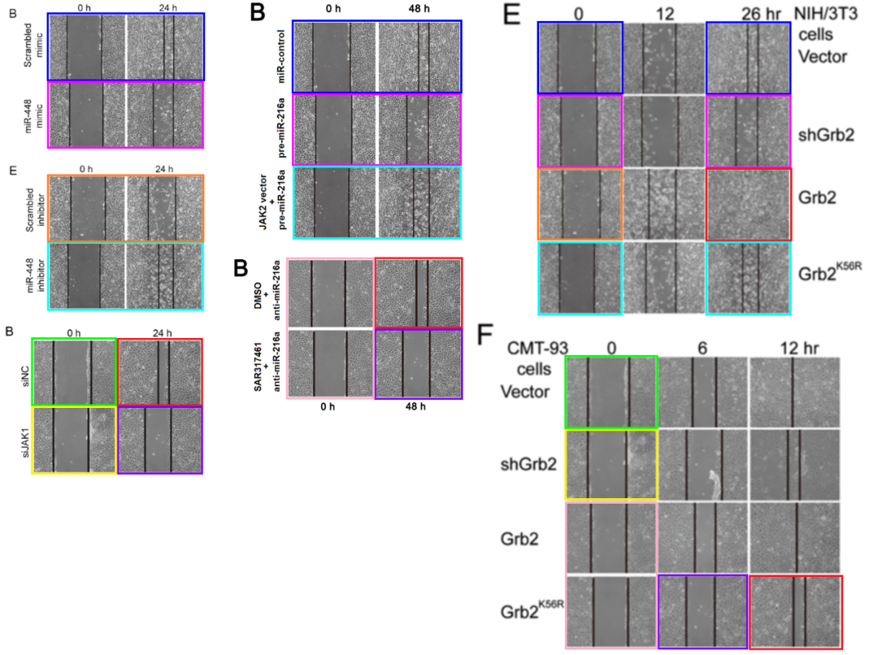

DataTwin图片查重



**撤稿原因**

**本文已于2025年3月10日被撤回：**

Oncotarget 已完成对该论文的调查，经核实，该论文中的多张图片是从先前发表的论文中重复使用的。特别是，图2（B和E面板）以及图7B和图8B中的伤口愈合试验图像是从四篇不同的早期论文[1-4]中重复使用的伤口愈合试验图像的复制品。图2的C和F面板以及图7C和图8C中的Transwell试验图像被发现是另一篇随后已被撤回的早期论文中Transwell试验图像的复制品[5]。图4A、5C、6和7A重复使用了多篇不相关论文[6-8]中的众多Western blot图像，其中一篇随后也被撤回[8]。此外，图6还重复使用了图5C以及同一实验室早期论文中的Western blot图像[9]。我们尝试联系作者以获取有关这些重复使用的更多信息，但作者未予回应。因此，编辑部决定撤回本文。

涉及文章：

1. Sun M, Liu XH, Lu KH, Nie FQ, Xia R, Kong R, Yang JS, Xu TP, Liu YW, Zou YF, Lu BB, Yin R, Zhang EB, et al. EZH2-mediated epigenetic suppression of long noncoding RNA SPRY4-IT1 promotes NSCLC cell proliferation and metastasis by affecting the epithelial-mesenchymal transition. Cell Death Dis. 2014; 5:e1298. https://doi.org/10.1038/cddis.2014.256.

2. Sun M, Liu XH, Wang KM, Nie FQ, Kong R, Yang JS, Xia R, Xu TP, Jin FY, Liu ZJ, Chen JF, Zhang EB, De W, Wang ZX. Downregulation of BRAF activated non-coding RNA is associated with poor prognosis for non-small cell lung cancer and promotes metastasis by affecting epithelial-mesenchymal transition. Mol Cancer. 2014; 13:68. https://doi.org/10.1186/1476-4598-13-68.

3. Qu Y, Chen Q, Lai X, Zhu C, Chen C, Zhao X, Deng R, Xu M, Yuan H, Wang Y, Yu J, Huang J. SUMOylation of Grb2 enhances the ERK activity by increasing its binding with Sos1. Mol Cancer. 2014; 13:95. https://doi.org/10.1186/1476-4598-13-95.

4. Yu DL, Zhang T, Wu K, Li Y, Wang J, Chen J, Li XQ, Peng XG, Wang JN, Tan LG. MicroRNA-448 suppresses metastasis of pancreatic ductal adenocarcinoma through targeting JAK1/STAT3 pathway. Oncol Rep. 2017; 38:1075–82. https://doi.org/10.3892/or.2017.5781. [PubMed]. Retraction in: Oncol Rep. 2022; 48:209. https://doi.org/10.3892/or.2022.8424.

5. Pan T, Chen W, Yuan X, Shen J, Qin C, Wang L. miR-944 inhibits metastasis of gastric cancer by preventing the epithelial-mesenchymal transition via MACC1/Met/AKT signaling. FEBS Open Bio. 2017; 7:905–14. https://doi.org/10.1002/2211-5463.12215. [PubMed]. Retraction in: FEBS Open Bio. 2022; 12:2260. https://doi.org/10.1002/2211-5463.13512.

6. Sun XF, Sun JP, Hou HT, Li K, Liu X, Ge QX. MicroRNA-27b exerts an oncogenic function by targeting Fbxw7 in human hepatocellular carcinoma. Tumour Biol. 2016; 37:15325–32. https://doi.org/10.1007/s13277-016-5444-9.

7. Liu X, Yang L, Tu J, Cai W, Zhang M, Shou Z, Yao Y, Xu Q. microRNA-526b serves as a prognostic factor and exhibits tumor suppressive property by targeting Sirtuin 7 in hepatocellular carcinoma. Oncotarget. 2017; 8:87737–49. https://doi.org/10.18632/oncotarget.21209.

8. Wang X, Lin C, Zhao X, Liu A, Zhu J, Li X, Song L. Acylglycerol kinase promotes cell proliferation and tumorigenicity in breast cancer via suppression of the FOXO1 transcription factor. Mol Cancer. 2014; 13:106. https://doi.org/10.1186/1476-4598-13-106.

9. Tao Y, Han T, Zhang T, Ma C, Sun C. LncRNA CHRF-induced miR-489 loss promotes metastasis of colorectal cancer via TWIST1/EMT signaling pathway. Oncotarget. 2017; 8:36410–22. https://doi.org/10.18632/oncotarget.16850.

**参考信息**

https://pubpeer.com/publications/32B611AC1BD530A362C0E798B303B7

https://pubmed.ncbi.nlm.nih.gov/29179483/

https://www.oncotarget.com/article/28702/

**声明：**

任何单位或个人认为本内容可能涉嫌侵犯其合法权益，及时向我们提出书面权利通知及详细侵权情况，我们将会依法尽快移除相关涉嫌侵权的内容。

联系微信号：DataTwin



**往期报道精选**

[全网最低价！文件图片查重+比对Pubmed和Pubpeer数据库查重，DataTwin高效权威图片识别！众多知名打假人士推荐使用](http://mp.weixin.qq.com/s?__biz=MzkzNjYxMTEzMA==&mid=2247486008&idx=5&sn=43a2d45f61ed36770808541d737ca3cd&chksm=c29d566df5eadf7bcf1cee3ab814981f26fd4b8aef7a56bb740c999691685526232641ed1bc9&scene=21" \l "wechat_redirect" \t "_blank)

[一区Top9.2分，西安交通大学第二附属医院(西北医院)单涛等人论文撤稿。](http://mp.weixin.qq.com/s?__biz=MzkzNjYxMTEzMA==&mid=2247496577&idx=1&sn=5f6c203ab8c8a90910fb169fb557f09e&chksm=c29eafd4f5e926c23429d2cdbfa4b858d50d365ccedb076342024a06cdef3503285527c04f71&scene=21#wechat_redirect)

[图片重复未作解释，成武县人民医院岳彩云&山东第一医科大学第一附属医院（千佛山医院）杨敏等人论文被撤稿。](http://mp.weixin.qq.com/s?__biz=MzkzNjYxMTEzMA==&mid=2247496577&idx=2&sn=f7e9d4976a062f45ab4c82678d64d647&chksm=c29eafd4f5e926c22879afc68758ce79092ccd6e09bdcf84ed33af28cb858720cdd98d8d1f8b&scene=21#wechat_redirect)

[希腊期刊撤稿，涉与多篇重复的老问题，常州市第一人民医院整形烧伤科李玲巧论文撤回。](http://mp.weixin.qq.com/s?__biz=MzkzNjYxMTEzMA==&mid=2247496577&idx=3&sn=adf0cc7a805cb0b3022cee01276ed136&chksm=c29eafd4f5e926c25f570665cbfe7cf5453ccca0d903d47b581b521c3496e83427771694da50&scene=21#wechat_redirect)

[网友玩微信发现问题论文，浙江大学贺永教授、浙江大学医学院附属口腔医院石钰等人发表到Small的论文存在图片重复使用问题！](http://mp.weixin.qq.com/s?__biz=MzkzNjYxMTEzMA==&mid=2247496547&idx=1&sn=e28eef8cce3be96e2c9b87e9b47742f3&chksm=c29eaf36f5e926205da762928b9510337e641e83d400e166df0687fdaa0597e99598739585a7&scene=21#wechat_redirect)

[一篇声称新冠疫苗具有广泛危害的论文将被撤回，作者回应：出版社不允许对抗性陈述的论文存在](http://mp.weixin.qq.com/s?__biz=MzkzNjYxMTEzMA==&mid=2247496526&idx=1&sn=a7684678c2d1f7537332323923be6239&chksm=c29eaf1bf5e9260dff6cc8d0fa5823592736a87e03adaf78ed3aa67722776822efdf084c09eb&scene=21#wechat_redirect)

# [今日学术问题发现 | 兄弟借一步说话，看你是不是火眼金睛](http://mp.weixin.qq.com/s?__biz=MzkzNjYxMTEzMA==&mid=2247484202&idx=4&sn=6c887f60b170b0352211a4056136471d&chksm=c29d5f7ff5ead669026d14f9ce4fc72a33dc49b4872d0649ae332312a1497f95ee48b6e39aac&scene=21#wechat_redirect)

# [今日学术问题发现 | 你把Error Bar当作奖励给幼儿园小朋友的小红花？](http://mp.weixin.qq.com/s?__biz=MzkzNjYxMTEzMA==&mid=2247484202&idx=5&sn=6726065dc778f5d6f734f6d8e4bb4519&chksm=c29d5f7ff5ead669fa3cf39a0504fbcdd0a8856dc8e893c0c7d5a64114b6d7c0fd1bdd1274b6&scene=21#wechat_redirect)

[今日学术问题发现 | Table中的异常数据（PMID：26111626）](http://mp.weixin.qq.com/s?__biz=MzkzNjYxMTEzMA==&mid=2247484202&idx=6&sn=fa04280bf1e13fb388f5fcd7364dca92&chksm=c29d5f7ff5ead66915da906253ca3fcbdc95955d9bedfa1484acbbd6ec65069baea3c7617f17&scene=21#wechat_redirect)

[今日学术问题发现 | 不要侥幸，白天到黑夜，你还是你（荧光图片造假重复）](http://mp.weixin.qq.com/s?__biz=MzkzNjYxMTEzMA==&mid=2247484091&idx=3&sn=b4812492b782f5b1098df327c7118b29&chksm=c29d5eeef5ead7f8a36ba0a2fe28ebca0c0abf09d97a9c311ffe16fe8c6204436dafa6ed02af&scene=21#wechat_redirect)

[今日学术问题发现 | 山西医科大学贺婵婷等人论文数据图片出现多处重复](http://mp.weixin.qq.com/s?__biz=MzkzNjYxMTEzMA==&mid=2247484091&idx=4&sn=465b44b280962a59b5f3a38e18c7ccd1&chksm=c29d5eeef5ead7f8daf6a43c748db2b408fc71ae5377942fbc3ff48c3fe5b68be6a8808bb641&scene=21#wechat_redirect)

[Hepatology论文被质疑，南京医科大学第一附属医院孙倍成/南京大学医学院姜润秋教授发表的论文因图片重复](http://mp.weixin.qq.com/s?__biz=MzkzNjYxMTEzMA==&mid=2247495175&idx=2&sn=ff4146bc29b7ed9cefbbd2d02ba2454c&chksm=c29eb252f5e93b4416dd8000e979b09f21e70a7b0e188a9e8853a5957148362a894a5393c1e1&scene=21#wechat_redirect)

[DataTwin图片查重| 浙大医二院神经外科陈高教授发表的论文因图片重复被质疑](http://mp.weixin.qq.com/s?__biz=MzkzNjYxMTEzMA==&mid=2247495175&idx=3&sn=8cf91fc18af7e9230a0b51de678e4b77&chksm=c29eb252f5e93b44e6a3c09af3c60cbb0b41bf002b9e43946628019dc0250c78ec7f6301f816&scene=21#wechat_redirect)

[国家优青、海军军医大学（第二军医大学）药学院孙鹏教授发表的论文因图片重复被质疑](http://mp.weixin.qq.com/s?__biz=MzkzNjYxMTEzMA==&mid=2247495175&idx=4&sn=ceb343c415ac6e1eafde0114fff757b0&chksm=c29eb252f5e93b4452873038b8a8fa8593679122f3b552f04bfeff67d46e25d425d8a9ea08a1&scene=21#wechat_redirect)

[上海九院普外科刘斌发表的论文因图片重复被质疑](http://mp.weixin.qq.com/s?__biz=MzkzNjYxMTEzMA==&mid=2247495175&idx=5&sn=052dad49954ae38cdfcc83c7bf4bb92a&chksm=c29eb252f5e93b4449543cd4b808a98122448a7b588d2c3b0f41a03dace7e9f952d7fd128926&scene=21#wechat_redirect)

*END*



    客服微信：DataTwin



文件内部+Pubmed&Pubpeer数据库全网查重 请联系客服。