[重灾区 ！27 篇Int. Wound J被pubpeer标记撤稿，来自国内医学机构，“Effects ”居多 ，2.6万/篇。](https://mp.weixin.qq.com/s?__biz=MzIxMDEwNDU1OA==&mid=2647882561&idx=2&sn=ba6b33e0277b3df168340359e052bbf2&chksm=8ed149c90d9ca5f373f53ea082703aa2dda8dba4c3a6109d711b69dba1b763270bb39c96ae1e&scene=126&sessionid=1743441245)

原创  sleuth[Pubpeer](javascript:void(0);)2025-03-31 19:39:06新加坡

 **提示**：**欢迎点击上方「Pubpeer」↑关注我们！**

编者按

**最新、最快、最真实的科研匿名评价论文报道；关注高校院所科研生态，欢迎提供新闻线索。联系邮箱：Pubpeer@qq.com**



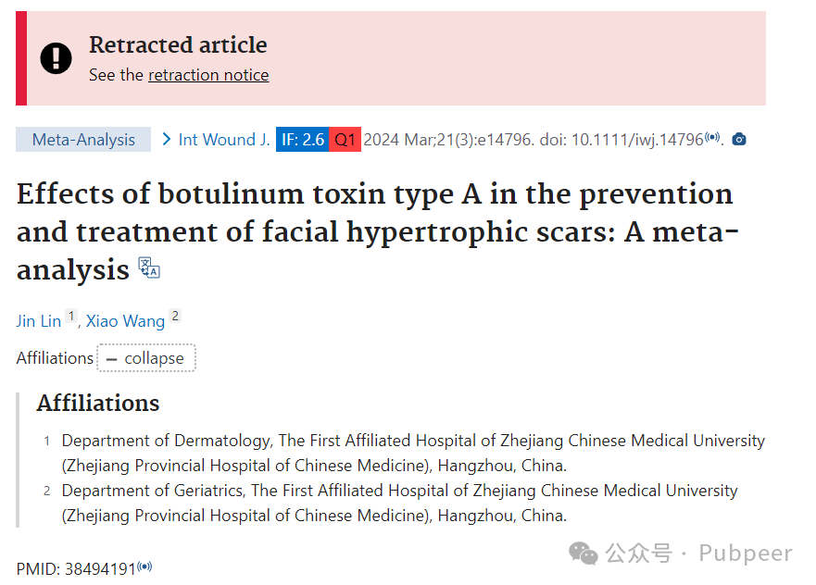

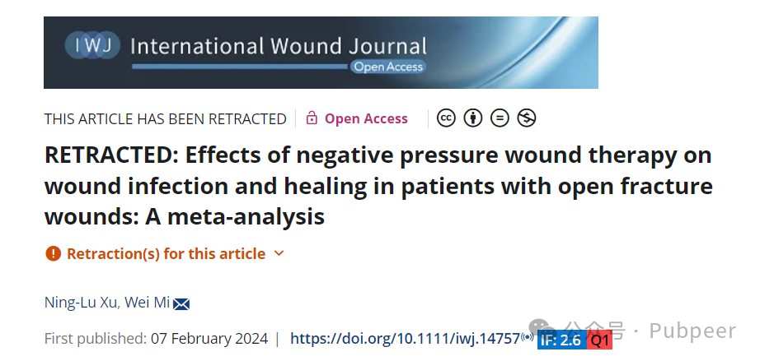

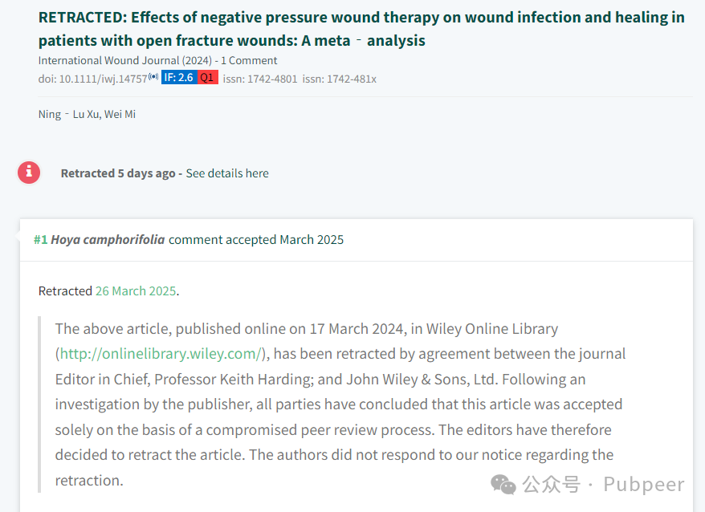

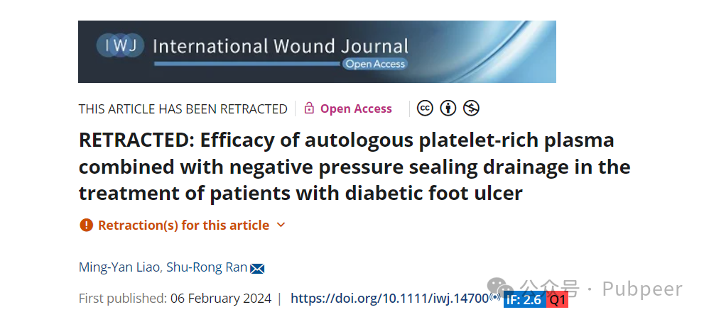

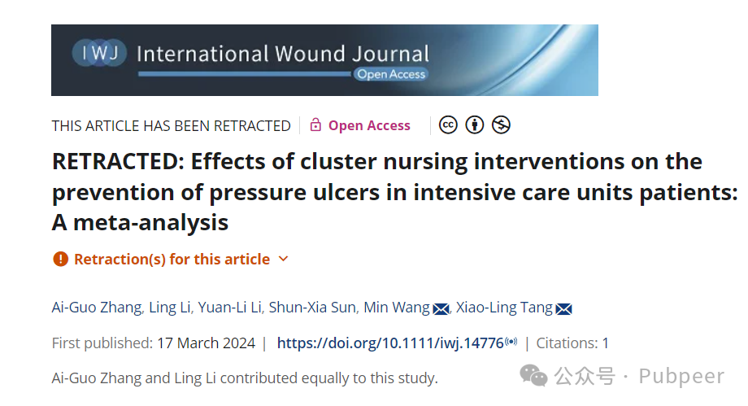

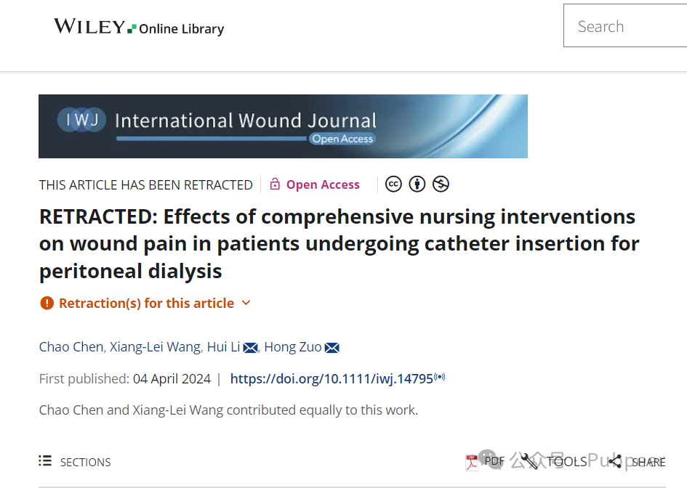

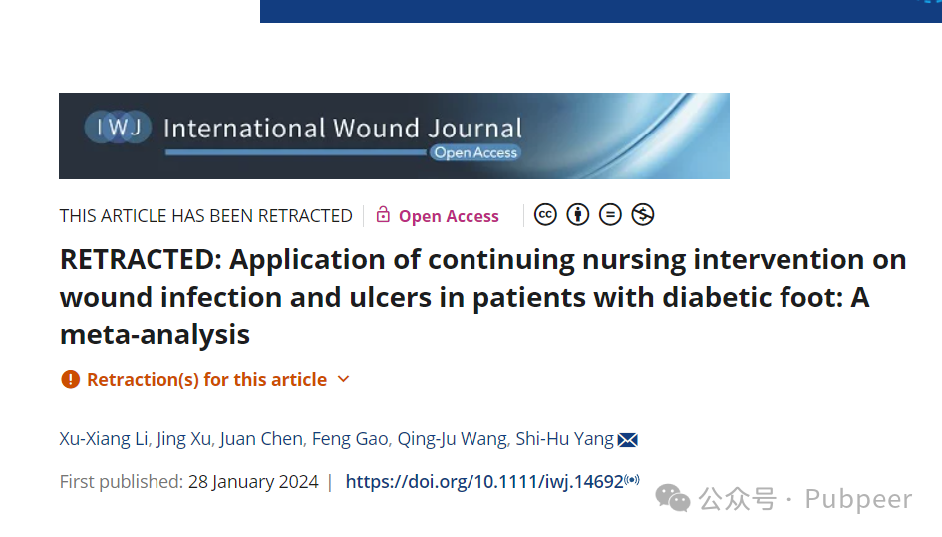

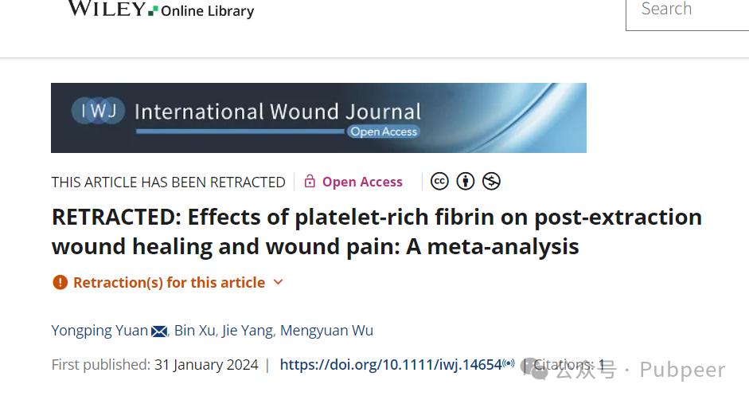

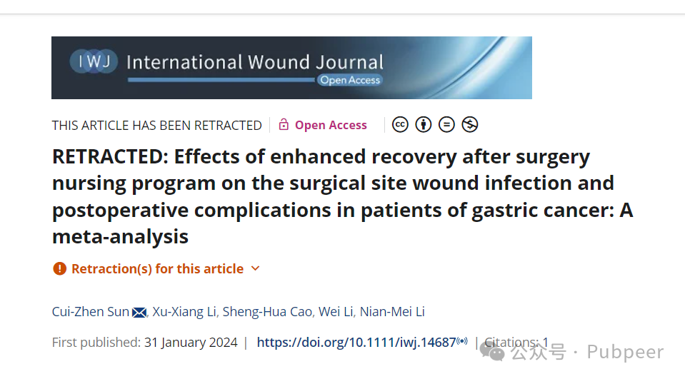

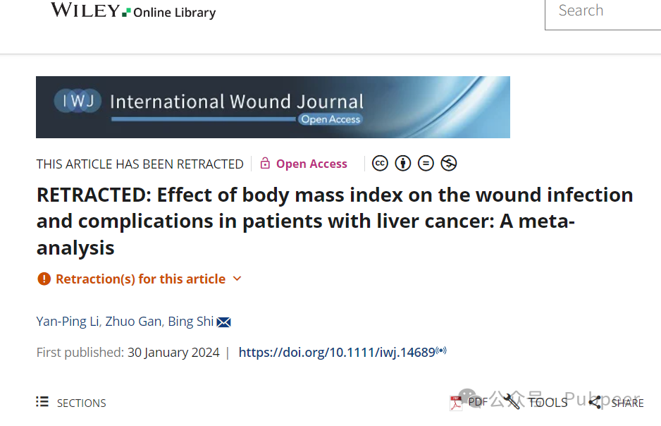

从你提供的信息可知，发表在*International Wound Journal*上的论文有 27 篇，其中 12 篇被撤回。具体如下：

1. **2024 年**10：
   * “Effect of quality nursing care on wound pain and anxiety in burn patients: A meta‐analysis”，作者 Ling Yang 等。
   * “Effects of botulinum toxin type A in the prevention and treatment of facial hypertrophic scars: A meta - analysis”，作者 Jin Lin 等。
   * “Risk and protective factors associated with wound infection after neurosurgical procedures: A meta‐analysis”，作者 Kang He 等。
   * “Effects of laparoscopic radical prostatectomy on wound infection of surgery in patients with prostate cancer: A meta‐analysis”，作者 Cheng Li 等。
   * “Effects of cluster nursing interventions on the prevention of pressure ulcers in intensive care units patients: A meta‐analysis”，作者 Ai‐Guo Zhang 等。
   * “Impacts of enhanced recovery after surgery nursing interventions on wound infection and complications following bladder cancer surgery: A meta‐analysis”，作者 Fan Yang 等。
   * “Effects of comprehensive nursing interventions on wound pain in patients undergoing catheter insertion for peritoneal dialysis”，作者 Chao Chen 等。
   * “Effect of wound drainage on the wound infection and healing in patients undergoing spinal surgery: A meta‐analysis”，作者 Huiming Yang 等。
   * “Impacts of continuous quality improvement on wound pain in the puncture site of arteriovenous fistula in haemodialysis patient”，作者 Hui Li 等。
   * “Utility of dexmedetomidine on surgical site wound pain undergoing thoracoscopic surgery: A meta - analysis”，作者 Mingzhu Li 等。
   * “Effect of comprehensive nursing intervention on wound pain and wound complications in patients with tonsillectomy: A meta‐analysis”，作者 Jian‐Li Wu 等。
   * “Application of hyperbaric oxygen therapy in diabetic foot ulcers: A meta‐analysis”，作者 Hai‐Rong Chen 等。
   * “Enhancing wound recovery in chemotherapy‐induced leukopenia for malignant tumours: A meta‐analysis of acupuncture treatment efficacy”，作者 Haoyang Wang 等。
   * “Wound healing and postoperative management in paediatric patients following 27 - Gauge Transconjunctival Sutureless Vitrectomy for vitreoretinal conditions”，作者 Dong WenTao 等。
   * “Comparative analysis of surgical and non‐surgical wound approaches in diabetic foot ulcer treatment: Meta‐analysis and systematic review”，作者 Yu Lei 等。
   * “Impact of type 2 diabetes on surgical site infections and prognosis post orthopaedic surgery: A systematic review and meta‐analysis”，作者 Chunyan He 等。
   * “Comparing the efficacy of chlorhexidine and povidone–iodine in preventing surgical site infections: A systematic review and meta‐analysis”，作者 Dunyao Bai 等。
2. **2023 年**10：
   * “Assessing postoperative wound infection rates in ultrasound‐guided microwave ablation versus conventional surgery for varicose veins”，作者 Jiawen Wu 等。
   * “Exploring the impact of TGF‐β family gene mutations and expression on skin wound healing and tissue repair”，作者 Kai Cui 等。
   * “Association between vitamin D deficiency and diabetic foot ulcer wound in diabetic subjects: A meta - analysis”，作者 Juan Lin 等。
   * “Effect of minimally invasive versus open surgery in hepatectomy on postoperative wound complications in patients with hepatocellular carcinoma: A meta‐analysis”，作者 Junli Zhang 等。
   * “Effect of stem cell treatment on burn wounds: A systemic review and a meta‐analysis”，作者 Yating Qiao 等。
   * “The influence of Chinese herbal medicines on cancer‐related pressure ulcer wound, fatigue, constipation, and anorexia: A meta‐analysis”，作者 Han Li 等。
3. **2022 年**10：
   * “The effect of different wound dressing materials used in postoperative treatment of wounds after total hip arthroplasty and total knee arthroplasty: A meta - analysis”，作者 Yingjia Yuan 等。
   * “Effect of chitosan - based gel dressing on wound infection, synechia, and granulations after endoscopic sinus surgery of nasal polyps: A meta - analysis”，作者 Ruyang Liu 等。
   * “The effect of preoperative smoking and smoke cessation on wound healing and infection in post - surgery subjects: A meta - analysis”，作者 Dazhen Liu 等。
   * “Effect of training programmes on nurses' ability to care for subjects with pressure injuries: A meta‐analysis”，作者 Bao Yan 等。
   * “Negative pressure wound therapy compared with conventional wound dressings for closed incisions in orthopaedic trauma surgery: A meta‐analysis”，作者 Weiwei Xie 等。
   * “Benign prostatic hyperplasia wound after surgical removal in subjects on anticoagulant or antiplatelet therapy: A meta‐analysis”，作者 Xuhui Ji 等。
   * “Effect of Chinese herbal topical medicine, acupuncture, and moxibustion on pressure ulcer wound healing: A meta - analysis”，作者 Feida Wang 等。

另外，被撤回的论文中，2024 年有 12 篇，2023 年有 2 篇10。

据悉，

《International Wound Journal》是一本来自英国的期刊，涉及皮肤科和外科手术领域。其刊名有全称和缩写，拥有不同版本的国际标准期刊编号。被多个重要数据库收录，办刊宗旨是为伤口护理专业人员提供应用研究以提高患者护理水平并促进合作。主要内容涵盖多种伤口类型及相关治疗、诊断等。期刊指标方面，影响因子在 2.6 分左右浮动，中科院分区和 JCR 分区各有不同，自引率不稳定，发文量近年上升。投稿可通过官网链接，有作者指南，发表周期较快，开放获取模式需支付 3580 美元 / 2720 英镑 / 3000 欧元的发表费用。。

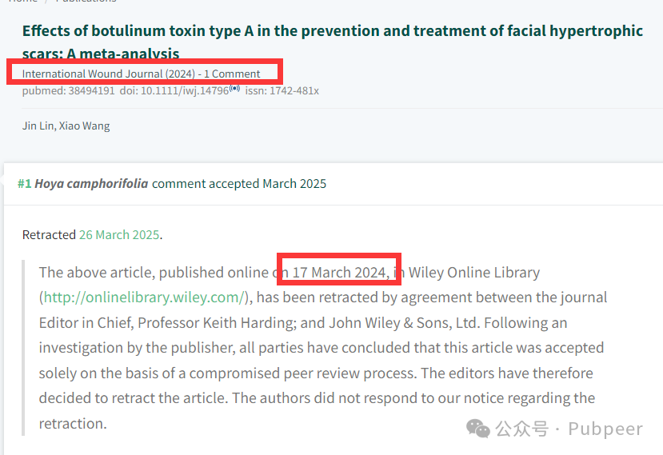

https://onlinelibrary.wiley.com/doi/10.1111/iwj.14757



                 This article has been retracted and there is a comment on PubPeer (by: Hoya Camphorifolia)



                 This article has been retracted and there is a comment on PubPeer (by: Hoya Camphorifolia)



                 This article has been retracted and there is a comment on PubPeer (by: Hoya Camphorifolia)

https://pubpeer.com/publications/880DEB96492C6A1324B528B835427D

https://pubmed.ncbi.nlm.nih.gov/38494191/

https://onlinelibrary.wiley.com/doi/10.1111/iwj.14700



                 This article has been retracted and there is a comment on PubPeer (by: Hoya Camphorifolia)



                 This article has been retracted and there is a comment on PubPeer (by: Hoya Camphorifolia)



                 This article has been retracted and there is a comment on PubPeer (by: Hoya Camphorifolia)

来源：公众号pubpeer原创，文章涉及作者姓名都为音译名字；转载贴子请注明出处，若没注明pubpeer公众号出处，构成侵权。





声明：转载此文是出于传递更多信息之目的。若有来源标注错误或侵犯了您的合法权益，请作者持权属证明与本网联系，我们将及时更正、删除，谢谢

**Pubpeer，专注科研工作者。关注请长按上方二维码。投稿、合作、转载授权事宜请联系本号，回复2025，微信ID：BikElisabeth  或邮箱：Pubpeer@qq.com**