[图片与多篇文献中的图片存在不当重复,吉林大学第二医院&吉林大学第一医院的论文被撤稿.PMID: 31819043](https://mp.weixin.qq.com/s?__biz=MzkzNjYxMTEzMA==&mid=2247531230&idx=2&sn=4bfb04aa92cf29922b5fcfa0b83e828a&chksm=c3cd3006139ca053add57fe1349f8154e5ffdad4b8d21ec459e662fbb08b276fa00183a3258b&scene=126&sessionid=1743475818)

图片查重[DataTwin](javascript:void(0);)2025-04-01 10:10:05浙江

**点击上方蓝字**关注我们







**论文信息**

2019年12月9日，吉林大学第二医院&吉林大学第一医院在Cell Death & Disease（中科院四一区 IF=8.1）期刊上在线发表题为**"BRD4 promotes tumor progression and NF-κB/CCL2-dependent tumor-associated macrophage recruitment in GIST"**(BRD4 促进 GIST 中肿瘤的进展和 NF-κB/CCL2 依赖性肿瘤相关巨噬细胞的招募)论文。

第一作者：吉林大学第一医院 Jianfeng Mu

通讯作者：吉林大学第二医院 Pengda Sun （音译 孙鹏达）

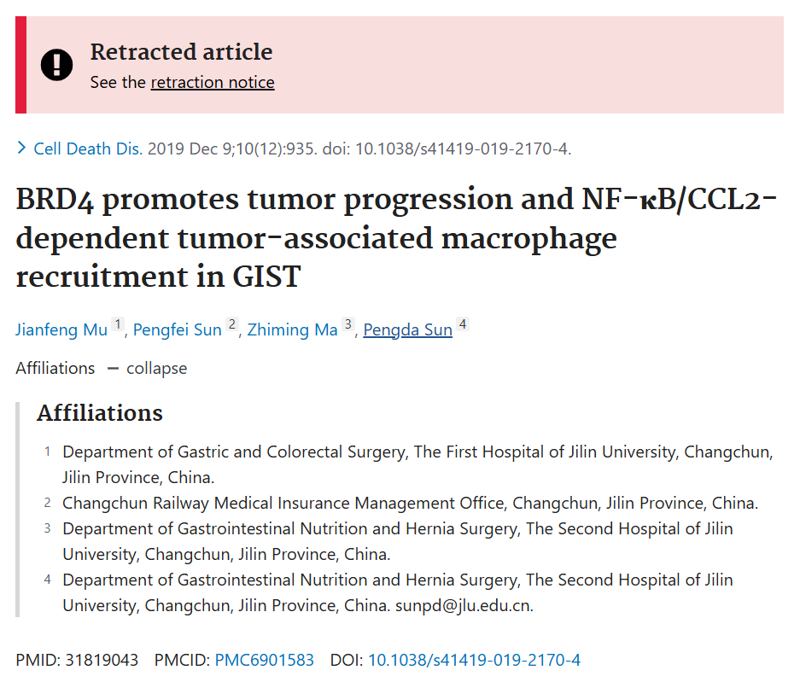

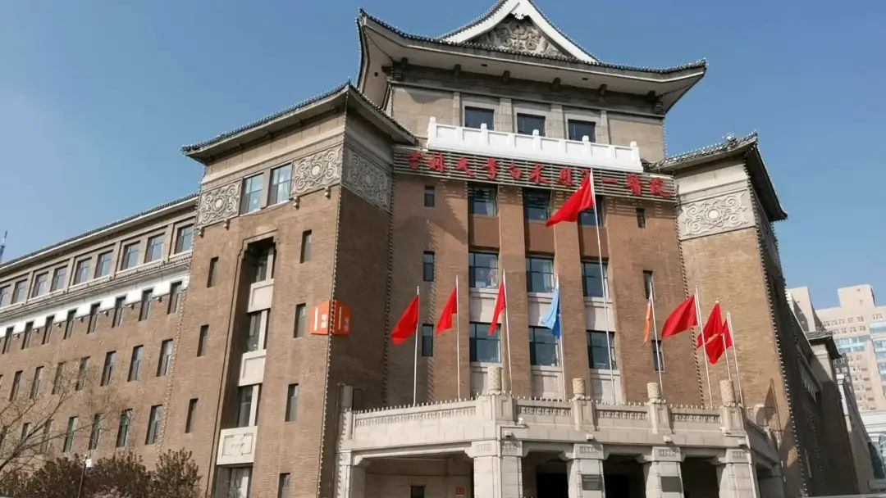

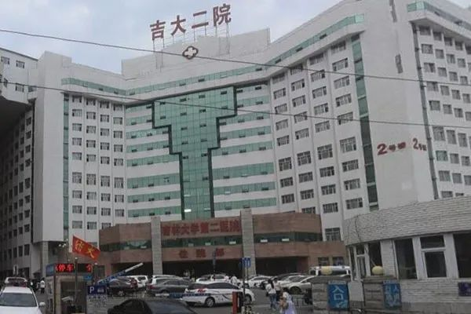



**质疑信息**

**#1**[left] Fig 4c. "Representative IHC staining of BRD4 and CD31 in the two groups".

Two panels are (rotated) enlargements of [right] Fig 4 from "Gauging NOTCH1 Activation in Cancer Using Immunohistochemistry" (Kluk et al 2013): "NICD1 immunoreactivity in archival FPE human cancers".

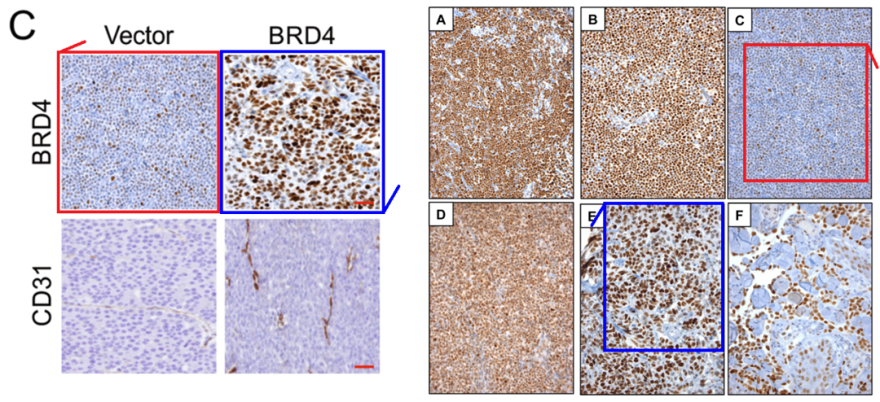

DataTwin图片查重

**#2**[left] Fig 7A. The panels are sourced from [right] Figs 3 and 4 of "Immunohistochemistry of Colorectal Cancer Biomarker Phosphorylation Requires Controlled Tissue Fixation" (Theiss et al 2014).

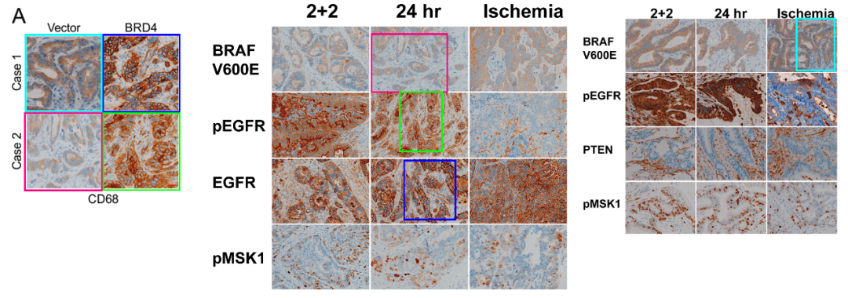

DataTwin图片查重

**#3**[above] Fig 3E/F.

[below] Fig 3A from "Novel Mechanisms of Compromised Lymphatic Endothelial Cell Homeostasis in Obesity: The Role of Leptin in Lymphatic Endothelial Cell Tube Formation and Proliferation" (Sato et al 2016).

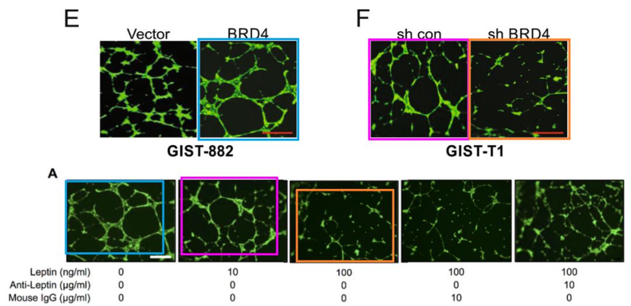

DataTwin图片查重

**#4**[left] Fig 1C. Two panels are rotated details of Fig 6 from "FGFR2 Is Amplified in the NCI-H716 Colorectal Cancer Cell Line and Is Required for Growth and Survival" (Mathur et al 2014).

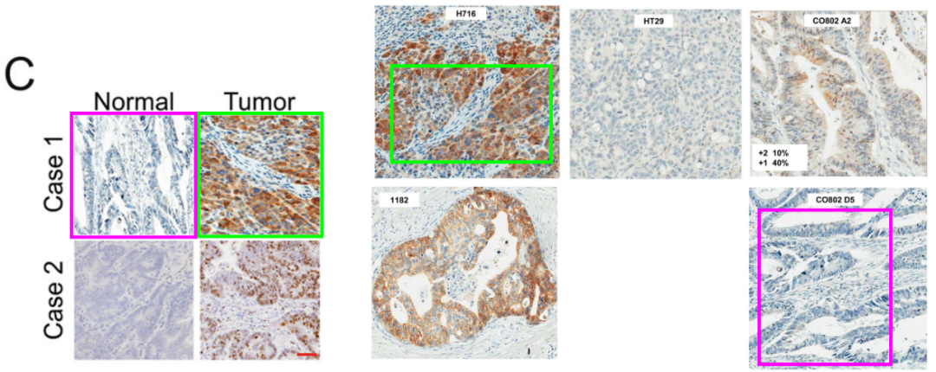

DataTwin图片查重

**#5**Figs 2E,F.

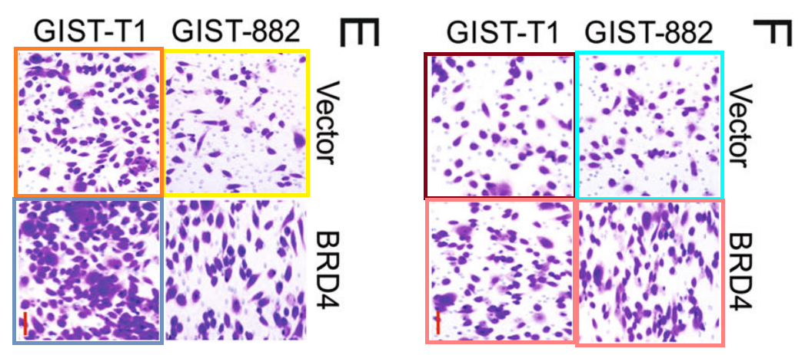

Rotated through 90 deg, to highlight the panels' origins as details of panels from Figs 2E, 4F of "LncRNA TTN?AS1 promotes endometrial cancer by sponging miR?376a?3p" (Shen et al 2020).

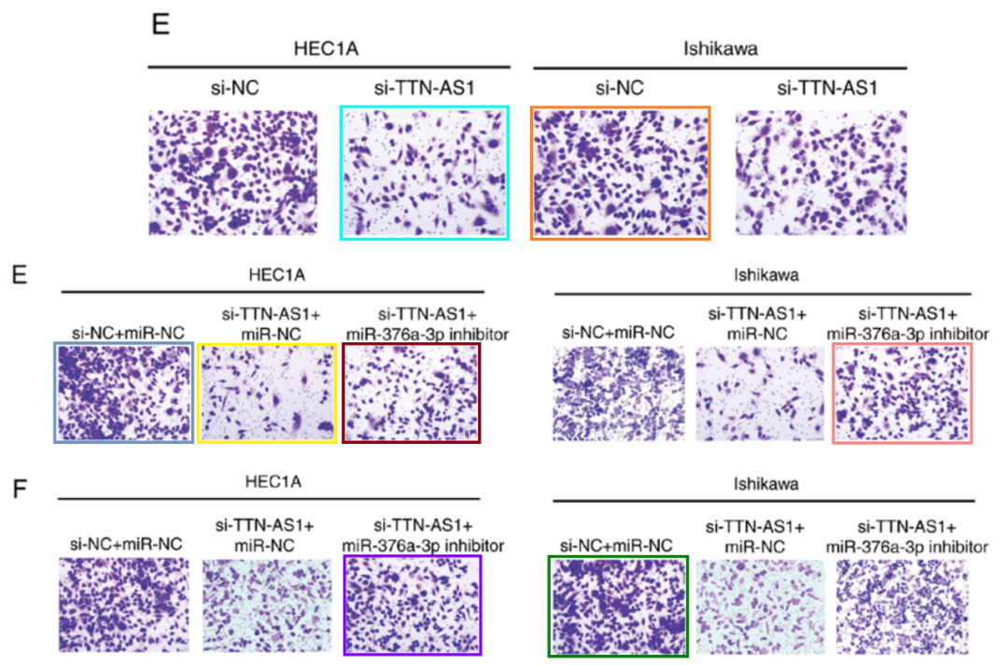

Also the MKN-45 panels of Fig 3B from "MicroRNA?9 inhibits gastric cancer cell proliferation and migration by targeting neuropilin?1" (Hang et al 2019).

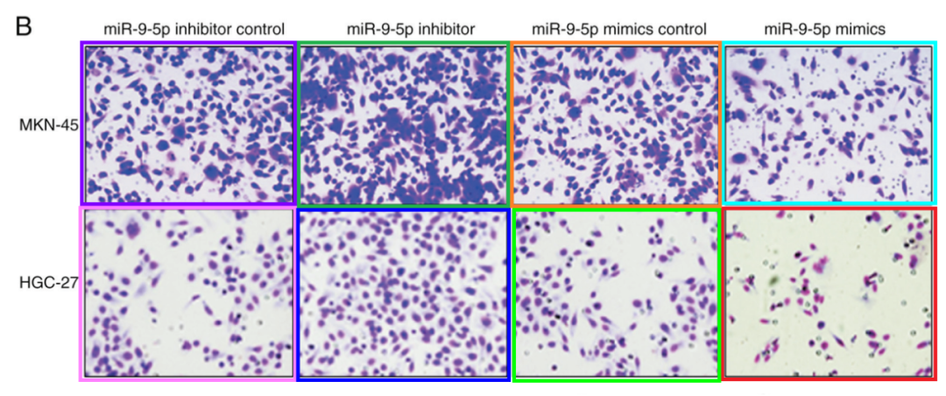

DataTwin图片查重



**撤稿原因**

**本文已于2025年3月17日被撤回：**

主编们已撤回本文，原因是本文所呈现的图片存在问题，这些问题对文章的整体科学严谨性提出了质疑。文章发表后进行的调查发现存在以下问题：

图1C中的正常组、病例1组和病例1肿瘤组图片在旋转后与文献[1]中图6的H716组和CO802 D5组图片似乎存在重叠；

图2E中的Vector, GIST-T1组图片在旋转后与文献[2]中图3B的mir-9-5p mimics control, MKN-45组图片似乎存在重叠；

图2E中的Vector, GIST-882组图片在旋转后与文献[3]中图4E的HEC1A, si-TTB-AS1+miR-NC组图片似乎存在重叠；

图3E中的BRD4组图片在旋转后与文献[4]中图3A的第一组图片似乎存在重叠；

图4C中的Vector, BRD4和BRD4, BRD4组图片在旋转后与文献[5]中图4的C和E组图片似乎存在重叠；

图7A中的四个面板图片在旋转后与文献[5]中图3的24h, BRAF V600E, 24h, pEGFR, 24h, EGFR组图片以及图4的Ischemia, BRAF V600E组图片似乎存在重叠；

图3F中的两个面板图片在旋转后与文献[6]中图3A的第二和第三组图片似乎存在重叠。

上述存在问题的图片代表了在不同实验条件下取自动物的组织。因此，主编们不再相信本文所呈现研究的完整性。

作者未回复出版商关于此次撤回的信件。

涉及文章

[1] Mathur A, Ware C, Davis L, Gazdar A, Pan B-S, Lutterbach B. FGFR2 is

amplified in the NCI-H716 colorectal cancer cell line and is required for growth and survival. PLoS ONE. 2014;9:e98515.

[2] Hang C, Yan H, Gong C, Gao H, Mao Q, Zhu J. MicroRNA-9 inhibits gastric cancer cell proliferation and migration by targeting neuropilin-1 Retraction in /10.3892/etm.2024.12687. Exp Ther Med. 2019;18:2524–2530.

[3] Shen L, Wu Y, Li A, Li L, Shen L, Jiang Q, et al. [Retracted] LncRNA TTN-AS1 promotes endometrial cancer by sponging miR-376a-3p. Oncol Rep. 2024;52:161.

[4] Theiss AP, Chafin D, Bauer DR, Grogan TM, Baird GS. Immunohistochemistry of colorectal cancer biomarker phosphorylation requires controlled tissue fixation. PLoS ONE. 2014;9:e113608.

[5] Kluk MJ, Ashworth T, Wang H, Knoechel B, Mason EF, Morgan EA, et al. Gauging NOTCH1 activation in cancer using immunohistochemistry. PLoS ONE. 2013;8:e67306.

[6] Sato A, Kamekura R, Kawata K, Kawada M, Jitsukawa S, Yamashita K, et al. Novel mechanisms of compromised lymphatic endothelial cell homeostasis in obesity: the role of leptin in lymphatic endothelial cell tube formation and proliferation. PLoS ONE. 2016;11:e0158408.

**参考信息**https://pubpeer.com/publications/B07B4AFC1C6F49E6C37EF6210242CC#2https://pubmed.ncbi.nlm.nih.gov/31322233/https://www.spandidos-publications.com/10.3892/mmr.2025.13493

**声明：**

任何单位或个人认为本内容可能涉嫌侵犯其合法权益，及时向我们提出书面权利通知及详细侵权情况，我们将会依法尽快移除相关涉嫌侵权的内容。

联系微信号：DataTwin



**往期报道精选**

[全网最低价！文件图片查重+比对Pubmed和Pubpeer数据库查重，DataTwin高效权威图片识别！众多知名打假人士推荐使用](http://mp.weixin.qq.com/s?__biz=MzkzNjYxMTEzMA==&mid=2247486008&idx=5&sn=43a2d45f61ed36770808541d737ca3cd&chksm=c29d566df5eadf7bcf1cee3ab814981f26fd4b8aef7a56bb740c999691685526232641ed1bc9&scene=21" \l "wechat_redirect" \t "_blank)

[一区Top9.2分，西安交通大学第二附属医院(西北医院)单涛等人论文撤稿。](http://mp.weixin.qq.com/s?__biz=MzkzNjYxMTEzMA==&mid=2247496577&idx=1&sn=5f6c203ab8c8a90910fb169fb557f09e&chksm=c29eafd4f5e926c23429d2cdbfa4b858d50d365ccedb076342024a06cdef3503285527c04f71&scene=21#wechat_redirect)

[图片重复未作解释，成武县人民医院岳彩云&山东第一医科大学第一附属医院（千佛山医院）杨敏等人论文被撤稿。](http://mp.weixin.qq.com/s?__biz=MzkzNjYxMTEzMA==&mid=2247496577&idx=2&sn=f7e9d4976a062f45ab4c82678d64d647&chksm=c29eafd4f5e926c22879afc68758ce79092ccd6e09bdcf84ed33af28cb858720cdd98d8d1f8b&scene=21#wechat_redirect)

[希腊期刊撤稿，涉与多篇重复的老问题，常州市第一人民医院整形烧伤科李玲巧论文撤回。](http://mp.weixin.qq.com/s?__biz=MzkzNjYxMTEzMA==&mid=2247496577&idx=3&sn=adf0cc7a805cb0b3022cee01276ed136&chksm=c29eafd4f5e926c25f570665cbfe7cf5453ccca0d903d47b581b521c3496e83427771694da50&scene=21#wechat_redirect)

[网友玩微信发现问题论文，浙江大学贺永教授、浙江大学医学院附属口腔医院石钰等人发表到Small的论文存在图片重复使用问题！](http://mp.weixin.qq.com/s?__biz=MzkzNjYxMTEzMA==&mid=2247496547&idx=1&sn=e28eef8cce3be96e2c9b87e9b47742f3&chksm=c29eaf36f5e926205da762928b9510337e641e83d400e166df0687fdaa0597e99598739585a7&scene=21#wechat_redirect)

[一篇声称新冠疫苗具有广泛危害的论文将被撤回，作者回应：出版社不允许对抗性陈述的论文存在](http://mp.weixin.qq.com/s?__biz=MzkzNjYxMTEzMA==&mid=2247496526&idx=1&sn=a7684678c2d1f7537332323923be6239&chksm=c29eaf1bf5e9260dff6cc8d0fa5823592736a87e03adaf78ed3aa67722776822efdf084c09eb&scene=21#wechat_redirect)

# [今日学术问题发现 | 兄弟借一步说话，看你是不是火眼金睛](http://mp.weixin.qq.com/s?__biz=MzkzNjYxMTEzMA==&mid=2247484202&idx=4&sn=6c887f60b170b0352211a4056136471d&chksm=c29d5f7ff5ead669026d14f9ce4fc72a33dc49b4872d0649ae332312a1497f95ee48b6e39aac&scene=21#wechat_redirect)

# [今日学术问题发现 | 你把Error Bar当作奖励给幼儿园小朋友的小红花？](http://mp.weixin.qq.com/s?__biz=MzkzNjYxMTEzMA==&mid=2247484202&idx=5&sn=6726065dc778f5d6f734f6d8e4bb4519&chksm=c29d5f7ff5ead669fa3cf39a0504fbcdd0a8856dc8e893c0c7d5a64114b6d7c0fd1bdd1274b6&scene=21#wechat_redirect)

[今日学术问题发现 | Table中的异常数据（PMID：26111626）](http://mp.weixin.qq.com/s?__biz=MzkzNjYxMTEzMA==&mid=2247484202&idx=6&sn=fa04280bf1e13fb388f5fcd7364dca92&chksm=c29d5f7ff5ead66915da906253ca3fcbdc95955d9bedfa1484acbbd6ec65069baea3c7617f17&scene=21#wechat_redirect)

[今日学术问题发现 | 不要侥幸，白天到黑夜，你还是你（荧光图片造假重复）](http://mp.weixin.qq.com/s?__biz=MzkzNjYxMTEzMA==&mid=2247484091&idx=3&sn=b4812492b782f5b1098df327c7118b29&chksm=c29d5eeef5ead7f8a36ba0a2fe28ebca0c0abf09d97a9c311ffe16fe8c6204436dafa6ed02af&scene=21#wechat_redirect)

[今日学术问题发现 | 山西医科大学贺婵婷等人论文数据图片出现多处重复](http://mp.weixin.qq.com/s?__biz=MzkzNjYxMTEzMA==&mid=2247484091&idx=4&sn=465b44b280962a59b5f3a38e18c7ccd1&chksm=c29d5eeef5ead7f8daf6a43c748db2b408fc71ae5377942fbc3ff48c3fe5b68be6a8808bb641&scene=21#wechat_redirect)

[Hepatology论文被质疑，南京医科大学第一附属医院孙倍成/南京大学医学院姜润秋教授发表的论文因图片重复](http://mp.weixin.qq.com/s?__biz=MzkzNjYxMTEzMA==&mid=2247495175&idx=2&sn=ff4146bc29b7ed9cefbbd2d02ba2454c&chksm=c29eb252f5e93b4416dd8000e979b09f21e70a7b0e188a9e8853a5957148362a894a5393c1e1&scene=21#wechat_redirect)

[DataTwin图片查重| 浙大医二院神经外科陈高教授发表的论文因图片重复被质疑](http://mp.weixin.qq.com/s?__biz=MzkzNjYxMTEzMA==&mid=2247495175&idx=3&sn=8cf91fc18af7e9230a0b51de678e4b77&chksm=c29eb252f5e93b44e6a3c09af3c60cbb0b41bf002b9e43946628019dc0250c78ec7f6301f816&scene=21#wechat_redirect)

[国家优青、海军军医大学（第二军医大学）药学院孙鹏教授发表的论文因图片重复被质疑](http://mp.weixin.qq.com/s?__biz=MzkzNjYxMTEzMA==&mid=2247495175&idx=4&sn=ceb343c415ac6e1eafde0114fff757b0&chksm=c29eb252f5e93b4452873038b8a8fa8593679122f3b552f04bfeff67d46e25d425d8a9ea08a1&scene=21#wechat_redirect)

[上海九院普外科刘斌发表的论文因图片重复被质疑](http://mp.weixin.qq.com/s?__biz=MzkzNjYxMTEzMA==&mid=2247495175&idx=5&sn=052dad49954ae38cdfcc83c7bf4bb92a&chksm=c29eb252f5e93b4449543cd4b808a98122448a7b588d2c3b0f41a03dace7e9f952d7fd128926&scene=21#wechat_redirect)

*END*



    客服微信：DataTwin



文件内部+Pubmed&Pubpeer数据库全网查重 请联系客服。