[江苏大学知名附属医院论文图片重复](https://mp.weixin.qq.com/s?__biz=Mzg5MTg0MDc4NQ==&mid=2247493349&idx=2&sn=a7289cf255f583b55e3dcf7f756b0187&chksm=ce247c1dafeb27fbea2d3adaf2ef05ccff2e71c064a8f14c15c0302b210d848e0869ced9e790&scene=126&sessionid=1743354906)

原创  F[图片重复](javascript:void(0);)2025-03-24 12:30:10广东

**Methyl-CpG-binding domain 3 inhibits epithelial–mesenchymal transition in pancreatic cancer cells via TGF-β/Smad signalling**

**British Journal of Cancer (2017)**

**PMID:**27898661

**DOI:**10.1038/bjc.2016.397

**AUTHORS**

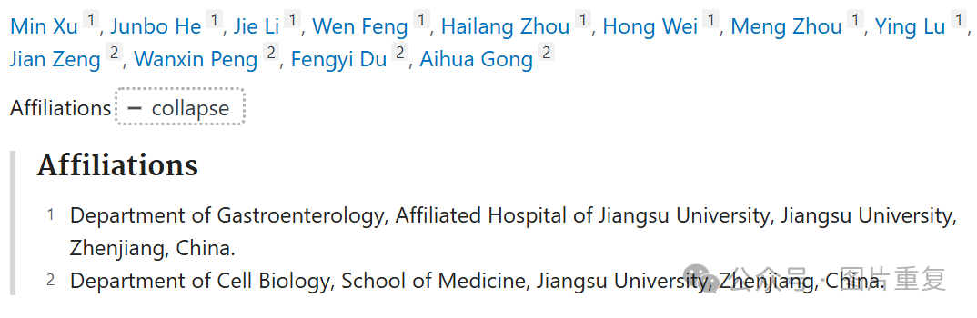

**#1Sholto David**

**8 hours ago**

**Figure 4A and Figure 5A**: According to my reading of the figure legend I think these overlapping areas are unexpected. I've added the red rectangles to show where I mean. Would the authors please double-check?

