[南京大学生命科学技术学院论文图片重复](https://mp.weixin.qq.com/s?__biz=Mzg5MTg0MDc4NQ==&mid=2247493280&idx=1&sn=7eca6e82b0892438391b83f31e4d0fb6&chksm=ce4f514a3380edc6a28929cf153a35123523bf08636e5a37a7b756dd03b816972a7e67844a03&scene=126&sessionid=1743268273)

原创  F[图片重复](javascript:void(0);)2025-03-19 21:43:14广东

## LYAR promotes colorectal cancer cell mobility by activating galectin-1 expression

**Oncotarget (2015)**

**PMID:**26413750

**DOI:**10.18632/oncotarget.5335

**AUTHORS**

**Yupeng Wu12,Ming Liu1,Zhuchen Li1,Xiao-Bin Wu3,Ying Wang1,Yadong Wang1,Min Nie1,Feifei Huang1,Junyi Ju1,Chi Ma1,Renxiang Tan1,Ke Zen1,Chen-Yu Zhang1,Keqin Fu2,Yu-Gen Chen3,Ming-Rong Wang4,Quan Zhao1**

**AFFILIATIONS**

1The State Key Laboratory of Pharmaceutical Biotechnology, School of Life Sciences, Nanjing University, Nanjing, 210046, China

2Anhui Research Institute for Family Planning, Anhui Research Center for Population and Birth Control, Hefei, 230031, China

3The Affiliated Hospital of Nanjing University of Chinese Medicine, Nanjing, 210029, China

4The State Key Laboratory of Molecular Oncology, Cancer Hospital and Institute, Chinese Academy of Medical Sciences, Peking Union Medical College, Beijing, 100021, China

**#1Arceuthobium Divaricatum 1 day ago**

Much more similar than expected. Similarities detected by ImageTwin.

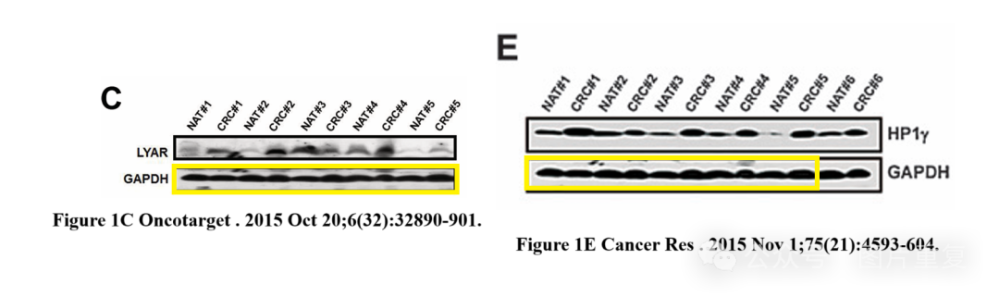

**#2Arceuthobium Divaricatum 1 day ago**

Much more similar than expected. Similarities detected by ImageTwin.

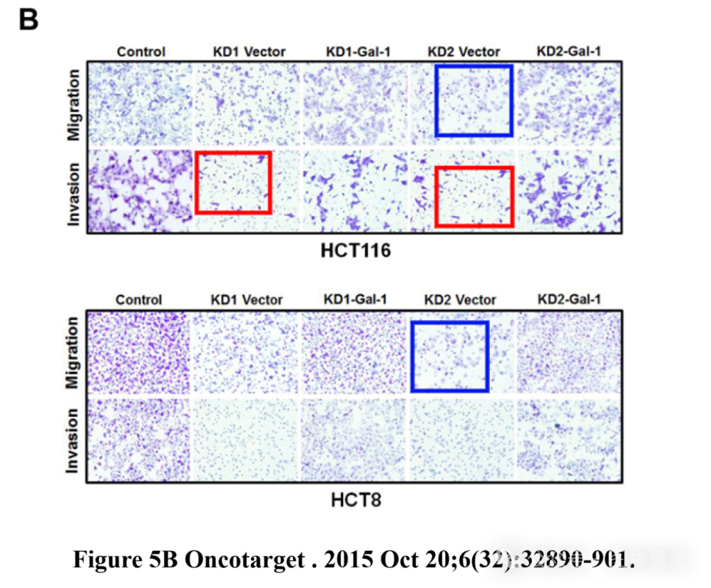

[#图片重复](https://mp.weixin.qq.com/mp/appmsgalbum?__biz=Mzg5MTg0MDc4NQ==&action=getalbum&album_id=2546994047780667392#wechat_redirect)[#南京大学](https://mp.weixin.qq.com/mp/appmsgalbum?__biz=Mzg5MTg0MDc4NQ==&action=getalbum&album_id=3905724863813468160#wechat_redirect)