[南京医科大学知名附属医院论文图片重复](https://mp.weixin.qq.com/s?__biz=Mzg5MTg0MDc4NQ==&mid=2247493227&idx=2&sn=67b0401c6a74249a0323f0e2a41fa10a&chksm=cee23ad4c8d5d0870e3d0f18321c7b92a2195fdcc23a9d7fabead9c78b5d6974fc58a9f29e5e&scene=126&sessionid=1743268273)

原创  F[图片重复](javascript:void(0);)2025-03-15 20:21:27广东

**Cardiac Sympathetic Denervation Suppresses Atrial Fibrillation and Blood Pressure in a Chronic Intermittent Hypoxia Rat Model of Obstructive Sleep Apnea**

**Journal of the American Heart Association (2019)**

**PMID:**30757948

**DOI:**10.1161/jaha.118.010254

**AUTHORS**

**Xuechao Yang1,Linfei Zhang1,Huan Liu1,Yongfeng Shao1,Shijiang Zhang1**

**AFFILIATIONS**

1Department of Cardiothoracic Surgery The First Affiliated Hospital of Nanjing Medical University Nanjing Jiangsu People's Republic of China

**#1René Aquarius**

**7 hours ago**

Dear authors,

We found unexpected overlap between a figure presented in this study and a figure presented in another study (see enclosed image below).

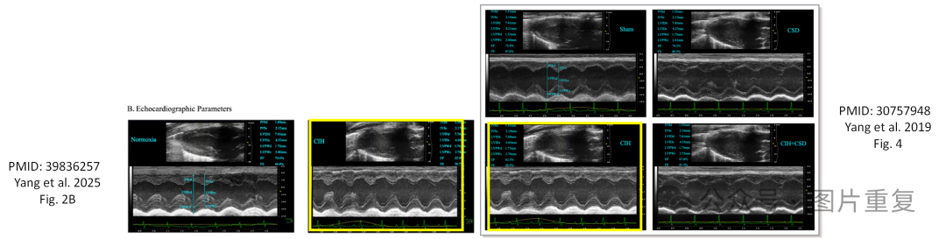The following papers are affected:

Paper 1: https://pubmed.ncbi.nlm.nih.gov/39836257/

Paper 2: https://pubmed.ncbi.nlm.nih.gov/30757948/

We will notify the publishers to resolve these issues.

Kind regards,

Rene Aquarius

[#图片重复](https://mp.weixin.qq.com/mp/appmsgalbum?__biz=Mzg5MTg0MDc4NQ==&action=getalbum&album_id=2546994047780667392#wechat_redirect)[#南京医科大学](https://mp.weixin.qq.com/mp/appmsgalbum?__biz=Mzg5MTg0MDc4NQ==&action=getalbum&album_id=3890809439615402004#wechat_redirect)