[中国医科大学附属盛京医院超声科某论文图像重复“泛滥成灾”](https://mp.weixin.qq.com/s?__biz=MzkzMzc1Nzg1OQ==&mid=2247486274&idx=1&sn=48179e21f4da1dab7cdd4b03a9dcaf72&chksm=c366aab76e16d55931d2f6e441401ab4033f59833ac329ae9d5475db579b38c60df815ab7b96&scene=126&sessionid=1743180712)

Figure 查重[Figure查重](javascript:void(0);)2025-03-26 09:47:41上海

**Part.1**



**论文简介**

**标题：miR-762 can negatively regulate menin in ovarian cancer**

**日期：**2017年4月12日

**单位与作者：**中国医科大学附属盛京医院超声科Rui Hou、Luo Jiang（通讯作者 音译 姜罗)

期刊：***OncoTargets and therapy***

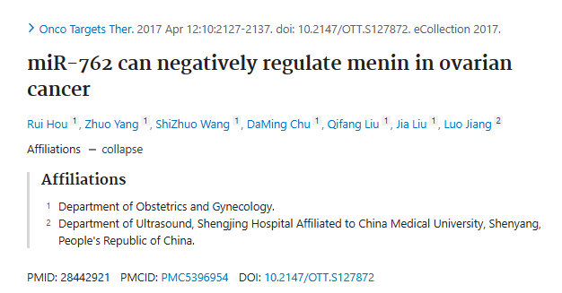

**Part.2**



**图像重复问题**

**#1 图4F与Guo et al 2016的4A出现重复。**

[left] Fig 4A from "miR-194 is a negative regulator of GEF-H1 pathway in melanoma" (Guo et al 2016).

[right] Fig 4F.

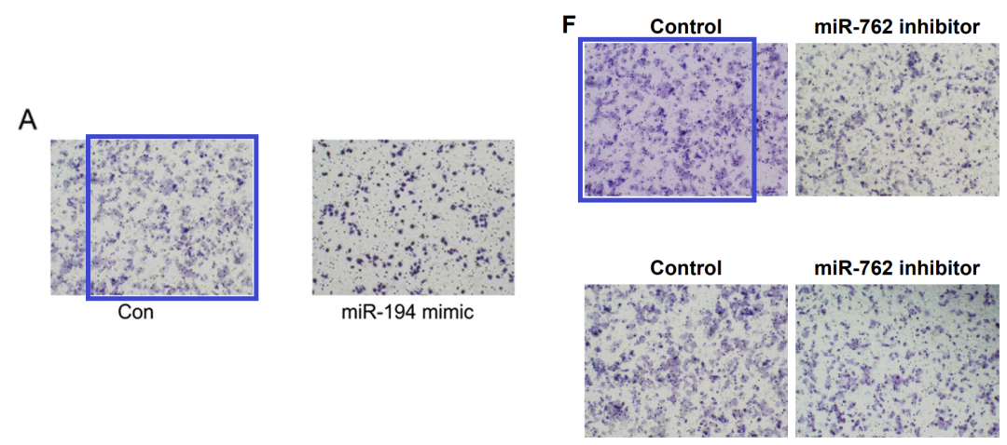

**#2 图3A与Yin et al 2020的3F出现重复。**

[left] Fig 3A.

[right] Fig 3F from "Effects of mild intrauterine hypoperfusion in the second trimester on memory and learning function in rat offspring" (Yin et al 2020).

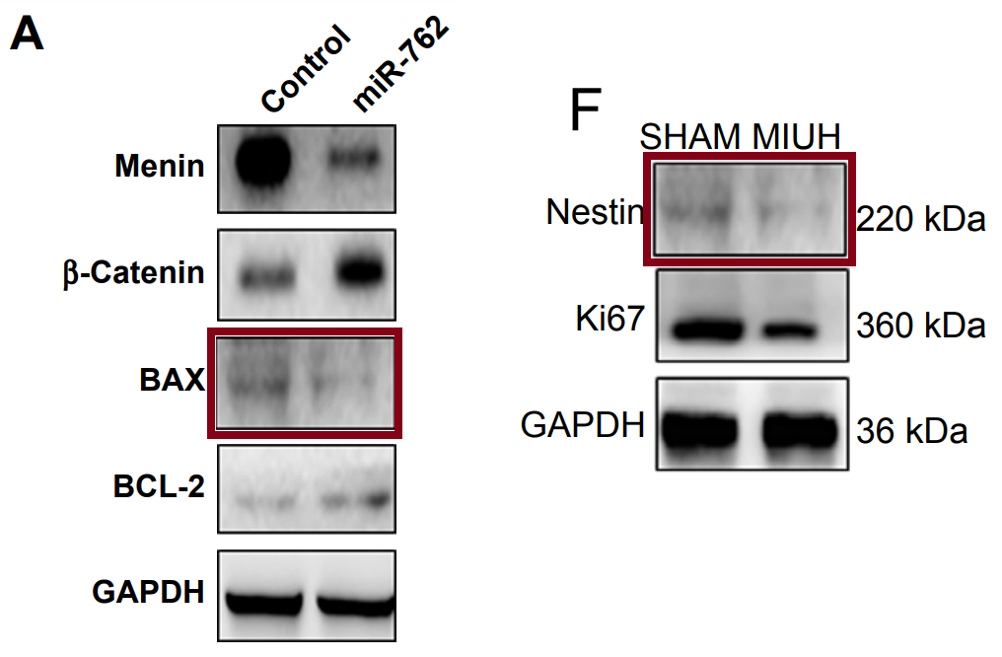

**#3 图4E与Wei et al 2019的5A出现重复。**

[left] Fig 3A.

[right] Fig 3F from "Effects of mild intrauterine hypoperfusion in the second trimester on memory and learning function in rat offspring" (Yin et al 2020).

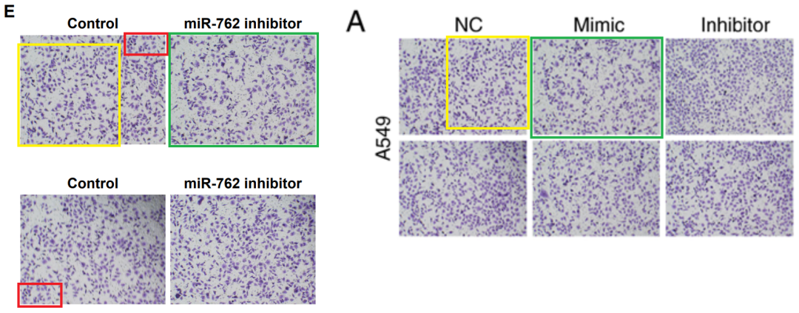

**#4 图4B与Wang et al 2019的5B出现重复。**

[left] Fig 4B.

[right] Fig 5B from "miR?489 promotes apoptosis and inhibits invasiveness of glioma cells by targeting PAK5/RAF1 signaling pathways" (Wang et al 2019) [retracted].

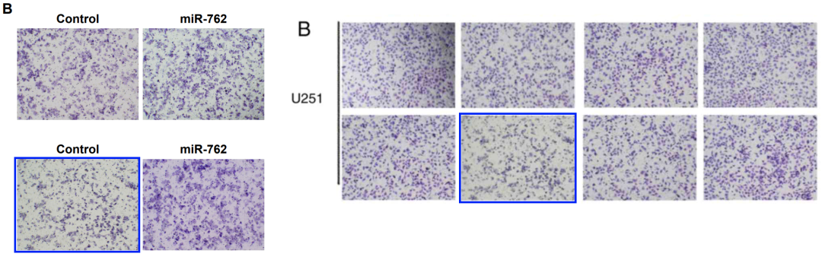

**参考信息：**

https://pubpeer.com/publications/B20ECCC0BBE59E0412E0C0F8C4D617#4

https://www.ncbi.nlm.nih.gov/pmc/articles/PMC5396954/

**联系我们：**

如果您需要使用Figure查重服务，请扫描下方二维码，添加客服微信，了解更多详情。我们将竭诚为您服务，确保您的科研工作更加高效、可信。

