[延边大学大牛团队论文图片重复](https://mp.weixin.qq.com/s?__biz=Mzg5MTg0MDc4NQ==&mid=2247493258&idx=2&sn=49840127cb13adc25f9c9078a87bbeda&chksm=ce4daae7d3f418b5c9f258a04aa1aa1ed3d66e9644b51a9ef569a327b3964ad716813b9477be&scene=126&sessionid=1743181578)

原创  F[图片重复](javascript:void(0);)2025-03-17 20:43:20广东

**Elevated expression of Tiam1 is associated with poor prognosis and promotes tumor progression in pancreatic cancer**

**OncoTargets and Therapy (2018)**

**PMID:**30100742

**DOI:**10.2147/ott.s171425

**AUTHORS**

**Mina Ding1,Yue Li1,Yang Yang2,Kun Zhu1,Shuanlong Che2,Zhenhua Lin23,Liyan Chen13**

**AFFILIATIONS**

1Department of Biochemistry and Molecular Biology, Yanbian University Medical College, Yanji 133002, China, .

2Department of Pathology and Cancer Research Center, Yanbian University Medical College, Yanji 133002, China.

3Department of Jilin Province, Key Laboratory of the Science and Technology, Yanji 133002, China, .

#### Author response

#### 6 hours ago

**#1Sholto David**

**2 day ago**

**Figure 3**: There are several unexpected similarities. I've added the coloured shapes to show where I mean. Identified with the help of ImageTwin.ai. Would the authors please check and comment?

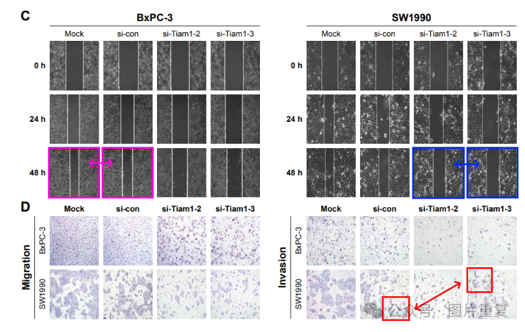

**#2Mina Ding (author)**

**6 hours ago**

Thank you for pointing out the issues in this article. We have saved the original data and will check these data carefully and respond as soon as possible.

[#图片重复](https://mp.weixin.qq.com/mp/appmsgalbum?__biz=Mzg5MTg0MDc4NQ==&action=getalbum&album_id=2546994047780667392#wechat_redirect)[#延边大学](https://mp.weixin.qq.com/mp/appmsgalbum?__biz=Mzg5MTg0MDc4NQ==&action=getalbum&album_id=3902765426681266178#wechat_redirect)