[来自外包公司可能性大！潍坊市人民医院颌面外科团队论文与多篇论文图片重复](https://mp.weixin.qq.com/s?__biz=MzkzMzc1Nzg1OQ==&mid=2247486274&idx=2&sn=ebb459607841d30495abd2eb05218efe&chksm=c39a63a57ae3b575c1fe1a130d10c594c1bb66f1c7eca86b9cd8437c27d69c1b106516ebd9b9&scene=126&sessionid=1743093923)

Figure 查重[Figure查重](javascript:void(0);)2025-03-26 09:47:41上海

**Part.1**



**论文简介**

**标题：MicroRNA-487a-3p inhibits the growth and invasiveness of oral squamous cell carcinoma by targeting PPM1A**

**日期：**2021年6月16日

**单位与作者：**潍坊市人民医院颌面外科 Lishan Wang、Futing Zhou(通讯作者 音译 周福亭)

**期刊：*Bioengineered***

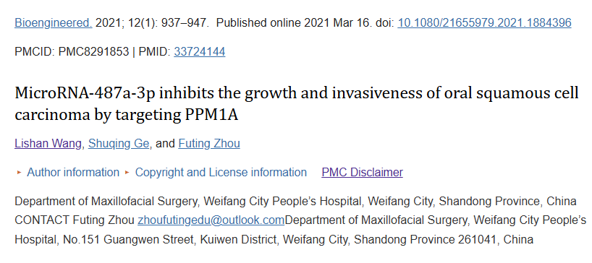

**Part.2**



**图像重复问题**

**#1 图2e与Wang et al 2021的图5D出现重复。**

[left] Fig 5D from "LncRNA PITPNA-AS1 as a Potential Diagnostic Marker and Therapeutic Target Promotes Hepatocellular Carcinoma Progression via Modulating miR-448/ROCK1 Axis" (Wang et al 2021).

[right] Fig 2e.

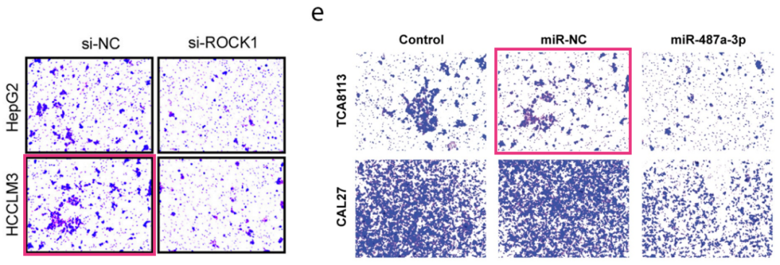

**#2 图5f与Song et al 2021的图4e出现重复。**

[left] Fig 4e from "circRNA hsa_circ_0005909 Predicts Poor Prognosis and Promotes the Growth, Metastasis, and Drug Resistance of Non-Small-Cell Lung Cancer via the miRNA-338-3p/SOX4 Pathway" (Song et al 2021).

[right] Fig 5f.

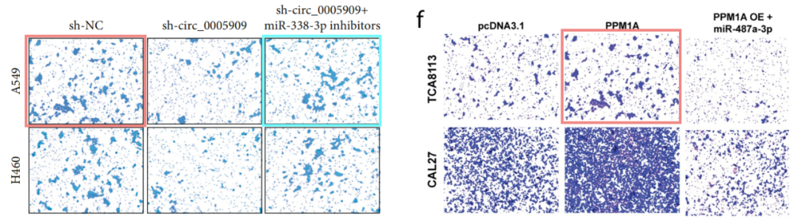

**#3 图5f与 Yang et al 2021的图1G出现重复。**

[left] Fig 1G from "Long Non-coding RNA SNHG12, a New Therapeutic Target, Regulates miR-199a-5p/Klotho to Promote the Growth and Metastasis of Intrahepatic Cholangiocarcinoma Cells" (Yang et al 2021).

[right] Fig 5f again

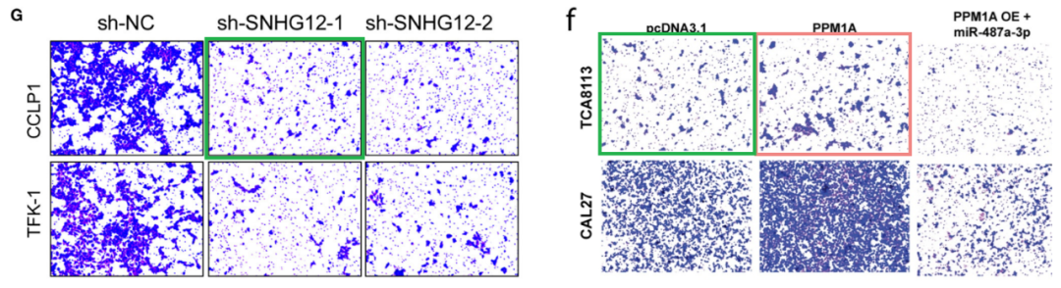

**参考信息：**

https://pubpeer.com/publications/94157D8571E68AEF04D1501AF8AE5C#1

https://pubmed.ncbi.nlm.nih.gov/33724144/

**联系我们：**

如果您需要使用Figure查重服务，请扫描下方二维码，添加客服微信，了解更多详情。我们将竭诚为您服务，确保您的科研工作更加高效、可信。

