[该论文图片重复，作者至今未回复！来自江苏大学医学院院长团队](https://mp.weixin.qq.com/s?__biz=MzkzMzc1Nzg1OQ==&mid=2247486227&idx=2&sn=bada830ab8d7d45603e6e5c46054db47&chksm=c3b8042dfa2b64bab3f340a02160e399a9f954886d7496114585b3d687c344573efd091518c4&scene=126&sessionid=1743093923)

Figure 查重[Figure查重](javascript:void(0);)2025-03-22 11:11:33上海

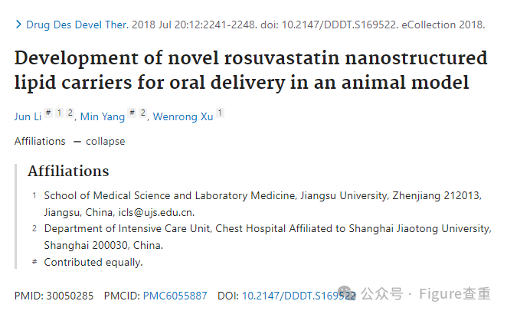

Development of novel rosuvastatin nanostructured lipid carriers for oral delivery in an animal model

Drug Design, Development and Therapy (2018) - 1 Comment  
pubmed: 30050285  doi: 10.2147/dddt.s169522  issn: 1177-8881

Jun Li author has email , Min Yang , Wenrong Xu author has email

#1 **Sholto David** comment accepted March 2025

**Figure 2**: Unexpected overlap between images that should show different samples. I've added the red rectangles to show where I mean. Would the authors please check and comment?

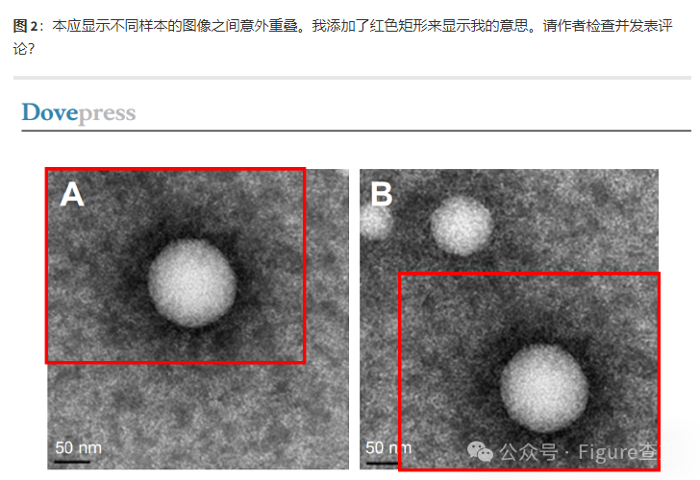

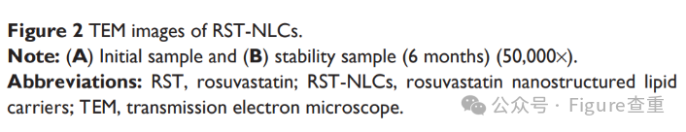

**参考链接：**

https://pubpeer.com/publications/4C247FAC5B72247B8325791C3AD2E2

**联系我们：**

如果您需要使用Figure查重服务，请扫描下方二维码，添加客服微信，了解更多详情。我们将竭诚为您服务，确保您的科研工作更加高效、可信。

