[皖南医学院Zhang Yao团队论文图片重复](https://mp.weixin.qq.com/s?__biz=Mzg5MTg0MDc4NQ==&mid=2247493360&idx=2&sn=6d3be6d34dce024d6dafb7bf68796d1f&chksm=ceb432537d96b2ca16d8defa418009c4ff1a528c43342aff87813972cbd6fe91ce0bc7a5e354&scene=126&sessionid=1743094819)

F[图片重复](javascript:void(0);)2025-03-25 18:15:23广东

**Inhibition of ROS-mediated activation Src-MAPK/AKT signaling by orientin alleviates H2O2-induced apoptosis in PC12 cells**

**Drug Design, Development and Therapy (2018)**

**PMID:**30510405

**DOI:**10.2147/dddt.s178217

**AUTHORS**

**Shimei Qi12,Zunyong Feng13,Qiang Li12,Zhilin Qi12,Yao Zhang12**

**AFFILIATIONS**

1Anhui Province Key Laboratory of Active Biological Macro-molecules, Wannan Medical College, Wuhu 241002, People's Republic of China, .

2Department of Biochemistry, Wannan Medical College, Wuhu 241002, People's Republic of China, .

3Department of Forensic Medicine, Wannan Medical College, Wuhu 241002, People's Republic of China.

**#1René Aquarius 4 hours ago**

Dear authors,

We found unexpected overlap between a figure presented in this study and a figure presented in another study (see enclosed image below).

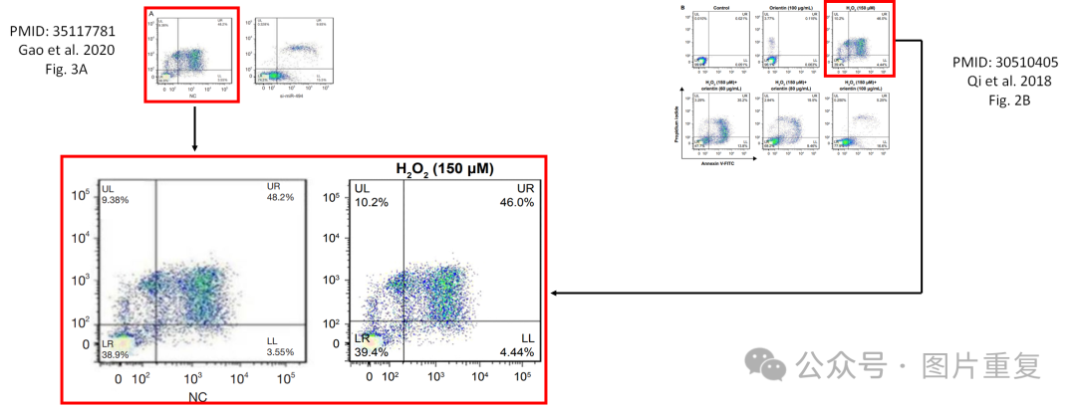

The following papers are affected:

Paper 1: https://pubmed.ncbi.nlm.nih.gov/35117781/

Paper 2: https://pubmed.ncbi.nlm.nih.gov/30510405/

We will notify the publishers to resolve the issue.

Kind regards,

Rene Aquarius