[赣南医科大学知名团队论文图片重复](https://mp.weixin.qq.com/s?__biz=Mzg5MTg0MDc4NQ==&mid=2247493320&idx=1&sn=cac2d8675f8ad4560cdf365f1f486a51&chksm=ce69f19e127ba96afaef8c07deaca7b967e70347b093dfdb1b856602e083c9cbe83a87b12264&scene=126&sessionid=1743094819)

原创  F[图片重复](javascript:void(0);)2025-03-21 19:41:01广东

**The role and mechanism of JAK2/STAT3 signaling pathway regulated by m6A methyltransferase KIAA1429 in osteosarcoma**

**Journal of Bone Oncology (2023)**

**PMID:**36915895

**DOI:**10.1016/j.jbo.2023.100471

**AUTHORS**

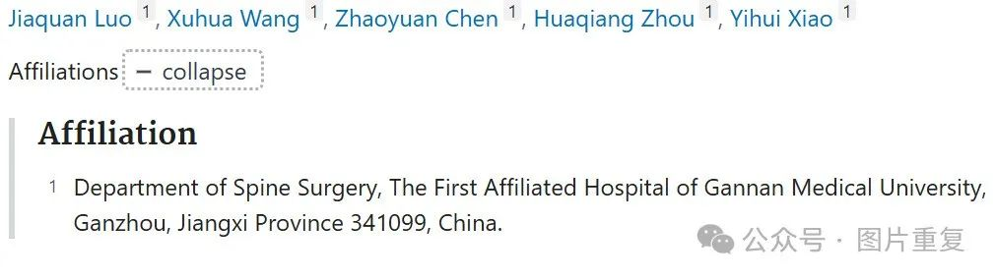

**#1René Aquarius**

**5 hours ago**

Dear authors,

We found unexpected overlap between a figure presented in this study and a figure presented in another study (see enclosed image below).

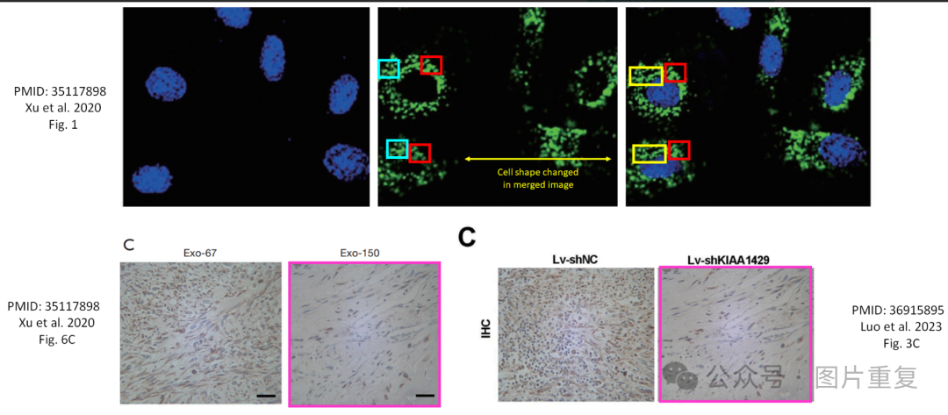

The following studies are affected.

Study 1: https://pubmed.ncbi.nlm.nih.gov/35117898/

Study 2: https://pubmed.ncbi.nlm.nih.gov/36915895/

We will contact the publishers to resolve these issues.

Kind regards,

Rene Aquarius