[与5篇无关文章图像重复，临沂市人民医院Xuemei Zheng的论文被撤稿](https://mp.weixin.qq.com/s?__biz=MzkwMjY4ODQ5Mw==&mid=2247496507&idx=3&sn=e5df0210b05e0219fe1fb49839fed7ab&chksm=c1ee0b58b43e84fe3190f921257c4a2010c3a3ac8abd143c18c4885de709f4c76e88efb01183&scene=126&sessionid=1742833867)

[Reviewer 2](javascript:void(0);)2025-03-09 14:41:57浙江



点击蓝字关注我们



**论文信息**

2019年6月6日，临沂市人民医院妇产科的Hui Zhao(第一作者) & Xue-Mei Zheng(通讯作者)在Journal of Cellular Physiology(中科院二区 IF=4.2)期刊上在线发表题为"Long noncoding RNA LINC00958 regulates cell sensitivity to radiotherapy through RRM2 by binding to microRNA-5095 in cervical cancer"(长非编码 RNA LINC00958 通过与 microRNA-5095 结合，通过 RRM2 调节宫颈癌细胞对放疗的敏感性)论文。

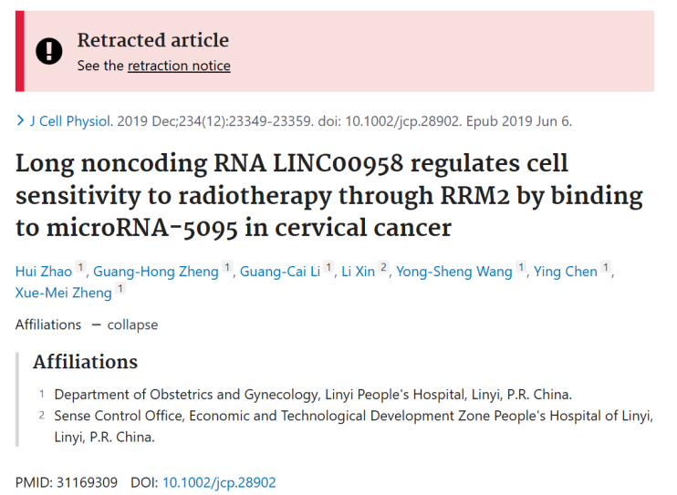

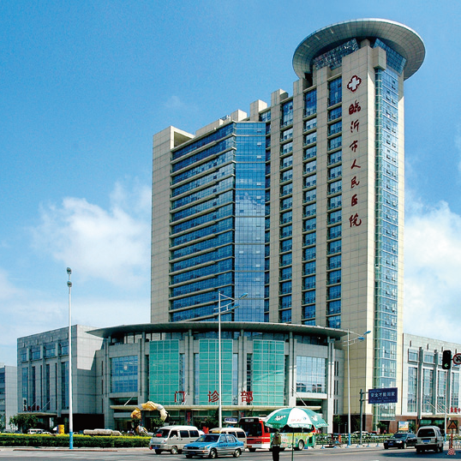



**质疑信息**

* **WB印迹程式化。**

Here is a montage of curious Western Blots, representing a distinct style. They are marked by high contrast and an absence of any background texture, and resemble ink blobs.

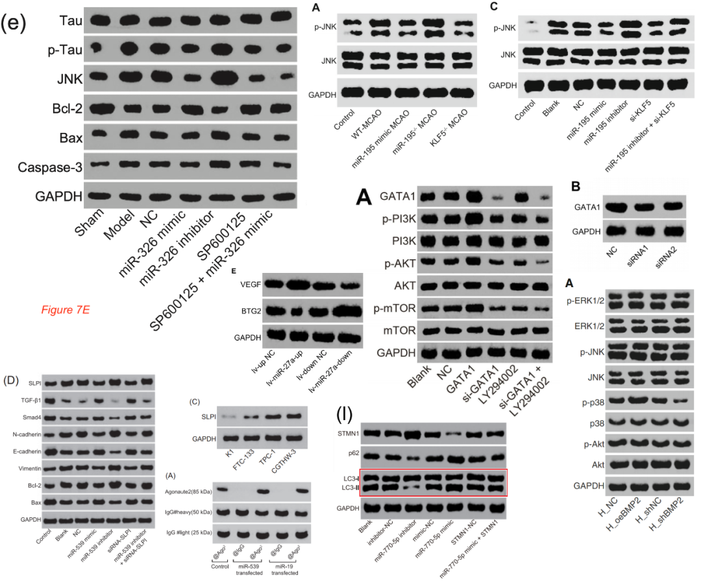

Sources include

He et al (2020)

Chang et al (2020)

Shang et al (2020)

Shi et al (2019) [RETRACTED]

Xu et al (2019) [RETRACTED]

Jia et al (2020)

Feng et al (2019)

Examples could be multiplied but I will settle for three more examples, to show the range of this gamut, from

Qu et al (2019) [RETRACTED]

Song et al (2019) [RETRACTED]

Shi et al (2019).

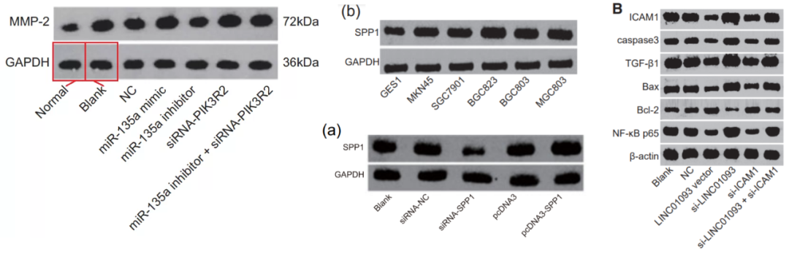

Figs 1h, 2f, 3f, 4g, 5g(本文): They appear to be manifestations of the same style.

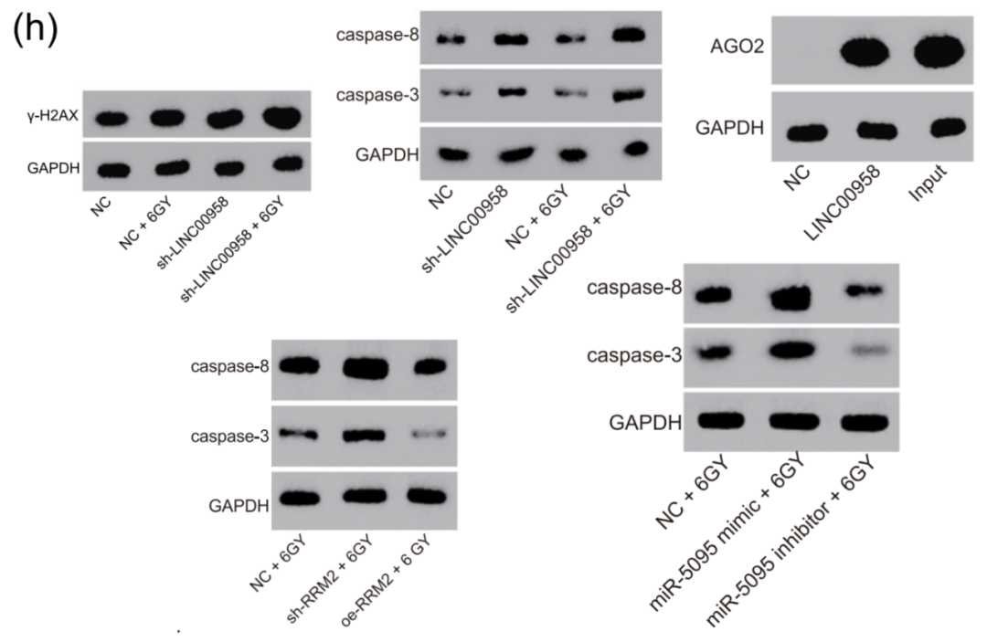

* **图6a与无关论文肿瘤图及直尺存在重复之处。**

Fig 6a.

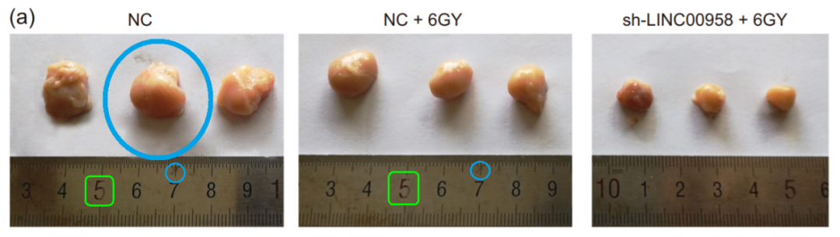

A ruler with the same scratches and markings provides scale in Fig 7B of Feng et al (2019):

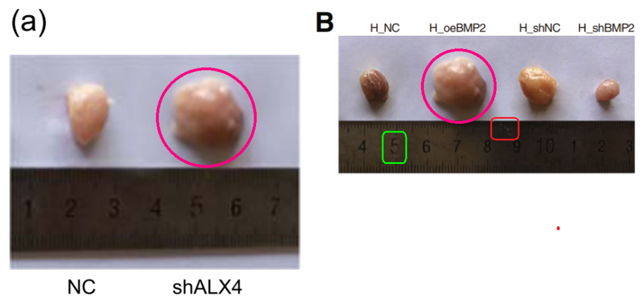

In Fig 6K of Lu et al (2020， doi: 10.1016/j.omtn.2019.11.002).

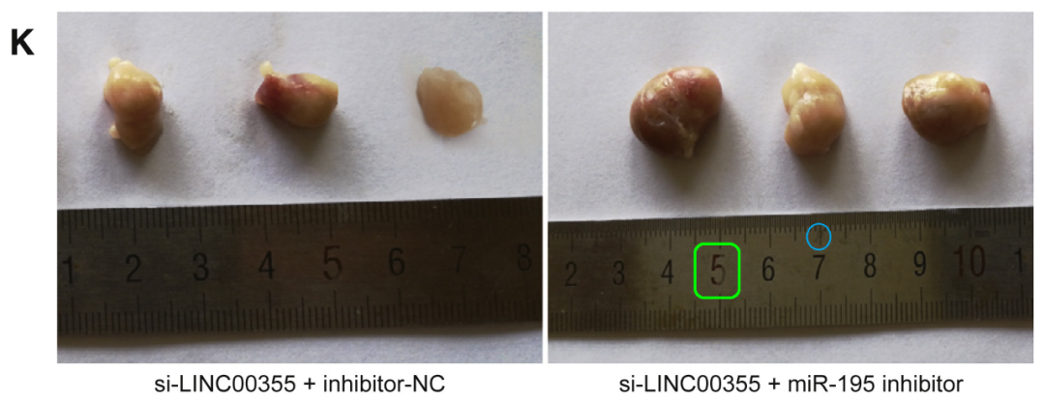

In Fig 5a of Shi et al (2020，doi: 10.1002/jcp.29529  issn: 0021-9541).

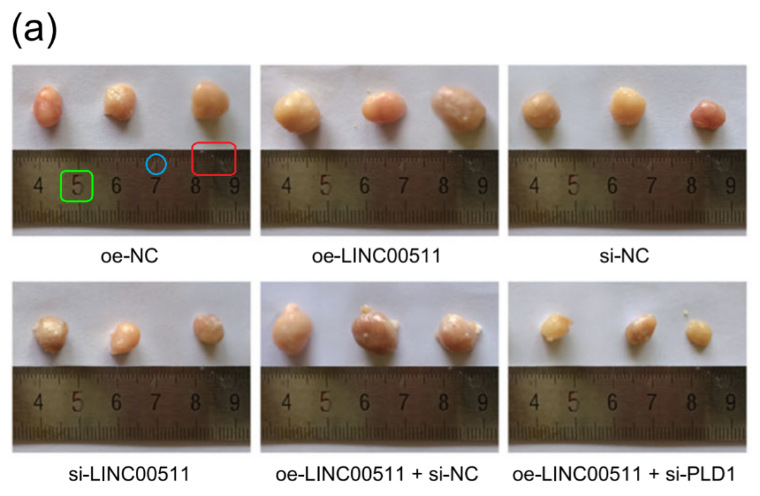

Fig 4A from "Long non-coding RNA TUG1 enhances chemosensitivity in non-small cell lung cancer by impairing microRNA-221-dependent PTEN inhibition" (Guo et al 2019.doi: 10.18632/aging.102271)

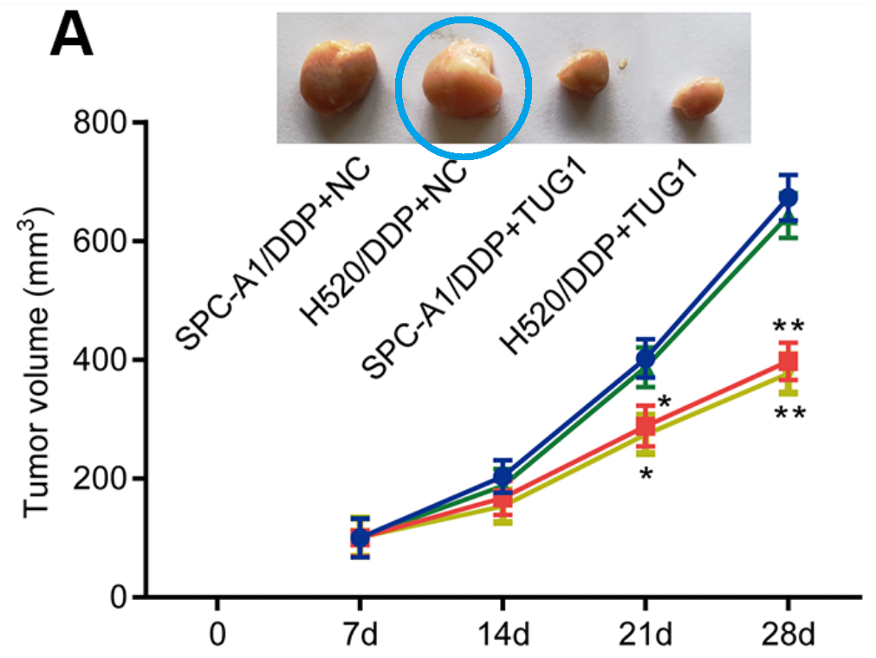

* **图2b与无关图像重复之处。**

Fig 2b

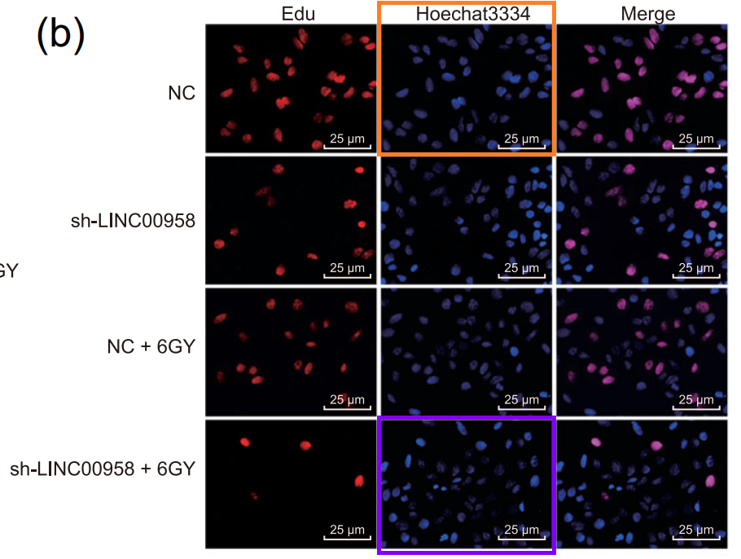

Fig 5a from "Autologous blood transfusion augments impaired wound healing in diabetic mice by enhancing lncRNA H19 expression via the HIF-1α signaling pathway" (Guo et al 2018，doi: 10.1186/s12964-018-0290-6).

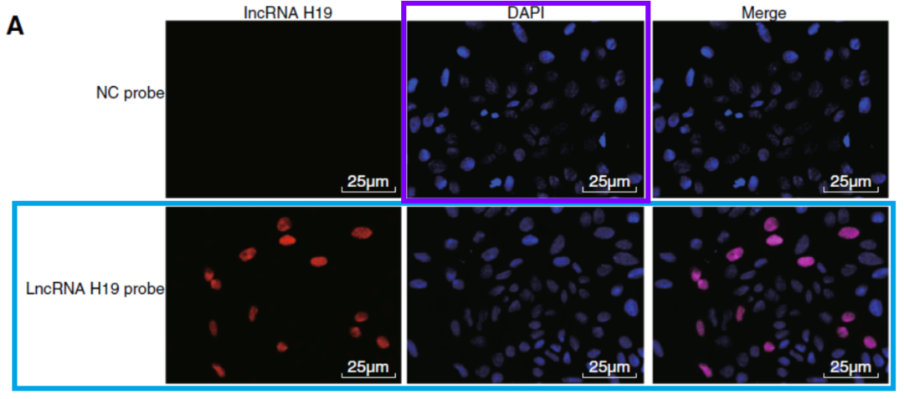

Fig 4a from "Long noncoding RNA LINC00261 suppresses prostate cancer tumorigenesis through upregulation of GATA6-mediated DKK3" (Li et al 2020，doi: 10.1186/s12935-020-01484-5).

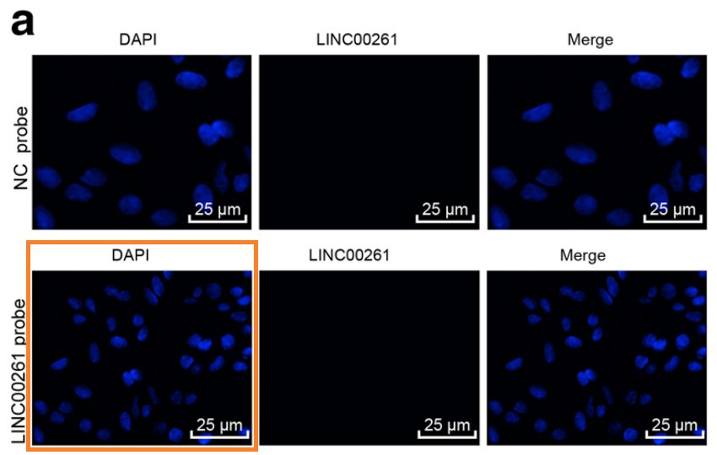

Another sighting! Fig 3B (MKN45 panels) from "Long noncoding RNA DLEU1 aggravates glioma progression via the miR-421/MEF2D axis" (Feng et al 2019，doi: 10.2147/ott.s207542) [retracted].

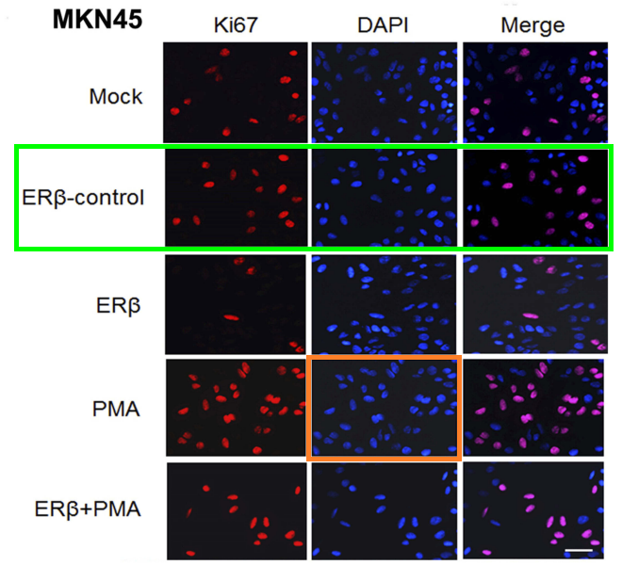

* **图4b与无关图像重复。**

Fig 4b

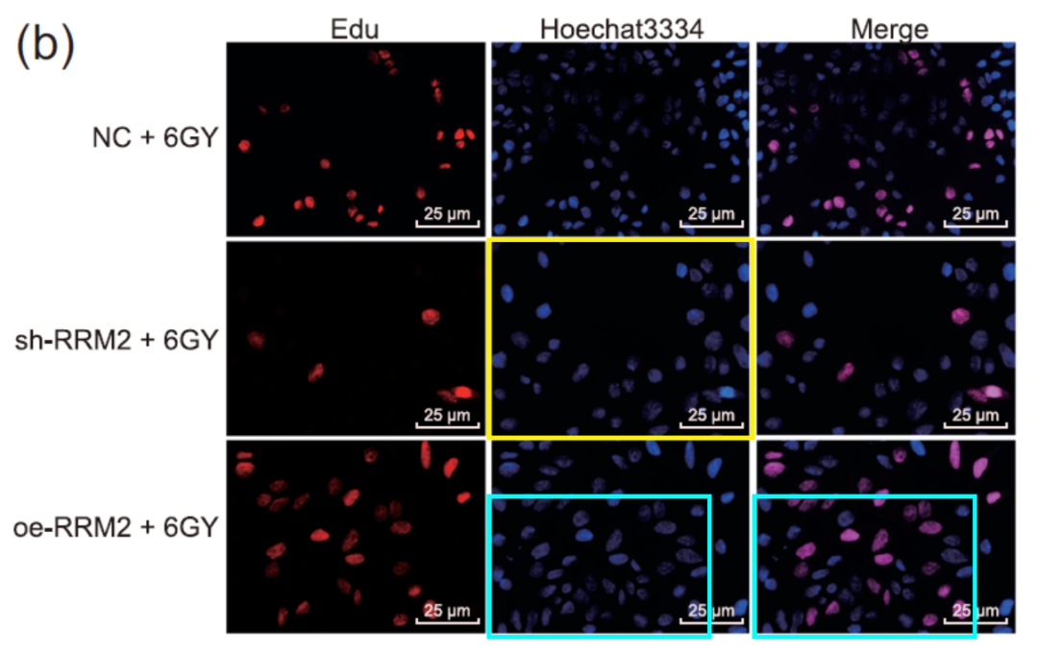

Fig 5a from Guo et al (2018)(doi: 10.1186/s12964-018-0290-6).

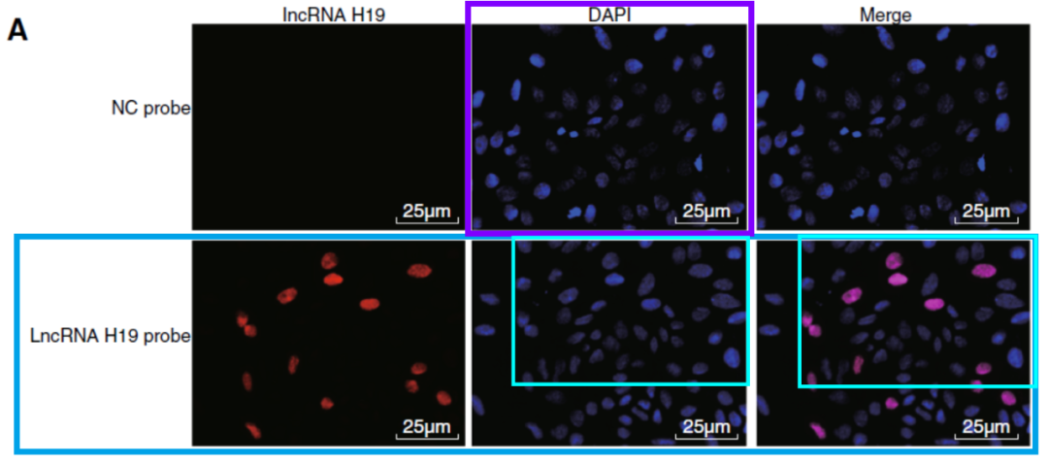

Further overlaps with Fig 5D from "Silencing lncRNA XIST exhibits antiproliferative and proapoptotic effects on gastric cancer cells by up-regulating microRNA-132 and down-regulating PXN" (Li et al 2020， doi: 10.18632/aging.103635).

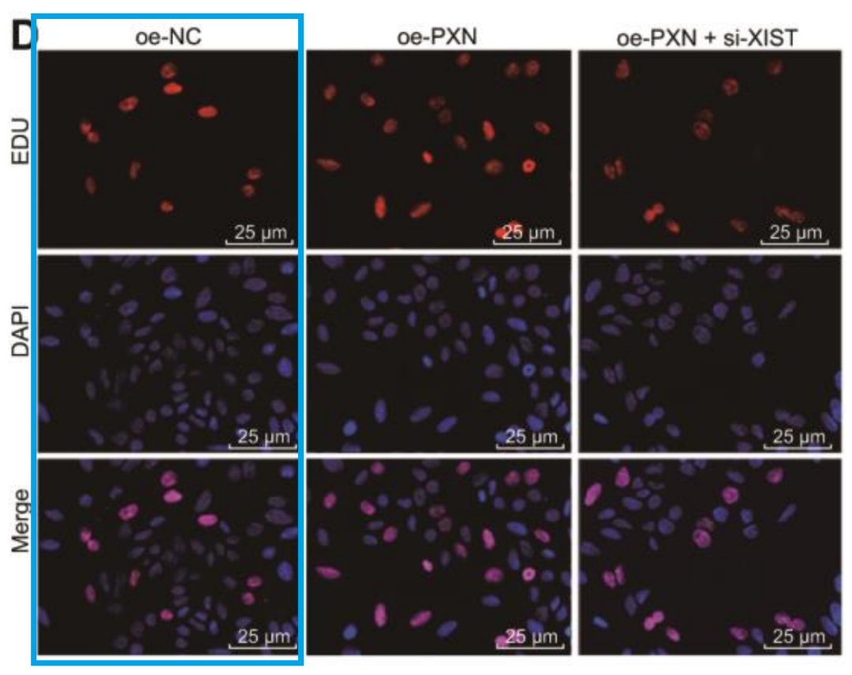

Fig 7b from "Long noncoding RNA LEF1‐AS1 silencing suppresses the initiation and development of prostate cancer by acting as a molecular sponge of miR‐330‐5p via LEF1 repression" (Liu et al 2019, doi: 10.1002/jcp.27893).

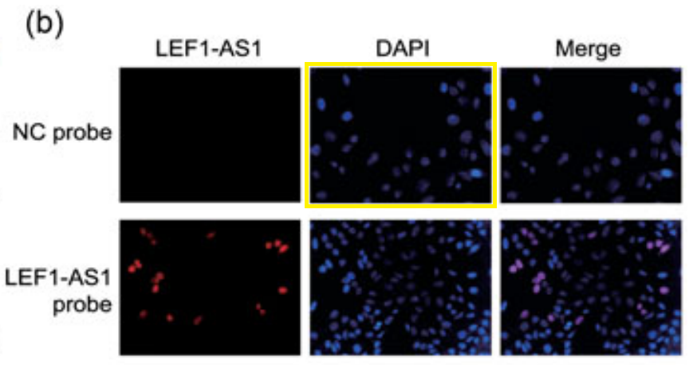

UPDATE: Fig 1e from "Long non-coding RNA CDKN2B-AS1 contributes to atherosclerotic plaque formation by forming RNA-DNA triplex in the CDKN2B promoter" (Qu et al 2020, doi: 10.1016/j.ebiom.2020.102694 ).

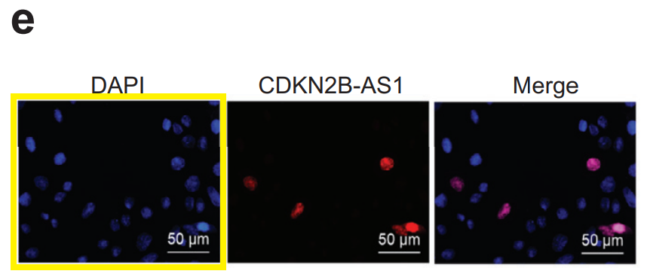



**撤稿原因**

**本文已于2025年1月13日被撤回：**上述文章于2019年6月6日在线发表于Wiley Online Library（wileyonlinelibrary.com），并已经由期刊主编Robert Heath与Wiley Periodicals LLC协商一致后撤回。第三方报告指出，本文中的图6A与另一篇文章（Guo等人，2019年，[https://doi.org/10.18632/aging.102271]）中的图7B检测到了相同的肿瘤图像。第三方还报告了本文中的图2B与其他不同作者的文章之间存在图像重复（Guo等人，2018年，[https://doi.org/10.1186/s12964-018-0290-6]；Liu等人，2019年，[https://doi.org/10.1002/jcp.27893]；Wen等人，2019年，[https://doi.org/10.1096/fj.201900310R]；以及Ou等人，2020年，[https://doi.org/10.1016/j.ebiom.2020.102694]）。每篇提及的文章都描述了不同的科学背景。作者未对出版商的询问作出回应。由于存在与其他文章图像重复的证据，从根本上损害了本文所报告的结论，因此已同意撤回该文章。作者未对我们关于撤回的通知作出回应。



**参考信息**

https://pubpeer.com/publications/5B27DD30AEE1CB77340CD0F7697B8B

https://pubmed.ncbi.nlm.nih.gov/31169309/

https://onlinelibrary.wiley.com/doi/10.1002/jcp.31525