[上海交通大学医学院知名论文图片重复](https://mp.weixin.qq.com/s?__biz=Mzg5MTg0MDc4NQ==&mid=2247493242&idx=2&sn=289d4a941e0235bf2b483763331f4bf5&chksm=ce6e25e26a46feb44c5b62529a703a6b1bbdf1da07eb7e97aee74b1d14a4fb1228af76ba3510&scene=126&sessionid=1742834175)

原创  Figure[图片重复](javascript:void(0);)2025-03-16 08:46:00广东

All-Trans Retinoic Acid Ameliorates Myocardial Ischemia/Reperfusion Injury by Reducing Cardiomyocyte Apoptosis

**PLoS ONE (2015)**

**PMID:**26186635

**DOI:**10.1371/journal.pone.0133414

**AUTHORS**

**Zhengbin Zhu1,Jinzhou Zhu1,Xiaoran Zhao1,Ke Yang2,Lin Lu1,Fengru Zhang3,Weifeng Shen1,Ruiyan Zhang1**

**AFFILIATIONS**

1Department of Cardiology, Rui Jin Hospital, School of Medicine, Shanghai Jiao Tong University, Shanghai, 200025, PR China; Institute of Cardiovascular Diseases, School of Medicine, Shanghai Jiao Tong University, Shanghai, 200025, PR China.

2Institute of Cardiovascular Diseases, School of Medicine, Shanghai Jiao Tong University, Shanghai, 200025, PR China.

3Department of Cardiology, Rui Jin Hospital, School of Medicine, Shanghai Jiao Tong University, Shanghai, 200025, PR China.

#### Author response

#### 5 month ago

**#1Actinopolyspora Biskrensis**

**5 month ago**

This paper includes at least one image that appears in a different paper submitted to a different journal in the same year but by a different group of authors.

Figure 6, PLoS ONE (2015), doi: 10.1371/journal.pone.0133414, Received: January 26, 2015, discussed here: https://pubpeer.com/publications/2C8054AA2ABBC138A455CADB3130CF

Figure 2, Molecular Medicine Reports (2017), doi: 10.3892/mmr.2017.6230, Received December 30, 2015, discussed here: https://pubpeer.com/publications/A111B058E6637B8B5F0E8E1BDBB811

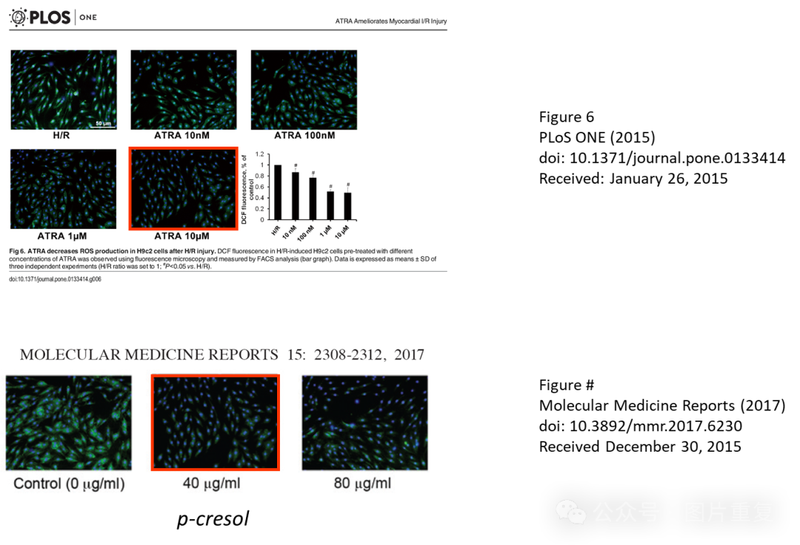

**#2Actinopolyspora Biskrensis**

**5 month ago**

The ethics statement reads:

"The study protocol was approved by the Animal Use and Care Committee (Shanghai Jiao Tong University School of Medicine, document number: SYKX-2008-0050)."

The format of the document number suggests a 2008 approval. Can the authors confirm that this document was specific authorization for the procedures described in this paper?

I ask in part because this same document was referenced in a different paper in this journal for very different research: Shen S, Yang W, Wang Z, Lei X, Xu L, Wang Y, et al. (2011) Tumor-Initiating Cells Are Enriched in CD44hi Population in Murine Salivary Gland Tumor. PLoS ONE 6(8): e23282. https://doi.org/10.1371/journal.pone.0023282.

"All the procedures described were approved by the Animal Use and Care Committee of Shanghai Jiaotong University School of Medicine (approval number: SYKX-2008-0050)."

We would like to thank Qiujing Chen for assistance in ordering all the materials. This study was supported by National Natural Science Foundation of China (grants 81000050, 81300178 and 81370401).

**#3Jinzhou Zhu (author)**

**5 month ago**

#1 We claimed that the "Measurement of ROS production" study was performed by our group but on a public laboratory platform. We believe all authors listed in our article have no conflict of interest with other research group. #2 SYKX-2008-0050 is the use license of animal experiment of Shanghai Jiao Tong University School of Medicine. Ethical Number was not required to provide by “Plos one” journal when we submitted the manuscript.