[华中科技大学同济医院论文图片重复](https://mp.weixin.qq.com/s?__biz=Mzg5MTg0MDc4NQ==&mid=2247493215&idx=2&sn=c4cfa7363697dcccf46de26b1e8f8b7e&chksm=ceee08bd9b50fd32e68b5ce99f2bdc8f0035c11e5dc5f7df65e3e875c18e220990e162342798&scene=126&sessionid=1742834175)

原创  F[图片重复](javascript:void(0);)2025-03-14 12:50:56广东

**miR-195 inhibits cell proliferation via targeting AEG-1 in hepatocellular carcinoma**

**Oncology Letters (2017)**

**PMID:**28529562

**DOI:**10.3892/ol.2017.5826

**AUTHORS**

**Jing-Jun Yan1,Ying Chang1,Yu-Nan Zhang1,Ju-Sheng Lin1,Xing-Xing He1,Huan-Jun Huang1**

**AFFILIATIONS**

1Institute of Liver Diseases, Tongji Hospital, Tongji Medical College, Huazhong University of Science and Technology, Wuhan, Hubei 430030, P.R. China.

**#1Mycosphaerella Arbuticola 6 day ago**

Much more similar than expected. Similarities detected by ImageTwin.

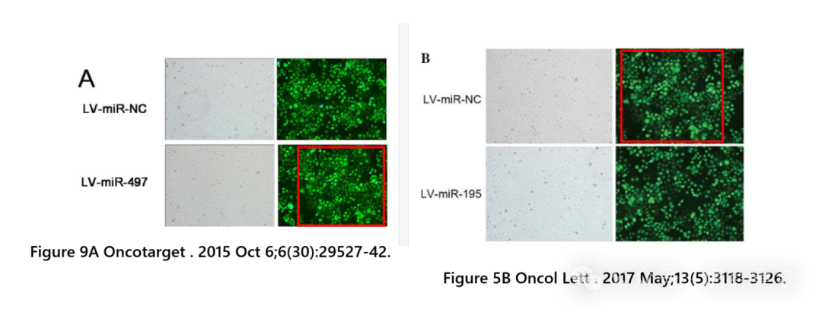

[#华中科技大学](https://mp.weixin.qq.com/mp/appmsgalbum?__biz=Mzg5MTg0MDc4NQ==&action=getalbum&album_id=3891931461149999111#wechat_redirect)[#图片重复](https://mp.weixin.qq.com/mp/appmsgalbum?__biz=Mzg5MTg0MDc4NQ==&action=getalbum&album_id=2546994047780667392#wechat_redirect)[#查重系统](https://mp.weixin.qq.com/mp/appmsgalbum?__biz=Mzg5MTg0MDc4NQ==&action=getalbum&album_id=3076605976766332935#wechat_redirect)