[中国医科大学附属盛京医院超声科姜罗的论文图像重复频出，科研成果遭质疑](https://mp.weixin.qq.com/s?__biz=Mzk3NTEwMTE3OA==&mid=2247484957&idx=1&sn=7015a0df280dc1c8ff3356664669c322&chksm=c5af8b3b2d5bfa979d4e5a954b9096c9a3bff59f73316ecef7851cf3a247b786aa3faf2d2977&scene=126&sessionid=1742748101)

[学术荟萃](javascript:void(0);)2025-03-23 22:01:00山东

**Part.1**



**论文简介**

**标题：miR-762 can negatively regulate menin in ovarian cancer**

**日期：**2017年4月12日

**单位与作者：**中国医科大学附属盛京医院超声科Rui Hou、Luo Jiang（通讯作者 音译 姜罗)

期刊：***OncoTargets and therapy***

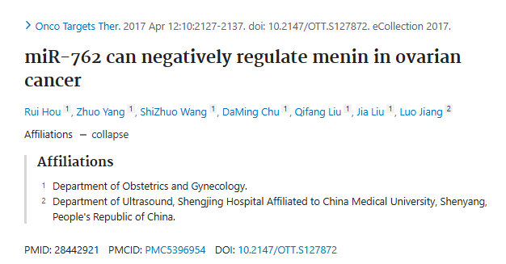

**Part.2**



**撤稿说明**

**#1 图4F与Guo et al 2016的4A出现重复。**

[left] Fig 4A from "miR-194 is a negative regulator of GEF-H1 pathway in melanoma" (Guo et al 2016).

[right] Fig 4F.

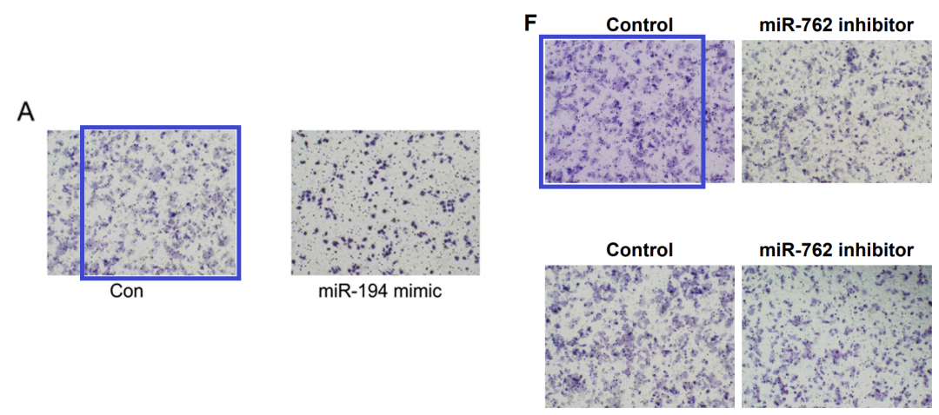

**#2 图3A与Yin et al 2020的3F出现重复。**

[left] Fig 3A.

[right] Fig 3F from "Effects of mild intrauterine hypoperfusion in the second trimester on memory and learning function in rat offspring" (Yin et al 2020).

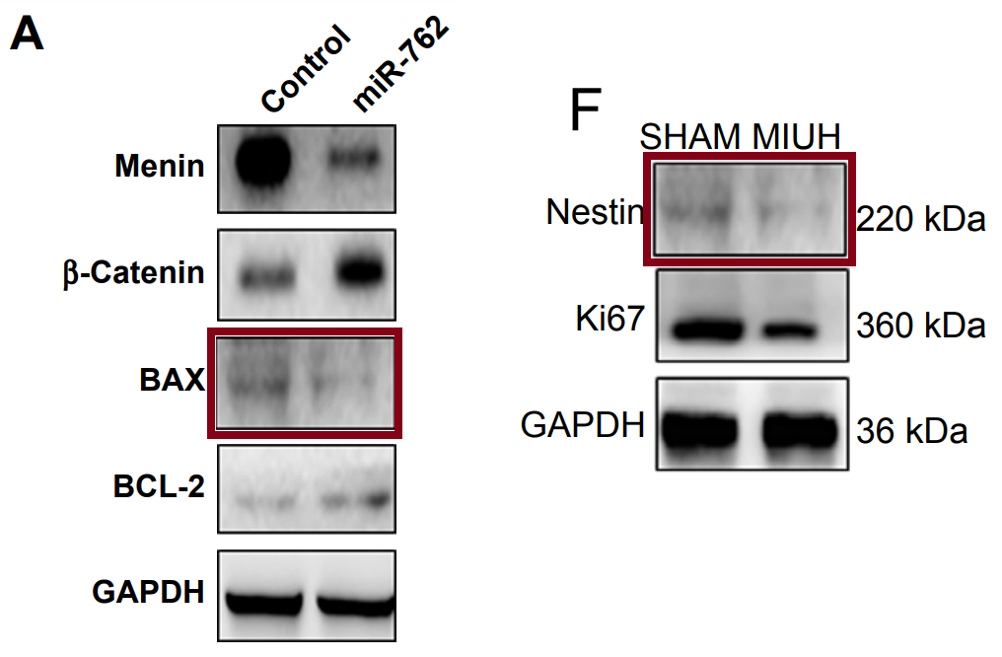

**#3 图4E与Wei et al 2019的5A出现重复。**

[left] Fig 3A.

[right] Fig 3F from "Effects of mild intrauterine hypoperfusion in the second trimester on memory and learning function in rat offspring" (Yin et al 2020).

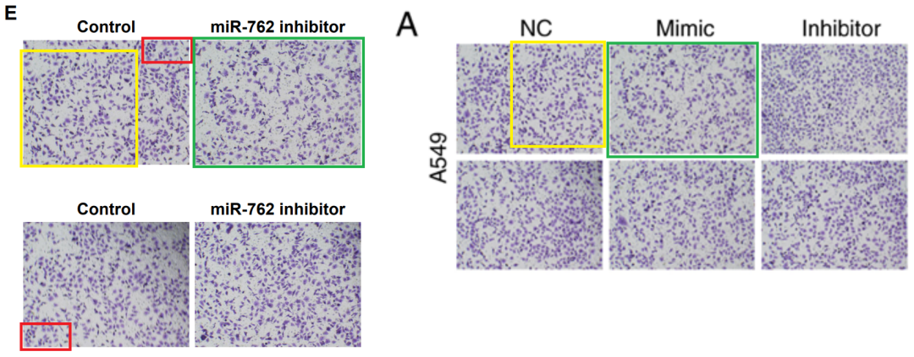

**#4 图4B与Wang et al 2019的5B出现重复。**

[left] Fig 4B.

[right] Fig 5B from "miR?489 promotes apoptosis and inhibits invasiveness of glioma cells by targeting PAK5/RAF1 signaling pathways" (Wang et al 2019) [retracted].

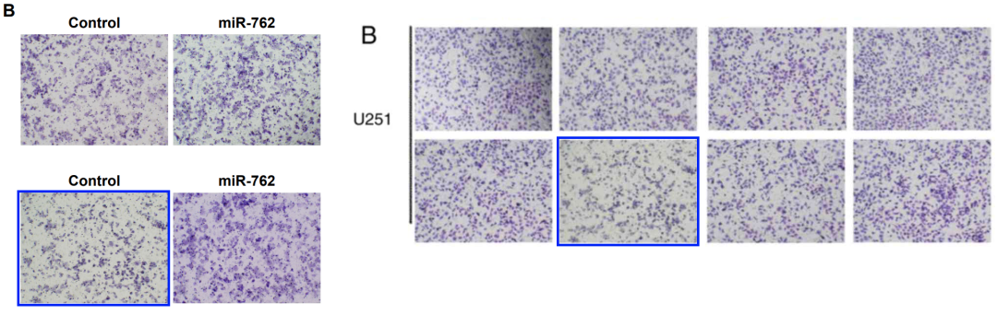

**参考信息：**

https://pubpeer.com/publications/B20ECCC0BBE59E0412E0C0F8C4D617#4

https://www.ncbi.nlm.nih.gov/pmc/articles/PMC5396954/