[厦门大学知名附属医院论文图片重复](https://mp.weixin.qq.com/s?__biz=Mzg5MTg0MDc4NQ==&mid=2247493349&idx=1&sn=673c03c0987ece046c3d975bc94dc93a&chksm=ce89a4aa468f60617f21a806964b67f74f8776ede5e6d333efee51ac6262c448d7e3cda8d59b&scene=126&sessionid=1742792300)

原创  f[图片重复](javascript:void(0);)2025-03-24 12:30:10广东

**KIF4A promotes tumor progression of bladder cancer via CXCL5 dependent myeloid-derived suppressor cells recruitment**

**Scientific Reports (2022)**

**PMID:**35399116

**DOI:**10.1038/s41598-022-10029-x

**AUTHORS**

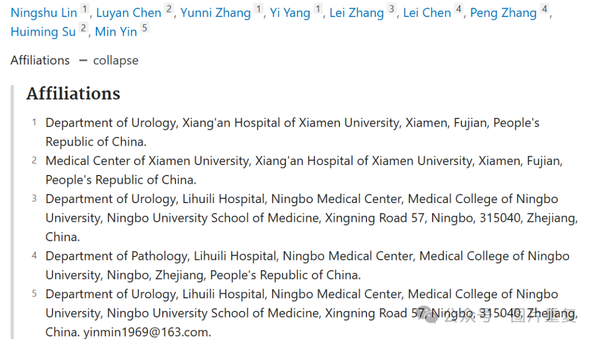

**#1Sholto David 9 hours ago**

**Figure 5**: Multiple overlapping areas. Identified and annotated with coloured rectangles with the help of ImageTwin.ai. Rotations are not indicated. Would the authors please check and comment?

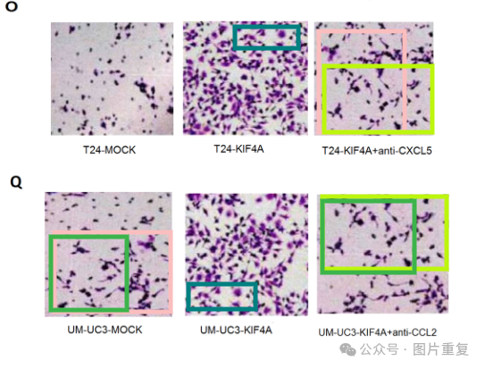**#2Sholto David**

**9 hours ago**

Also see **Figure 1G**:

