[重复！暨南大学生命科学技术学院论文受关注！](https://mp.weixin.qq.com/s?__biz=Mzg5MTg0MDc4NQ==&mid=2247493272&idx=2&sn=6b1a689c812260dbefe1d50270afb35f&chksm=ce51b73ed3552aed73fb81a4463c04ee955425cd1660f54742d1f0f4d67d7aa4a128745d6652&scene=126&sessionid=1742747084)

原创  F[图片重复](javascript:void(0);)2025-03-18 09:06:54广东

**Synergistic anticancer effects of triptolide and celastrol, two main compounds from thunder god vine**

**Oncotarget (2015)**

**PMID:**26447544

**DOI:**10.18632/oncotarget.5411

**AUTHORS**

**Qi-Wei Jiang1,Ke-Jun Cheng23,Xiao-Long Mei1,Jian-Ge Qiu1,Wen-Ji Zhang1,You-Qiu Xue1,Wu-Ming Qin1,Yang Yang1,Di-Wei Zheng1,Yao Chen1,Meng-Ning Wei1,Xu Zhang3,Min Lv4,Mei-Wan Chen5,Xing Wei1,Zhi Shi1**

**AFFILIATIONS**

1Department of Cell Biology & Institute of Biomedicine, National Engineering Research Center of Genetic Medicine, Guangdong Provincial Key Laboratory of Bioengineering Medicine, College of Life Science and Technology, Jinan University, Guangzhou, Guangdong, China.

2Chemical Biology Center, Lishui Institute of Agricultural Sciences, Lishui, Zhejiang, China.

3National First-Class Key Discipline for Traditional Chinese Medicine of Nanjing University of Chinese Medicine, Nanjing, Jiangsu, China.

4Institute of Materia Medica, Zhejiang Chinese Medical University, Hangzhou, Zhejiang, China.

5State Key Laboratory of Quality Research in Chinese Medicine, Institute of Chinese Medical Sciences, University of Macau, Macau, China.

**#1Arceuthobium Divaricatum 2 hours ago**

Much more similar than expected. Similarities detected by ImageTwin.

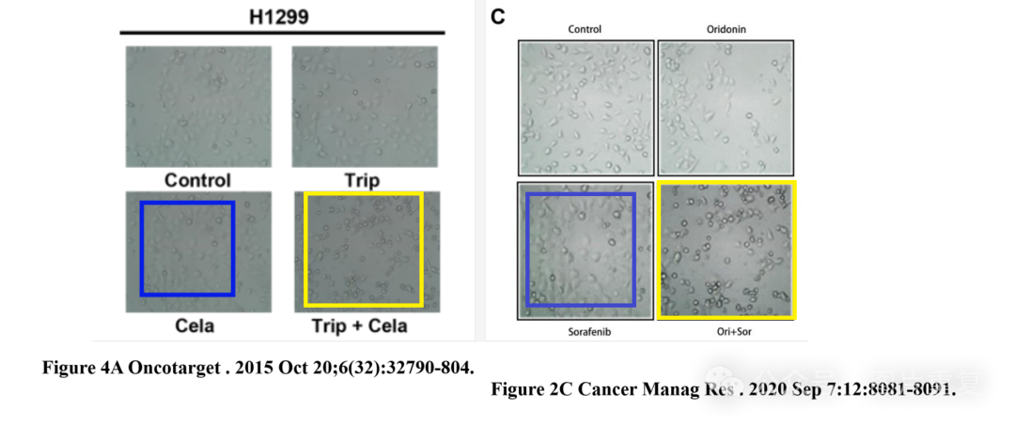

[#图片重复](https://mp.weixin.qq.com/mp/appmsgalbum?__biz=Mzg5MTg0MDc4NQ==&action=getalbum&album_id=2546994047780667392#wechat_redirect)[#暨南大学生命科学技术学院](https://mp.weixin.qq.com/mp/appmsgalbum?__biz=Mzg5MTg0MDc4NQ==&action=getalbum&album_id=3903516089941966860#wechat_redirect)