[局部重复？来自河南大学知名附属医院](https://mp.weixin.qq.com/s?__biz=Mzg5MTg0MDc4NQ==&mid=2247493215&idx=1&sn=8b178ff4029790591d5f0a83ee79cfde&chksm=cef2210fac48c7fe744eca90963150f637a907a337e861e66c1c370d18380e079d9e70f69fee&scene=126&sessionid=1742747084)

原创  F[图片重复](javascript:void(0);)2025-03-14 12:50:56广东

**UCA1 promotes cell proliferation and invasion and inhibits apoptosis through regulation of the miR129–SOX4 pathway in renal cell carcinoma**

**OncoTargets and Therapy (2018)**

**PMID:**29760557

**DOI:**10.2147/ott.s160192

**AUTHORS**

**Qian Liu1,Yang Li1,Weiling Lv2,Guangwei Zhang1,Xin Tian1,Xiaodong Li1,Hepeng Cheng1,Chaoyang Zhu1**

**AFFILIATIONS**

1Department of Urology, Huaihe Hospital of Henan University, Kaifeng, Henan.

2Department of Pharmacy, Huaihe Hospital of Henan University, Kaifeng, Henan, China.

**#1Sholto David 3 hours ago**

**Figure 2C**: Unexpected duplicated areas. I've added the coloured rectangles to show where I mean. There are some rotations. Would the authors please check and comment?

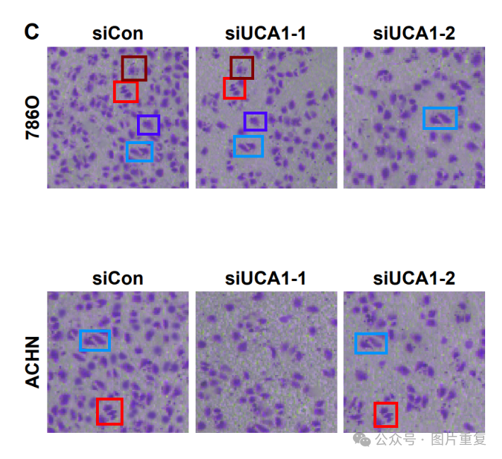

[#图片重复](https://mp.weixin.qq.com/mp/appmsgalbum?__biz=Mzg5MTg0MDc4NQ==&action=getalbum&album_id=2546994047780667392#wechat_redirect)[#河南大学](https://mp.weixin.qq.com/mp/appmsgalbum?__biz=Mzg5MTg0MDc4NQ==&action=getalbum&album_id=3897935528523415559#wechat_redirect)