[浙江大学的nature子刊论文图片重复](https://mp.weixin.qq.com/s?__biz=Mzg5MTg0MDc4NQ==&mid=2247493303&idx=2&sn=e97a4ee974c757dd1cc464b657097c56&chksm=ce4fbba73eb6c103450d02c8e33b9d30d936d01a146de66c472520df4b25212a02dd7c475636&scene=126&sessionid=1742663877)

原创  F[图片重复](javascript:void(0);)2025-03-20 09:47:29广东

**Targeting photodynamic and photothermal therapy to the endoplasmic reticulum enhances immunogenic cancer cell death**

**Nature Communications (2019)**

**PMID:**31350406

**DOI:**10.1038/s41467-019-11269-8

**AUTHORS**

**Wei Li1,Jie Yang1,Lihua Luo1,Mengshi Jiang1,Bing Qin1,Hang Yin1,Chunqi Zhu1,Xiaoling Yuan1,Junlei Zhang1,Zhenyu Luo1,Yongzhong Du1,Qingpo Li1,Yan Lou2,Yunqing Qiu2,Jian You3**

**AFFILIATIONS**

1College of Pharmaceutical Sciences, Zhejiang University, 866 Yuhangtang Road, 310058, Hangzhou, Zhejiang, P. R. China.

2The First Affiliated Hospital of Medical School of Zhejiang University, 79 Qingchun Road, 310058, Hangzhou, Zhejiang, P. R. China.

3College of Pharmaceutical Sciences, Zhejiang University, 866 Yuhangtang Road, 310058, Hangzhou, Zhejiang, P. R. China. .

**#1Sholto David 1 hours ago**

**Figure 5a**: Unexpected duplicate mice, I've added the red rectangles to show where I mean. Would the authors please check and comment?

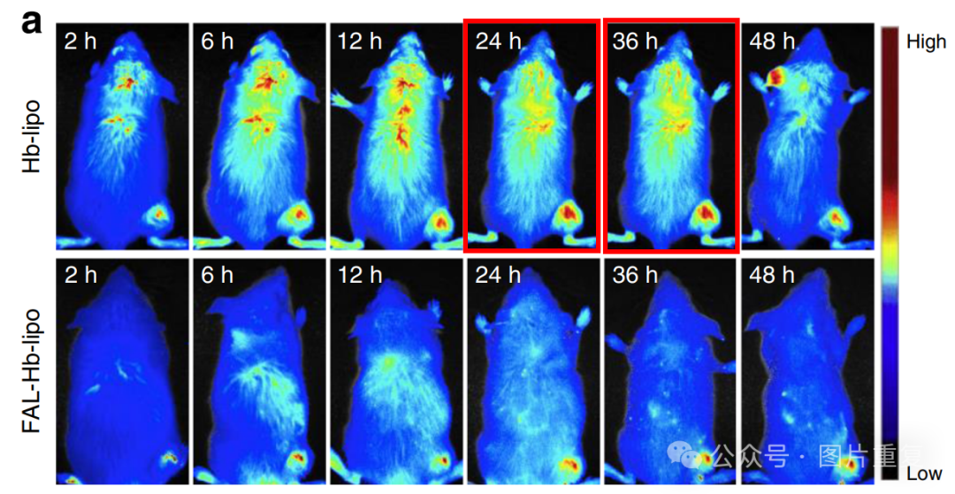

[#浙江大学](https://mp.weixin.qq.com/mp/appmsgalbum?__biz=Mzg5MTg0MDc4NQ==&action=getalbum&album_id=3876833882691502080#wechat_redirect)[#图片重复](https://mp.weixin.qq.com/mp/appmsgalbum?__biz=Mzg5MTg0MDc4NQ==&action=getalbum&album_id=2546994047780667392#wechat_redirect)