[郑州大学第一附属医院内分泌科的论文图片与同期刊两文雷同，图片问题指向论文工厂？](https://mp.weixin.qq.com/s?__biz=Mzk0NjYzMDcyNQ==&mid=2247513384&idx=2&sn=c7d4e1f70aed9f21b128ad1cea3c77c6&chksm=c2d57add50940cc625314de792bc6d059c3ad348c1293188e8606898b676b63d623a40a617f6&scene=126&sessionid=1742663915)

Imagetwin[图片查重指南针](javascript:void(0);)2025-03-05 09:03:51中国台湾

[](http://mp.weixin.qq.com/s?__biz=Mzk0NjYzMDcyNQ==&mid=2247494760&idx=1&sn=9f28762dc91428c028f15e4f752f2e88&chksm=c3019542f4761c5449a4b653c431eba3a2d17317fed2115923f1044eabc511f4a936059ae166&scene=21#wechat_redirect)

***01***

**论文信息**

2022年1月16日，郑州大学第一附属医院内分泌科在Bioengineered(中科院四区 IF=4.2)发表题为“CircularRNA circ_0071269 knockdown protects against from diabetic cardiomyopathy injury by microRNA-145/gasdermin A axis”的论文。

通讯作者：郑州大学第一附属医院内分泌科Lanfang Fu

第一作者：郑州大学第一附属医院内分泌科Guijun Qin

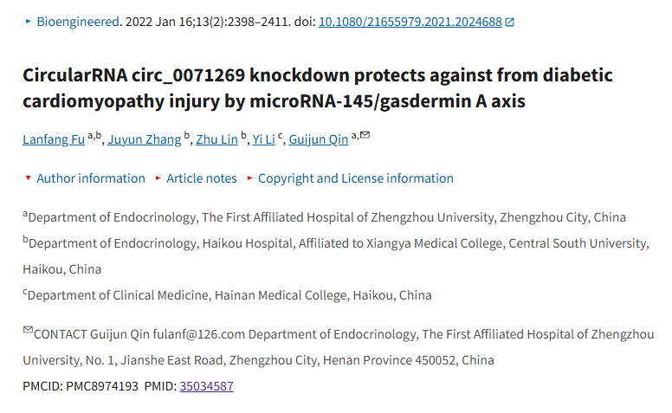

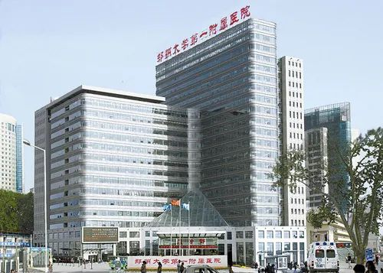

***02***

**质疑信息**

**质疑一：本文中的一张图片似乎也出现在大约同一时间在同一期刊上发表的一篇论文中。要发表的第二篇论文是在第一篇论文在线发表之前提交的，这表明这两篇论文都可能涉及第三方。**

An image in this paper seems to also appear in a paper published in the same journal around the same time.

The 2nd paper to be published was submitted before the 1st paper was published online suggesting a third party may have been involved on both.

Figure 7e, Bioengineered (2021), doi: 10.1080/21655979.2021.2000195, Received 17 Jun 2021, Accepted 26 Oct 2021, Published online: 13 Dec 2021. Discussed here: https://pubpeer.com/publications/3F7E6BFED7A827C8243F2CCB5CD89A

Figure 7F, Bioengineered (2022), doi: 10.1080/21655979.2021.2024688, Received 10 Nov 2021, Accepted 27 Dec 2021, Published online: 16 Jan 2022. Discussed here: https://pubpeer.com/publications/D9090453E3460163AC6365D1E4102C

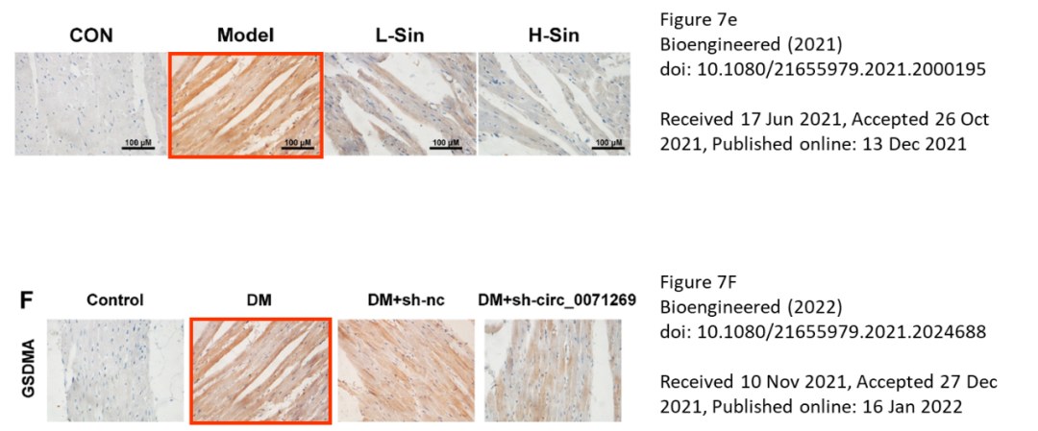

Imagetwin全网查(如需要查重服务，请联系文末客服微信)

**质疑二：本文中的图片与另外一篇同年发表的论文出现重复。**

We found additional unexpected overlap between a figure presented in this study and a figure presented in another study (see enclosed image below).

The following papers are affected:

Paper 1: https://pubmed.ncbi.nlm.nih.gov/35034587/

Paper 2: https://pubmed.ncbi.nlm.nih.gov/35635083/

We will notify the publisher to resolve the issue.

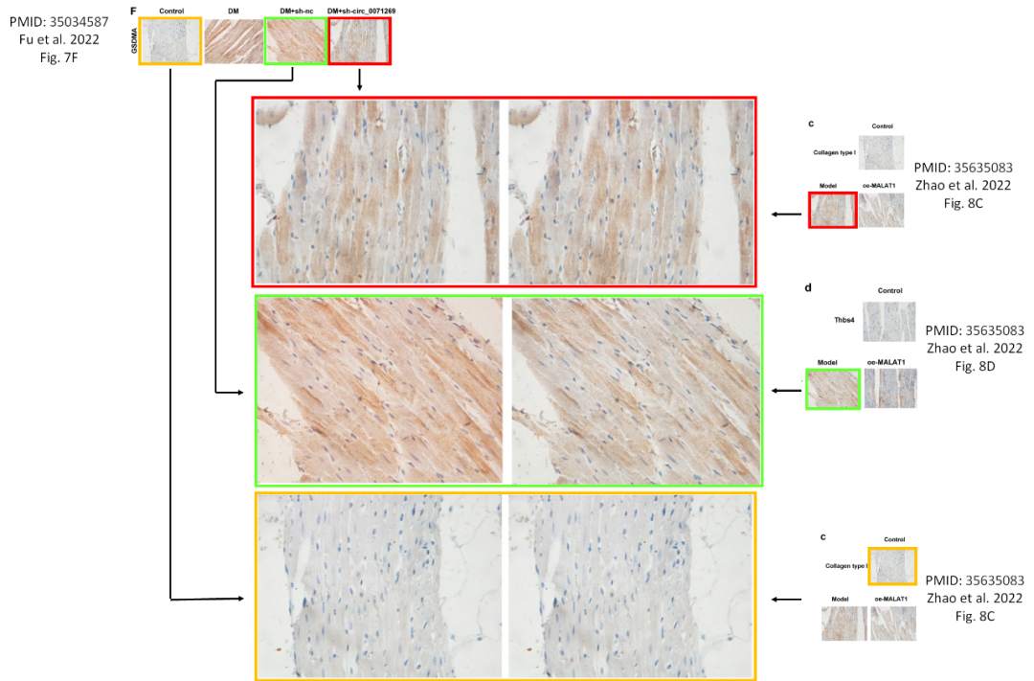

Imagetwin全网查(如需要查重服务，请联系文末客服微信)

**参考信息：**

https://pubpeer.com/publications/D9090453E3460163AC6365D1E4102C#1

https://pmc.ncbi.nlm.nih.gov/articles/PMC8974193/

**论文图片Imagetwin查重服务**

**请添加查重部客服微信：figfig04**



*#*

***往期精选***

城门失火，殃及池鱼| 涨知识，非洲大草原上的蚂蚁如何打败狮子：物种入侵的危害

**近日Onco Targets and Therapy接连撤稿数篇，本周涉四川省人民医院李刚教授文章，与两篇论文图片重复**

猎杀狼保护牲畜？可能会适得其反

DOVE期下期刊近期撤稿和质疑高发，重点警惕，南京医科大学附属第一医院顾艳宏等人文章因多处图片重复被质疑

[**Science最新封面研究！人类使用的植物都分布在哪里？**](http://mp.weixin.qq.com/s?__biz=Mzk0NjYzMDcyNQ==&mid=2247484011&idx=1&sn=c66c081849cf2df587aa956f14f783dc&chksm=c3027b41f475f2579f223d5f58c14d6000fc335b1147f43d6c7f76d056e1f6c4819a8373d34f&scene=21#wechat_redirect)

**校园霸凌导致逃避心理VS被打败的老鼠会绕道走！最新Nature重磅成果——专门的下丘脑催产素回路控制厌恶性社交学习**

[世界领先！柳叶刀-复旦大学舒易来教授团队成果，恢复先天性耳聋儿童听力的临床试验取得成功](http://mp.weixin.qq.com/s?__biz=Mzk0NjYzMDcyNQ==&mid=2247484011&idx=1&sn=c66c081849cf2df587aa956f14f783dc&chksm=c3027b41f475f2579f223d5f58c14d6000fc335b1147f43d6c7f76d056e1f6c4819a8373d34f&scene=21#wechat_redirect)

**和早期发表论文图片重复，北京大学人民医院郭卫教授的文章因图片重复被质疑**

[**普通的水也能引发核反应？Science Report新发现！**](http://mp.weixin.qq.com/s?__biz=Mzk0NjYzMDcyNQ==&mid=2247483830&idx=2&sn=537cebf16ad583dbd66f7b3189a53c16&chksm=c302789cf475f18a890d93724d2ac5f2d46b927242fdac92456d4d405e42fa839840ee8375e7&scene=21#wechat_redirect)

[**科研心法| 字字触动科研人的灵魂**](http://mp.weixin.qq.com/s?__biz=Mzk0NjYzMDcyNQ==&mid=2247483653&idx=1&sn=f7be4bed0253bd20d69b549bc1371b98&chksm=c302782ff475f139ced644ce446311f6444100157db60ffcbb33a81d844cd3bbd068315d108b&scene=21#wechat_redirect)

[**疑似数据在不同论文重复使用！国家卫健委直属北京医院国家老年病学中心内分泌科郭立新教授等发表的文章被质疑**](http://mp.weixin.qq.com/s?__biz=Mzk0NjYzMDcyNQ==&mid=2247483830&idx=3&sn=19dfc430973d4390f940258997ec5da2&chksm=c302789cf475f18a0ccf7c722741814d9b477fdfa256bfdc97a50cb3538c2a58fe48583ef55a&scene=21#wechat_redirect)

[**一图两用，双双撤稿，深圳大学第一附属医院放射科两篇论文近日被撤稿**](http://mp.weixin.qq.com/s?__biz=Mzk0NjYzMDcyNQ==&mid=2247483765&idx=1&sn=02944f4bc5de4cf631b484fe00fa5440&chksm=c302785ff475f1496244384c1ec34dd2fb9907d59cde4156637810f48dde2b40c908b01dfb88&scene=21#wechat_redirect)

[**通讯作者邮箱有误，论文工厂参与操作图片！聊城市人民医院肿瘤科马丹论文被撤稿**](http://mp.weixin.qq.com/s?__biz=Mzk0NjYzMDcyNQ==&mid=2247483765&idx=2&sn=eff726b58cf0ff803a53cf1b8591f8b6&chksm=c302785ff475f14901bcbb18a9f8134d1bb1fe2cc40ab8c3e418f3f56e4494b8334209ef741c&scene=21#wechat_redirect)

[**第三方参与操纵发表迹象，青岛大学附属医院/四川大学华西口腔医院/复旦大学附属妇产科医院三家单位的论文本周被撤稿**](http://mp.weixin.qq.com/s?__biz=Mzk0NjYzMDcyNQ==&mid=2247483690&idx=1&sn=bc06edadea5ca7926a7155565664a660&chksm=c3027800f475f1161978def48dc683f7964c6f493b03398c7f22a6c6cb9aadd51d0cca34f636&scene=21#wechat_redirect)

[**盗用他人多年前发表图片，上海中医药大学附属第七人民医院被撤稿**](http://mp.weixin.qq.com/s?__biz=Mzk0NjYzMDcyNQ==&mid=2247483690&idx=2&sn=a13ff72bf531150f978d559e5964edd5&chksm=c3027800f475f116462ad6cc0fcea63b0ee700741bedf113c3dbf81250d7a65ae5767ccfa0ce&scene=21#wechat_redirect)