[湖北医药学院附属十堰太和医院某研究团队被质疑与其他研究出现图片重叠](https://mp.weixin.qq.com/s?__biz=MzkzNTg2MDgwMQ==&mid=2247486331&idx=1&sn=79454d2821773b57cb6669feb4b5da85&chksm=c3f0f06f6b498df6071fd75fb7ce1b2f9eb779d73382033318044f731f63bbe58093abce0a47&scene=126&sessionid=1742576822)

plus[Pubpeer Plus](javascript:void(0);)2025-03-17 09:01:00河南



2011年12月8日，湖北医药学院附属十堰太和医院Du ShiMing（音译，杜士明）研究团队，在 ***International Journal of Nanomedicine***上发表的题为“Effects of quercetin nanoliposomes on C6 glioma cells through induction of type III programmed cell death”的研究论文，**被质疑与其他研究出现图片重叠。**

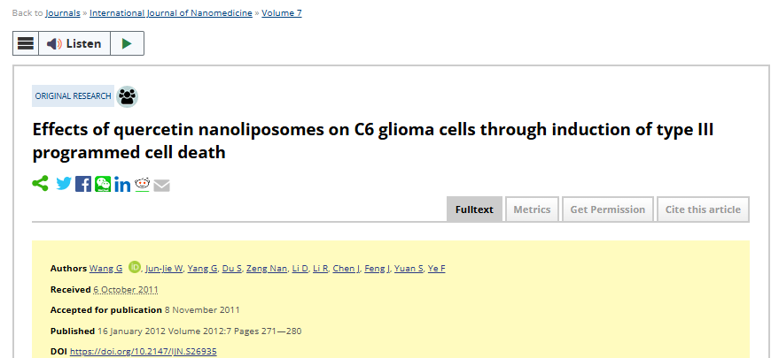

该文章于2024年6月在Pubpeer上被读者质疑：**文章与其他研究发生图片重叠。**

图2A, International Journal of Nanomedicine (2012), doi: 10.2147/ijn.s26935, discussed here: https://pubpeer.com/publications/ADB5EE8499A580181EEFF5FED7985A

图1a, 1b, 1c, Cell Death and Disease (2013), doi: 10.1038/cddis.2013.242, discussed here: https://pubpeer.com/publications/6C338986D0FF7852CD67899DDAC215

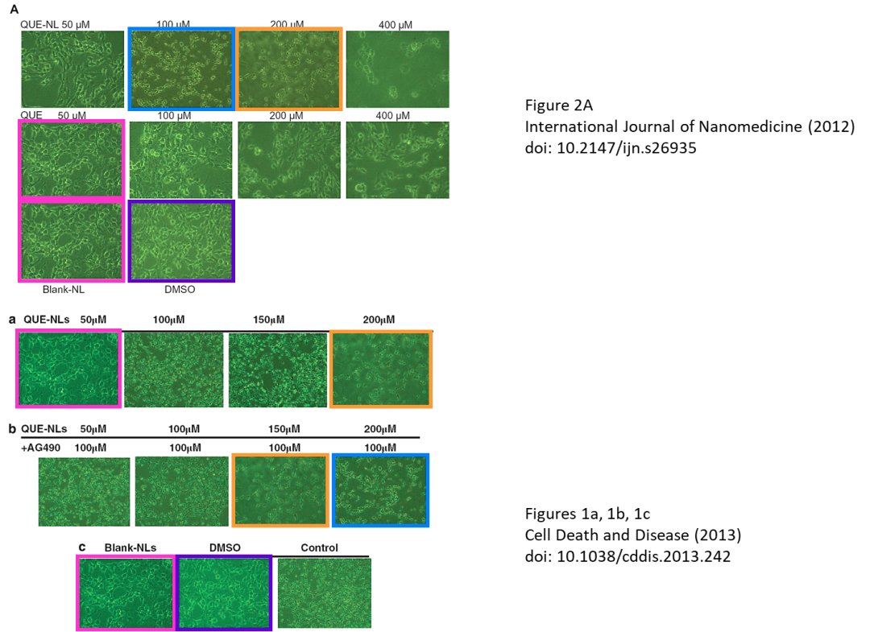

图3C-3E, International Journal of Nanomedicine (2015), doi: 10.2147/ijn.s82282，discussed here: https://pubpeer.com/publications/CAF29F4D25687ADD0D691FD78B392B

图2, BioMed Research International (2015), doi: 10.1155/2015/856349, discussed here: https://pubpeer.com/publications/4BFC40B2A9AD2AD477803E31A1EDED

图4B, International Journal of Molecular Medicine (2016), doi: 10.3892/ijmm.2016.2458, discussed here: https://pubpeer.com/publications/9AB176CEDFAFE52E0446E915670849

图3D, International Journal of Nanomedicine (2012), doi: 10.2147/ijn.s26935, discussed here: https://pubpeer.com/publications/ADB5EE8499A580181EEFF5FED7985A

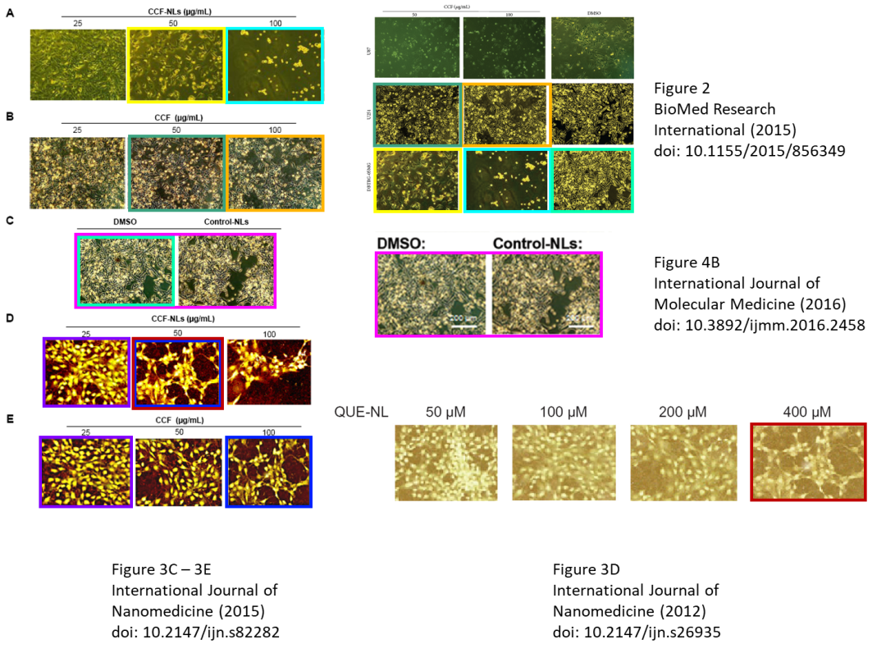

**相关消息**

https://www.pubpeer.com/publications/ADB5EE8499A580181EEFF5FED7985A#