[一区17.3分，三项国自然基金，中山大学附属第一医院&美国西北大学范伯格医学院被质疑图片重复、图像操纵等问题](https://mp.weixin.qq.com/s?__biz=Mzk0NjYzMDcyNQ==&mid=2247513008&idx=5&sn=386272930c2be92b9848d68541be3060&chksm=c29649ec07b92a5d3edcabcd8041d375a1c11a6d9f25b9a0d1ec31049d20c5aef58b3f1af186&scene=126&sessionid=1742577176)

Imagetwin[图片查重指南针](javascript:void(0);)2025-02-11 15:25:50中国台湾

[](http://mp.weixin.qq.com/s?__biz=Mzk0NjYzMDcyNQ==&mid=2247494760&idx=1&sn=9f28762dc91428c028f15e4f752f2e88&chksm=c3019542f4761c5449a4b653c431eba3a2d17317fed2115923f1044eabc511f4a936059ae166&scene=21#wechat_redirect)

***01***

**论文信息**

2021年3月4日，中山大学附属第一医院神经外科&美国西北大学范伯格医学院神经内科在Nature Cell Biology(一区 IF=17.3)发表题为“cCircular RNA-encoded oncogenic E-cadherin variant promotes glioblastoma tumorigenicity through activation of EGFR-STAT3 signalling”的论文。该论文涉嫌2处图片重复。

通讯作者：中山大学第一附属医院Nu Zhang, 美国西北大学范伯格医学院Shi-Yuan Cheng,

第一作者：中山大学附属第一医院Xinya Gao, Xin Xia, Fanying Li, Maolei Zhang

基金支持：本研究部分得到了国家自然科学杰出青年基金（81822033 to N.Z.）、国家重点研发计划（2016YFA0503000 to N.Z.）、国家自然科学基金（81572477 and 81772683 to N.Z.）、广东省创新创业研究团队计划（2016ZT06S638 to B.L.）以及西北医学中心 Lou and Jean Malnati 脑肿瘤研究所（S.-Y.C.）的支持。

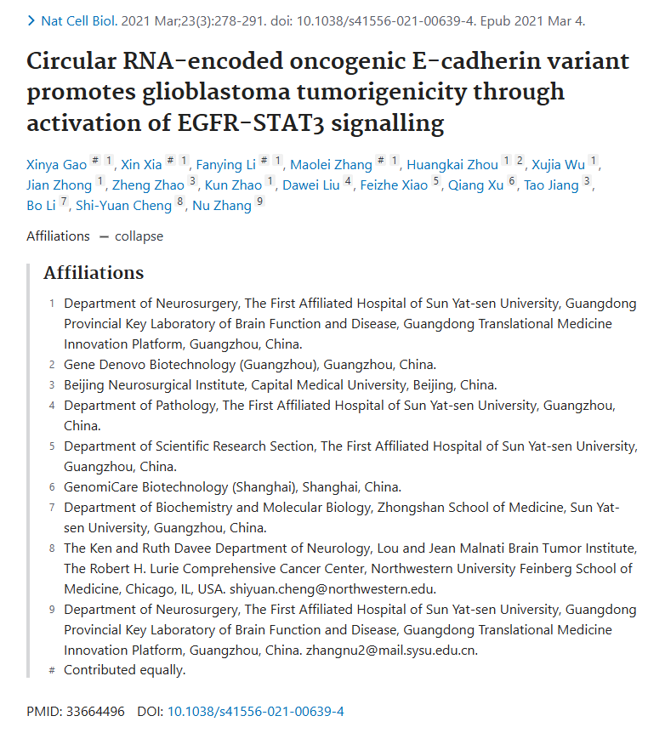

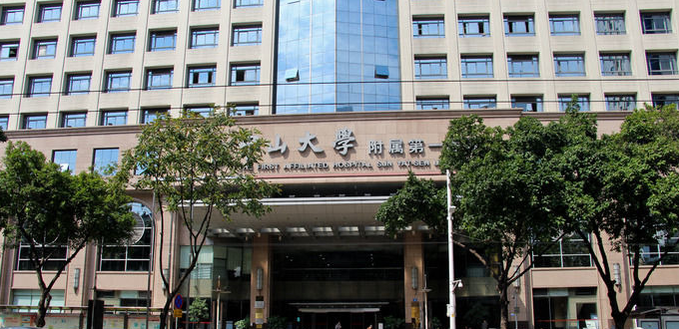

***02***

**质疑信息**

**质疑一：Ext. Fig5中存在图片重复。**

In Ext. Fig5, there were image duplications.

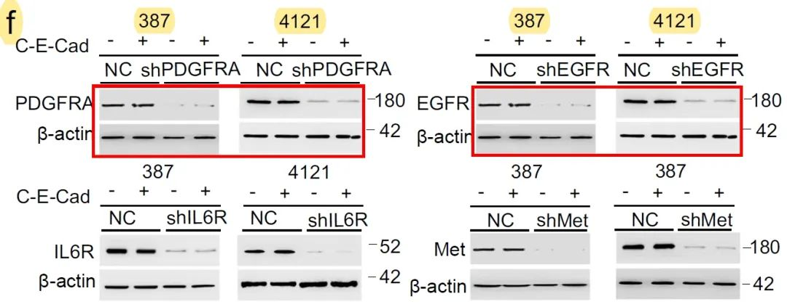

Imagetwin全网查(如需要查重服务，请联系文末客服微信)

**作者Nu Zhang回应：**感谢您对我们论文中数字问题的善意提醒。这些重复并不是故意的。当我们回看原始数据时，才发现我们在拼图时贴错了图片。不过，由于出版方的原因，我们在论文定稿时同时将源数据上传到了《Nature Cell Biology 》。正确的 Ext. 图 5f 如下所示，您也可以从 Nature cell biology 网站下载。在修改过程中，由于时间紧迫，最终版本没有经过其他作者的充分审阅，敬请谅解。我们再次对错误表示诚挚的歉意。

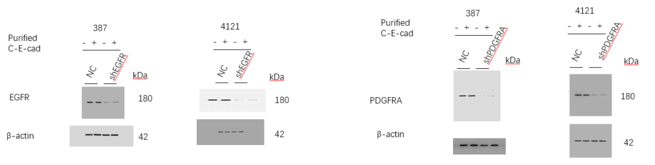

Imagetwin全网查(如需要查重服务，请联系文末客服微信)

**质疑二：图6D两个类似豌豆状的电泳图实际一模一样，作者只是通过根据同一图像调整亮度来制造不一致的表象。当右侧图像的亮度增加约 70% 时，可以清楚地发现两张图像来自相同的 DNA 电泳结果。**

Another issue, involved in Extended Data Figure 6d: DNA gel electrophoresis of RT-PCR for EGFR in GSC17-WT, 17-KO, NSC-WT, and NSC-KO cells.

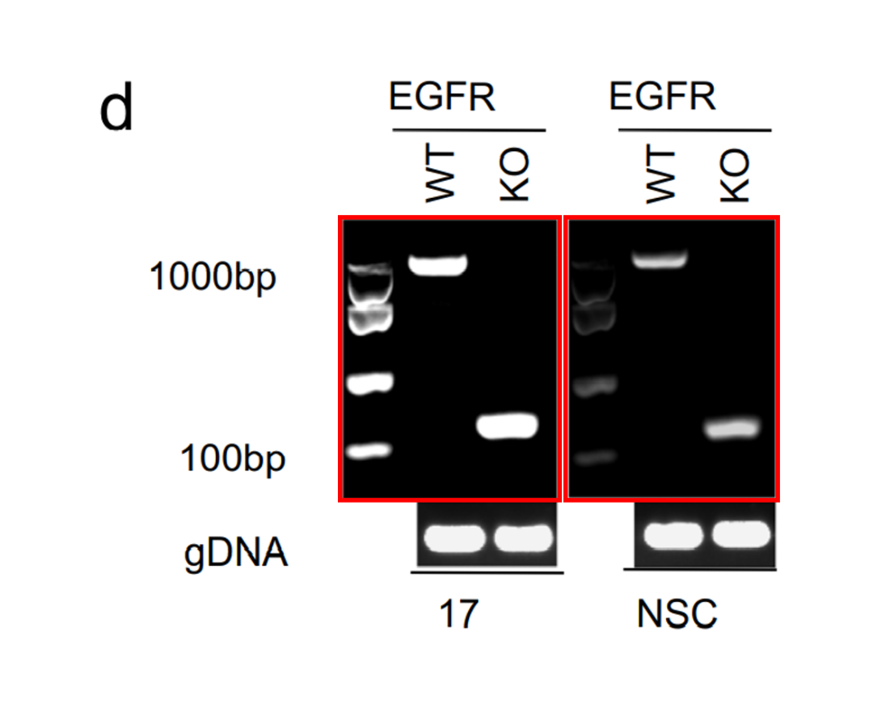

Imagetwin全网查(如需要查重服务，请联系文末客服微信)

As like as two peas, the two red boxes of DNA electrophoresis were exactly the same actually. The authors just made the appearance of inconsistency by adjusting the brightness based on the same image. When the brightness of the image on the right is increased by about 70%, it could be clearly found that the two images were from the same DNA electrophoresis result.

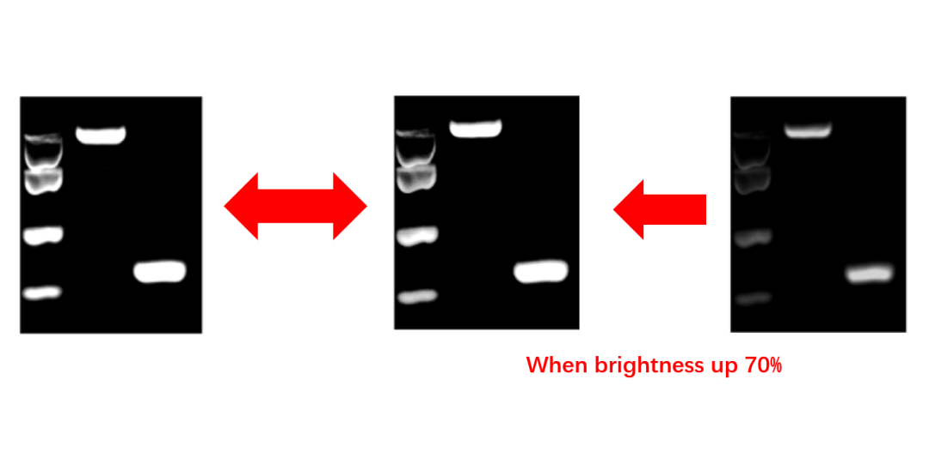

Imagetwin全网查(如需要查重服务，请联系文末客服微信)

作者Xinya Gao回应：我是本文的第一作者。感谢您指出这个问题。我们检查了原始数据，证实这确实是一个错误。我们在拍摄凝胶图像时，将 GSC17 和 NSC 的高曝光和低曝光图片保存在同一个文件夹中。我们在图组装过程中错误地将其粘贴到了源数据和 Ext.Fig.6d 中。我们对自己的粗心表示诚挚的歉意。但请注意，我们也提供了 NSC K.O. 细胞的 IB 和 Sanger 测序结果，因此数据完整性和结论不受影响。我们稍后会在 NCB 上发布勘误。

**质疑三：Extended Data Figure 2g中的患者数量和生存曲线数据存在疑问，C-E-Cad高组和低组之间的数字在左右生存图中不一致**

Extended Data Figure 2g was confusing, the authors stated in the figure legends that , Two-sided, Log-rank analysis of GBM patients (n?=?45) biologically independent samples) from cohort 3 correlated with C-E-Cad levels (left); CGGA database with C-E-Cad levels (middle) and E-Cad levels (right)

CGGA database with C-E-Cad levels in the middle panel, the number of patients was 45? Please be noted that 45 was the number for cohort 3.

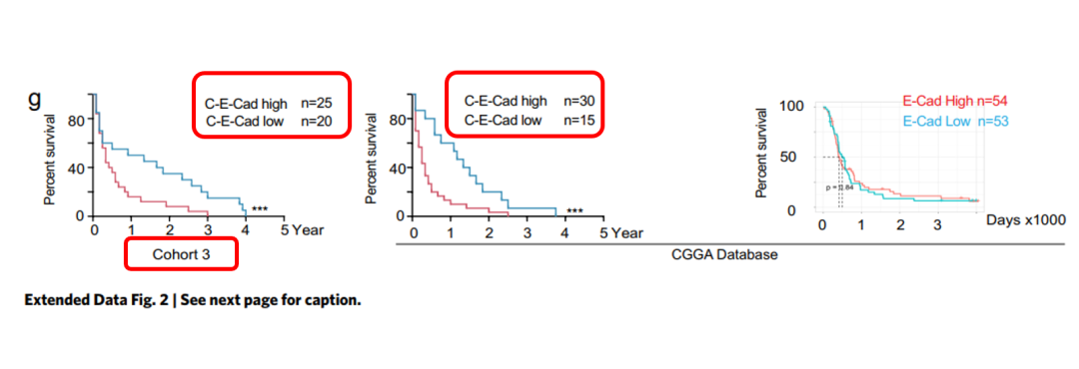

Imagetwin全网查(如需要查重服务，请联系文末客服微信)

**质疑四：为什么在第 3 组中，C-E-Cad 高组和 C-E-Cad 低组之间的数字在左右生存图之间不一致，如下所示：**

Also, one more question, why the numbers in cohort 3, between the C-E-Cad high group and C-E-Cad low group, were inconsistent between the left and right survival plots, as follows:

25 vs 20? or 30 vs 15?

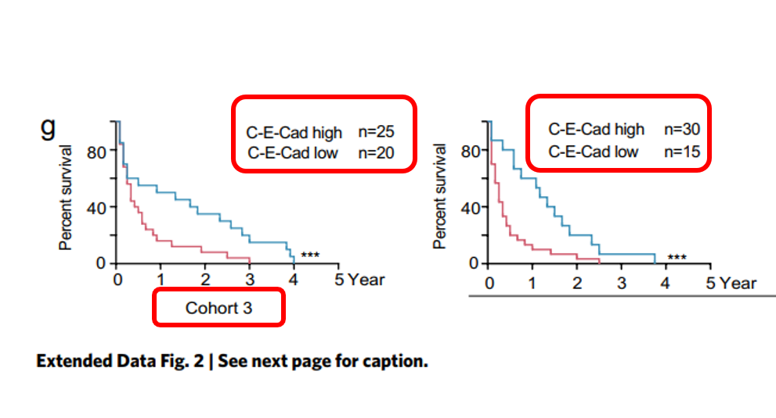

Imagetwin全网查(如需要查重服务，请联系文末客服微信)

**作者Xinya Gao回应质疑三和质疑四：**感谢您的提问。请注意，群组 3 和 CGGA 样本是独立的群组，我们从中各随机抽取了 45 个样本。

**质疑五：图2E：作者试图用自己的样本来证明 E-Cad（CDH1）在正常组织中的高表达。然而，这一结果与 TCGA 数据库完全相反。验证了 E-cad 在 GBM 中的生存分析，但作者刻意回避了 TCGA 数据库中 E-cad 在 GBM 和正常组织中的表达对比结果，只使用了自己的样本进行对比。**

**在 TCGA 数据库中，E-cad 在肿瘤组织中略有上调，但在作者自己的标本中却有非常明显的下降，这只是为了突出 C-E-Cad 的作用，而这是作者在**本**文中新报道的。**

Figure 2E

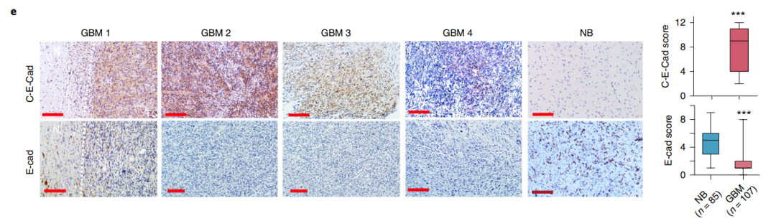 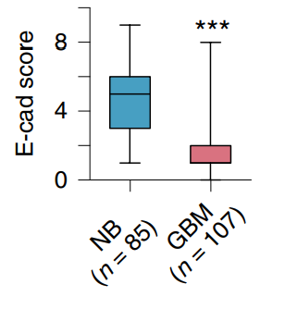

Imagetwin全网查(如需要查重服务，请联系文末客服微信)

The authors tried to use their own samples to testify that E-Cad (CDH1) is high expressed in the normal tissue. However, this result is completely opposite to the TCGA database

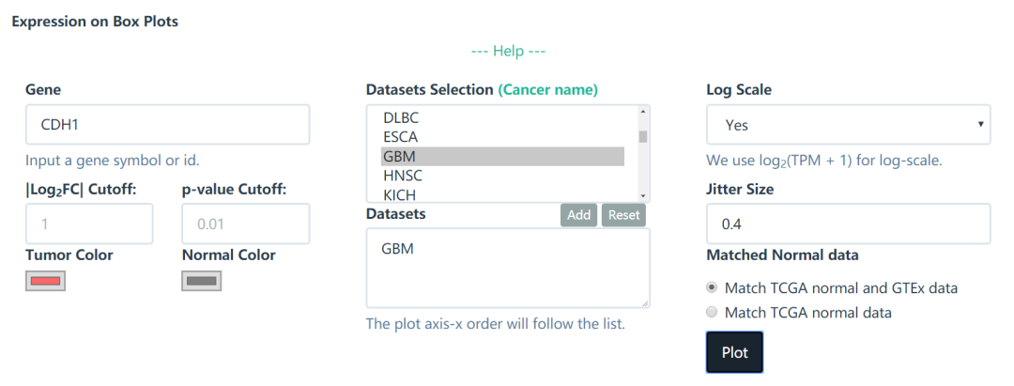 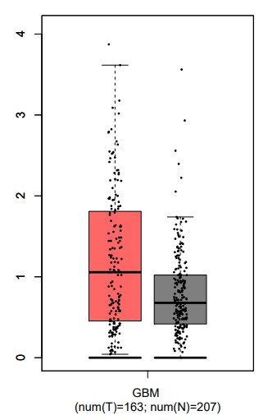

Imagetwin全网查(如需要查重服务，请联系文末客服微信)

The author then used TCGA database to verify the survival analysis of E-cad in GBM in the subsequent Fig. 2F, but the author deliberately avoided the comparison results of E-cad expression between GBM and normal tissues by the TCGA database, only used their own samples for comparison.

In TCGA database, E-cad was slightly up-regulated in tumor tissues, but it did decrease very significantly in the author's own specimens, just to highlight the effect of C-E-Cad? which was newly reported by the authors in this paper

**作者Xinya Gao回应：**TCGA 不包含循环 RNA-seq 数据。正如您所提到的，E-cad RNA 在 TCGA GBM 中仅轻微上调（不显著），但在我们的样本中，E-cad 蛋白（通过 IHC）却下调了。可能还有其他机制导致了这种下调。

**质疑六：注意到队列 3 和 CGGA 样本是独立的队列。那么，标为红色的 CGGA 数据库包括中间和右边的面板吗？**

Thanks for your relpy. I have noticed that cohort 3 and CGGA samples were independent cohorts. Then, the CGGA database marked in red included the middle and the right panels?

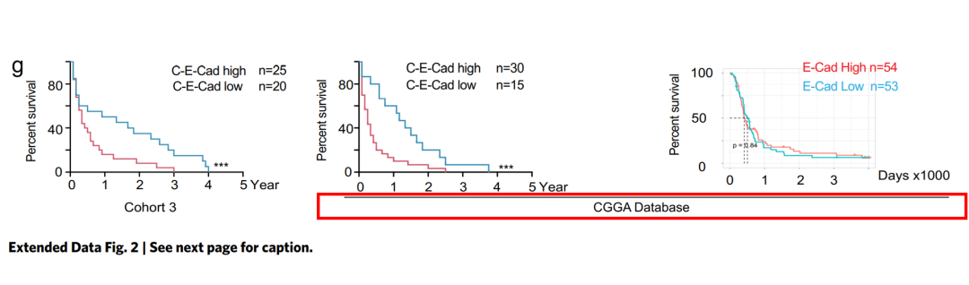

Imagetwin全网查(如需要查重服务，请联系文末客服微信)

**质疑七：至于作者基于 CGGA 数据的分析，读者也访问了数据库，但无法重复作者的结果，无论是原发性还是复发性，或者是不同阶段的结果。**

As for your analysis based on the CGGA data, I have also accessed to the database, however, I could not repeat your results, whether for the primary or the recurrent, or in different stages. Kindly upload your analysis process？

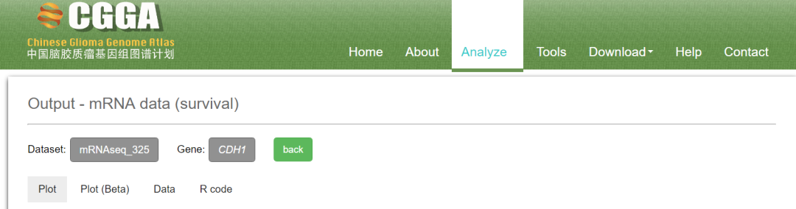 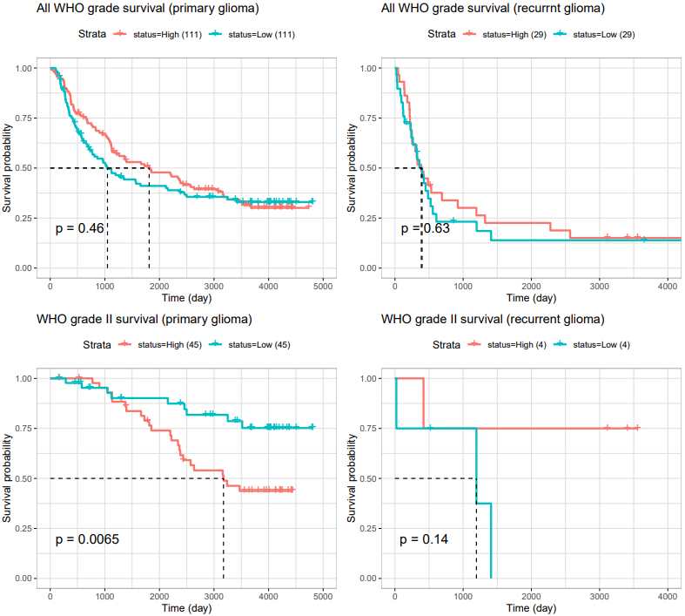 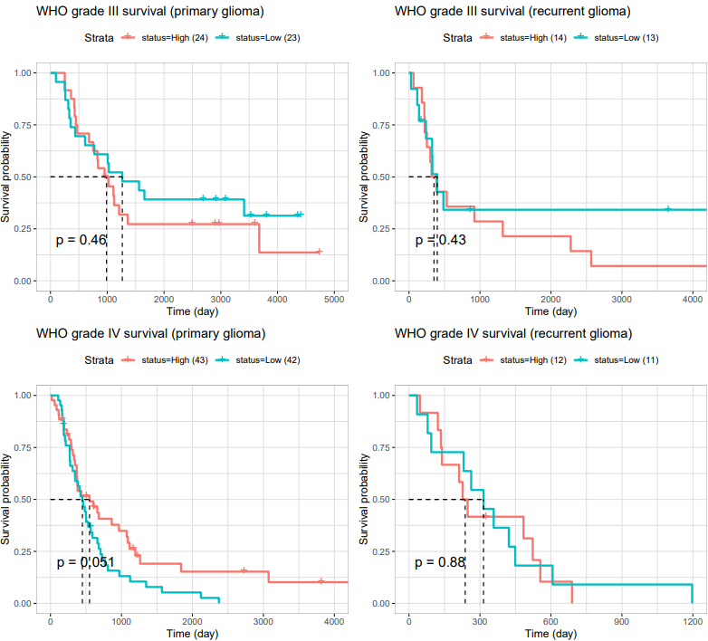

Imagetwin全网查(如需要查重服务，请联系文末客服微信)

**质疑八：作者能否具体说明您在 CGGA 数据库中使用了哪些数据进行分析？**

Could the authors specify which data you used for analysis, in CGGA database?

link for CGGA database: http://www.cgga.org.cn/index.jsp

Of note was the observation that in your paper, the Extended Figure 2G, The patient number of E-Cad high group was 54, E-Cad low group was 53. 54+53=97

The problem is the number of 97, which is the corresponding dataset in CGGA database?

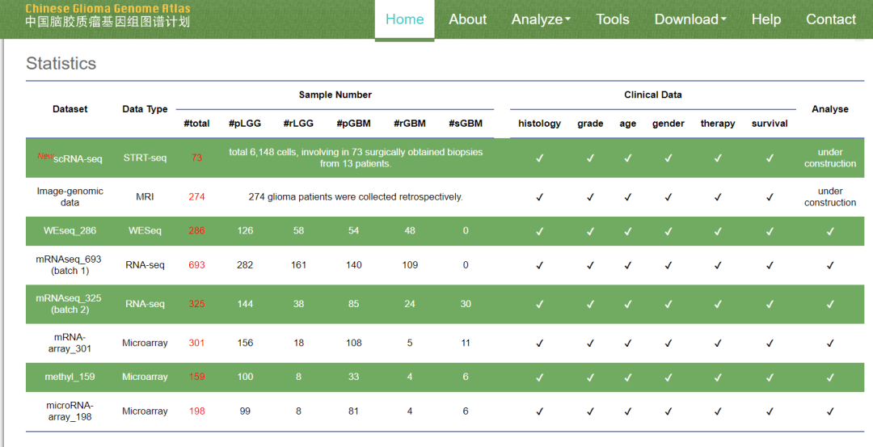

Imagetwin全网查(如需要查重服务，请联系文末客服微信)

**质疑九：**值得注意的是，在您的论文扩展图 2G 中，E-Cad 高组患者人数为 54 人，E-Cad 低组患者人数为 53 人。54+53=107。问题在于 107 这个数字，CGGA 数据库中对应的数据集是哪个？

Of note was the observation that in your paper, the Extended Figure 2G, The patient number of E-Cad high group was 54, E-Cad low group was 53. 54+53=107

The problem is the number of 107, which is the corresponding dataset in CGGA database?

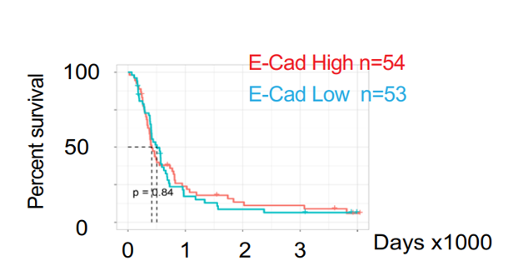Imagetwin全网查(如需要查重服务，请联系文末客服微信)

**质疑十：图作者应解释基于 CGGA 数据库的 mRMA 微阵列和 mRNA 序列在 GBM（即 WHO IV 级胶质瘤）中 E-Cad 表达结果之间的差异。**

Finally, I have found that the authors used the mRNA_array_301 dataset, the WHO IV glioma, to demonstrated the Extended Figure 2G, as follows:

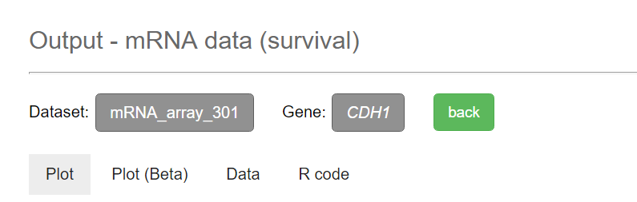 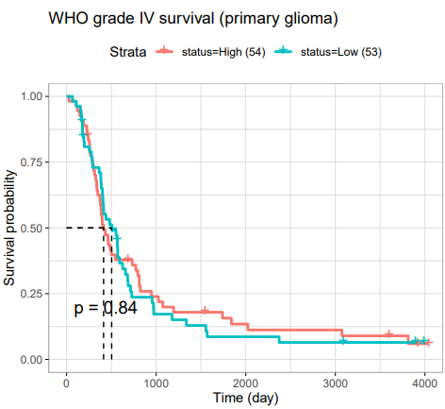

Still, why not use the result from mRNAseq_325?

Please be noted that in mRNAseq_325 dataset there was a significantly better survival result in E-Cad high group as compared with low group, P = 0.05.

The authors should explain the difference between the results from mRMA micro-array and mRNA sequence, based on the CGGA database for E-Cad expression, in GBM, i.e., in WHO IV Grade Glioma.

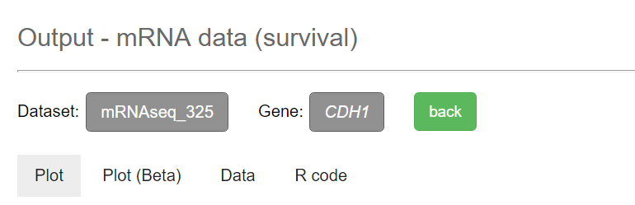 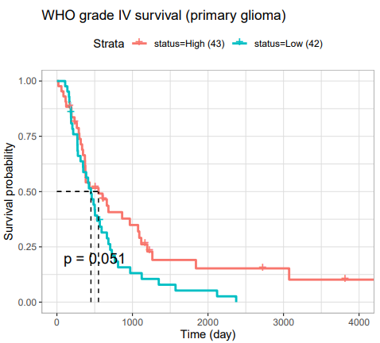

Imagetwin全网查(如需要查重服务，请联系文末客服微信)

**作者Shi-Yuan Cheng回应：**感谢您在本网站上发布的重复电子邮件、评论和作者的回复。我现在知道这些对与此联合出版物相关的数据的评论。我仔细查看了第一作者和最后一位资深作者对所发表评论的回复。我相信这些回复令人满意地解决了每条评论，发布评论的人或您办公室的编辑应该发布您的回复，要么您接受这些回复，要么您有其他评论要发表。此外，请不要在一分钟内向我发送多封电子邮件，例如五封电子邮件。这不是专业的行为！

另一方面，所有的实验和生物信息学分析都是在中国广州的张博士实验室进行的。作为共同高级作者，我帮助重新组织、重新分析了本研究中提供的大部分数据和图表，进行了多次修改和编辑，在整个提交过程中与张博士一起审查和讨论了所有结果和数据。因此，如果您对本文中的数字和数据有任何其他意见或疑虑，请将您对本文中的数字和数据的意见/问题直接发送给第一作者和张博士。

**质疑十一：除了 WB 条带重复的问题外，您的 PDGFRA 的分子量也是错误的，应该是 190kDa。更重要的是，当读者查看扩展数据图 5 的注释时，发现面板 F 甚至没有注释。**

In addition to the problem of WB bands duplication, the molecular weight of your PDGFRA is also wrong, which should be 190kDa. See: https://www.cellsignal.com/

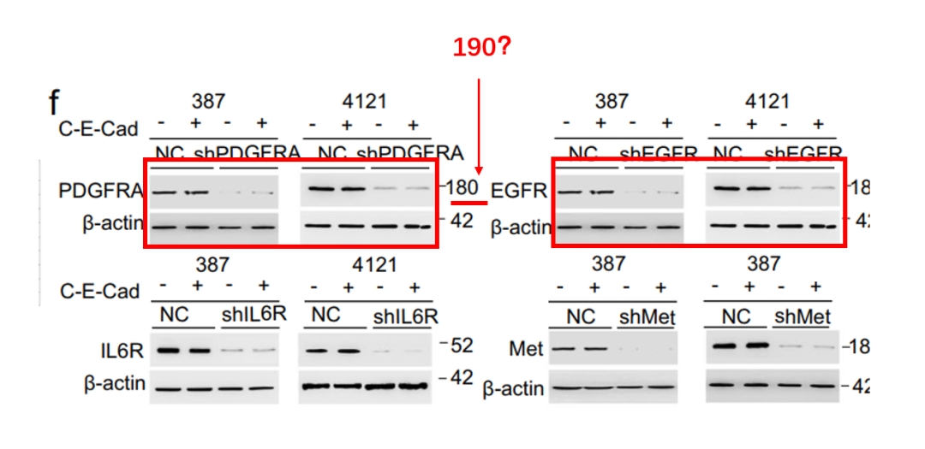

What's more, when I looked at the annotation of Extended Data Fig. 5, I found that there was even no annotation of the panel F.

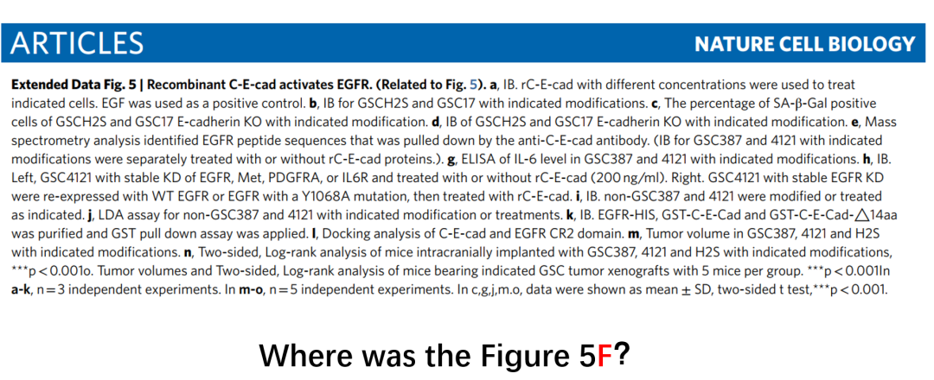

**质疑十二：作者在《Nature cell biology》网站上提到了源数据。遗憾的是，在扩展数据图 5D 中，WB 条带与上传的原始数据不一致。**

The authors have mentioned the source data in the website of Nature cell biology. Unfortunately, Also in Extended Data Fig. 5D, the WB bands were inconsistent with the uploaded source data.

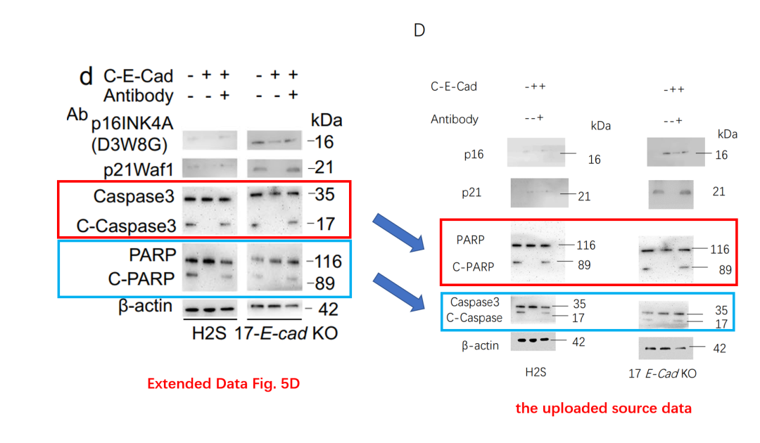

In the uploaded original source data (right), the WB bands for PARP have turned into Caspase3 in the Extended Figure 5D, the WB bands for Caspase3 have turned into PARP.

When enlarged:

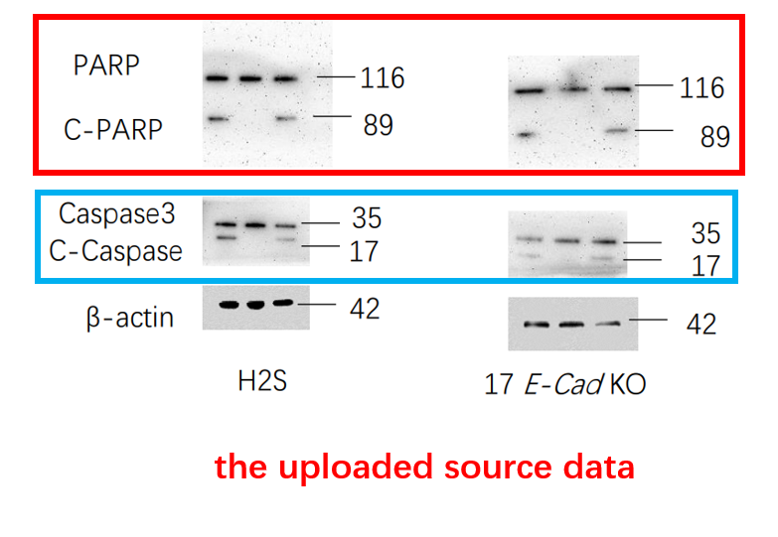

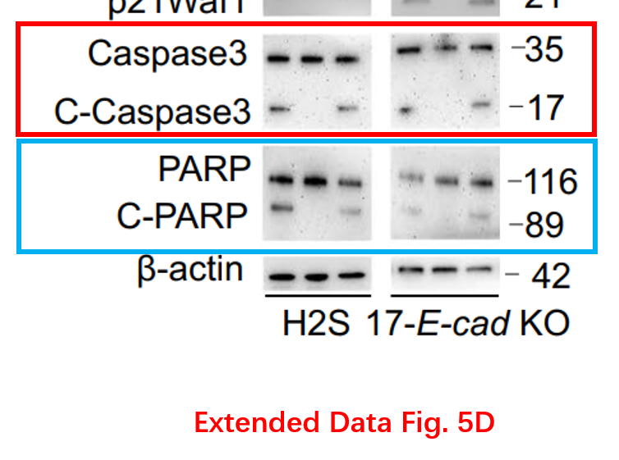

**质疑十三：发现了更多出乎意料的相似图片，包括同一只小鼠被稍微调整位置并以不同强度拍摄的情况，以及视野被稍微移动、图像被拉伸的免疫荧光图像。**

I’ve discovered even more pictures that are unexpectedly similar, including instances where the same mouse was slightly repositioned and photographed at different intensities, as well as immunofluorescence images where the field of view was slightly shifted and the images were stretched.

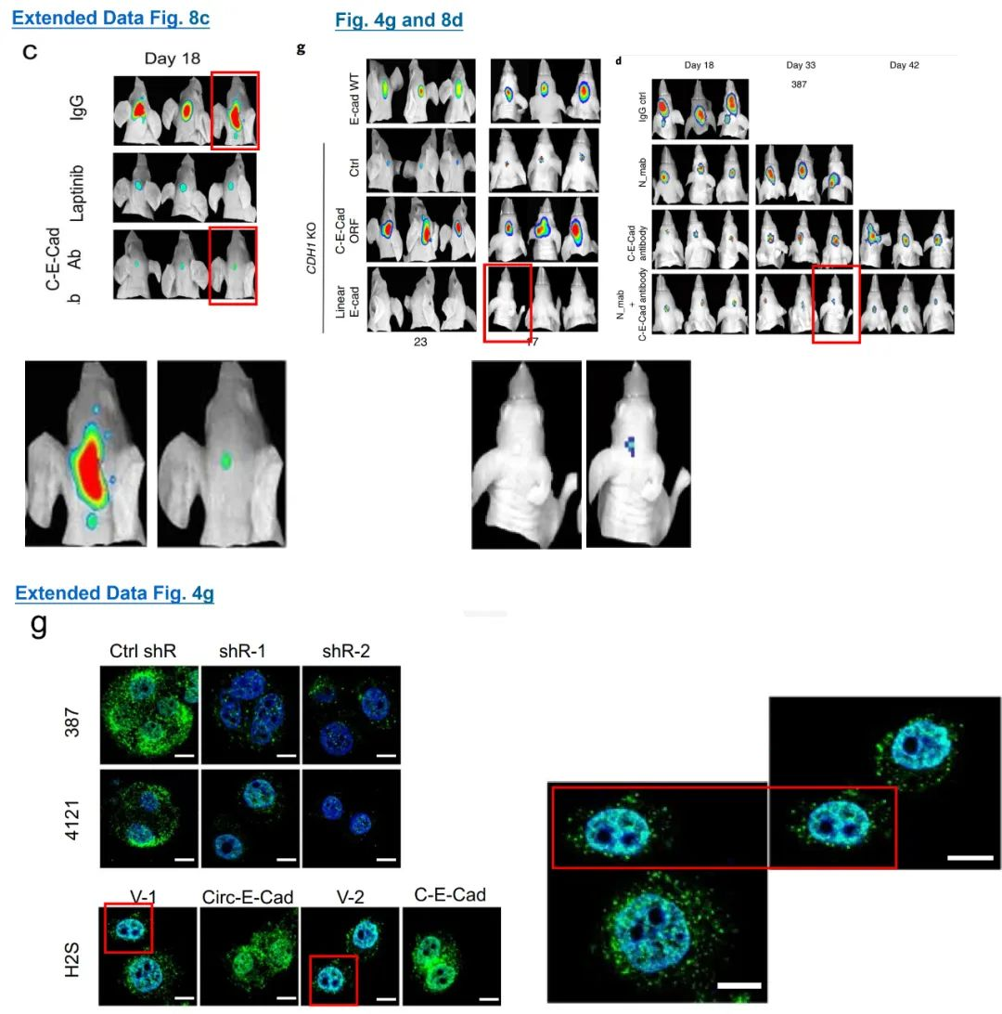

**参考信息：**

https://pubpeer.com/publications/83597B2134196D50E1E29F51DE9BFC#

https://www.sciencedirect.com/science/article/abs/pii/S0144861724008919?via%3Dihub

**论文图片Imagetwin查重服务**

**请添加查重部客服微信：figfig04**



*#*

***往期精选***

[城门失火，殃及池鱼| 涨知识，非洲大草原上的蚂蚁如何打败狮子：物种入侵的危害](http://mp.weixin.qq.com/s?__biz=Mzk0NjYzMDcyNQ==&mid=2247484248&idx=1&sn=efcb850740bbd8ee6c629083ae619143&chksm=c3027a72f475f3647667d2a9e1fbe818aad2c33b31900d659367fa4a3d2eb5173f2064594d0e&scene=21#wechat_redirect)

[近日Onco Targets and Therapy接连撤稿数篇，本周涉四川省人民医院李刚教授文章，与两篇论文图片重复](http://mp.weixin.qq.com/s?__biz=Mzk0NjYzMDcyNQ==&mid=2247483976&idx=1&sn=86c777790b9ce247fc6f6f2222d5f9ec&chksm=c3027b62f475f274a8edb2faa25c84963ec7cb13964abbc6a95826dbd00c23c8ecee533c008f&scene=21#wechat_redirect)

[猎杀狼保护牲畜？可能会适得其反](http://mp.weixin.qq.com/s?__biz=Mzk0NjYzMDcyNQ==&mid=2247484011&idx=1&sn=c66c081849cf2df587aa956f14f783dc&chksm=c3027b41f475f2579f223d5f58c14d6000fc335b1147f43d6c7f76d056e1f6c4819a8373d34f&scene=21#wechat_redirect)

[DOVE期下期刊近期撤稿和质疑高发，重点警惕，南京医科大学附属第一医院顾艳宏等人文章因多处图片重复被质疑](http://mp.weixin.qq.com/s?__biz=Mzk0NjYzMDcyNQ==&mid=2247484009&idx=1&sn=4dfc09a43150b1356296a6168ecab3e7&chksm=c3027b43f475f255ee985a4fb8b1cdd70dc1f242c88256f7c3feb221c27ea241b21eb469cfa4&scene=21#wechat_redirect)

[**Science最新封面研究！人类使用的植物都分布在哪里？**](http://mp.weixin.qq.com/s?__biz=Mzk0NjYzMDcyNQ==&mid=2247484011&idx=1&sn=c66c081849cf2df587aa956f14f783dc&chksm=c3027b41f475f2579f223d5f58c14d6000fc335b1147f43d6c7f76d056e1f6c4819a8373d34f&scene=21#wechat_redirect)

[校园霸凌导致逃避心理VS被打败的老鼠会绕道走！最新Nature重磅成果——专门的下丘脑催产素回路控制厌恶性社交学习](http://mp.weixin.qq.com/s?__biz=Mzk0NjYzMDcyNQ==&mid=2247483926&idx=1&sn=2682074fbb929764c19c443b8ed201cc&chksm=c3027b3cf475f22ade8694c4d47208f404ed9449d1866abbaa4b9a310106083dd7ca6f42a8bf&scene=21#wechat_redirect)

[世界领先！柳叶刀-复旦大学舒易来教授团队成果，恢复先天性耳聋儿童听力的临床试验取得成功](http://mp.weixin.qq.com/s?__biz=Mzk0NjYzMDcyNQ==&mid=2247483964&idx=1&sn=ef6f936d8a44515d9e4dca1b0ad92cb1&chksm=c3027b16f475f200351f2bb3586a87b58d2ba5a14220c09b21a2323155f8ca36a30ee1697b90&scene=21#wechat_redirect)

[和早期发表论文图片重复，北京大学人民医院郭卫教授的文章因图片重复被质疑](http://mp.weixin.qq.com/s?__biz=Mzk0NjYzMDcyNQ==&mid=2247484009&idx=2&sn=10798bad49a479fe828e0c49549012ad&chksm=c3027b43f475f25527b711bd629c09ddf0ee7df4b6be8021d70f3a8ccf5062fd0ba0e3299198&scene=21#wechat_redirect)

[**普通的水也能引发核反应？Science Report新发现！**](http://mp.weixin.qq.com/s?__biz=Mzk0NjYzMDcyNQ==&mid=2247483830&idx=2&sn=537cebf16ad583dbd66f7b3189a53c16&chksm=c302789cf475f18a890d93724d2ac5f2d46b927242fdac92456d4d405e42fa839840ee8375e7&scene=21#wechat_redirect)

[**科研心法| 字字触动科研人的灵魂**](http://mp.weixin.qq.com/s?__biz=Mzk0NjYzMDcyNQ==&mid=2247483653&idx=1&sn=f7be4bed0253bd20d69b549bc1371b98&chksm=c302782ff475f139ced644ce446311f6444100157db60ffcbb33a81d844cd3bbd068315d108b&scene=21#wechat_redirect)

[**疑似数据在不同论文重复使用！国家卫健委直属北京医院国家老年病学中心内分泌科郭立新教授等发表的文章被质疑**](http://mp.weixin.qq.com/s?__biz=Mzk0NjYzMDcyNQ==&mid=2247483830&idx=3&sn=19dfc430973d4390f940258997ec5da2&chksm=c302789cf475f18a0ccf7c722741814d9b477fdfa256bfdc97a50cb3538c2a58fe48583ef55a&scene=21#wechat_redirect)

[**一图两用，双双撤稿，深圳大学第一附属医院放射科两篇论文近日被撤稿**](http://mp.weixin.qq.com/s?__biz=Mzk0NjYzMDcyNQ==&mid=2247483765&idx=1&sn=02944f4bc5de4cf631b484fe00fa5440&chksm=c302785ff475f1496244384c1ec34dd2fb9907d59cde4156637810f48dde2b40c908b01dfb88&scene=21#wechat_redirect)

[**通讯作者邮箱有误，论文工厂参与操作图片！聊城市人民医院肿瘤科马丹论文被撤稿**](http://mp.weixin.qq.com/s?__biz=Mzk0NjYzMDcyNQ==&mid=2247483765&idx=2&sn=eff726b58cf0ff803a53cf1b8591f8b6&chksm=c302785ff475f14901bcbb18a9f8134d1bb1fe2cc40ab8c3e418f3f56e4494b8334209ef741c&scene=21#wechat_redirect)

[**第三方参与操纵发表迹象，青岛大学附属医院/四川大学华西口腔医院/复旦大学附属妇产科医院三家单位的论文本周被撤稿**](http://mp.weixin.qq.com/s?__biz=Mzk0NjYzMDcyNQ==&mid=2247483690&idx=1&sn=bc06edadea5ca7926a7155565664a660&chksm=c3027800f475f1161978def48dc683f7964c6f493b03398c7f22a6c6cb9aadd51d0cca34f636&scene=21#wechat_redirect)

[**盗用他人多年前发表图片，上海中医药大学附属第七人民医院被撤稿**](http://mp.weixin.qq.com/s?__biz=Mzk0NjYzMDcyNQ==&mid=2247483690&idx=2&sn=a13ff72bf531150f978d559e5964edd5&chksm=c3027800f475f116462ad6cc0fcea63b0ee700741bedf113c3dbf81250d7a65ae5767ccfa0ce&scene=21#wechat_redirect)