[上海健康医学院知名团队论文图片重复](https://mp.weixin.qq.com/s?__biz=Mzg5MTg0MDc4NQ==&mid=2247493320&idx=2&sn=6aa966c45c984293db8c23121a5f3ded&chksm=ceaac699dbd61ade26e390e0632428897adae50f12f8f6f2bd2c6d764a8f9ad83161ddce13ac&scene=126&sessionid=1742557631)

原创  F[图片重复](javascript:void(0);)2025-03-21 19:41:01广东

**Mesenchymal stem cell-derived exosomes carrying microRNA-150 suppresses the proliferation and migration of osteosarcoma cells via targeting IGF2BP1**

**Translational Cancer Research (2020)**

**PMID:**35117898

**DOI:**10.21037/tcr-20-83

**AUTHORS**

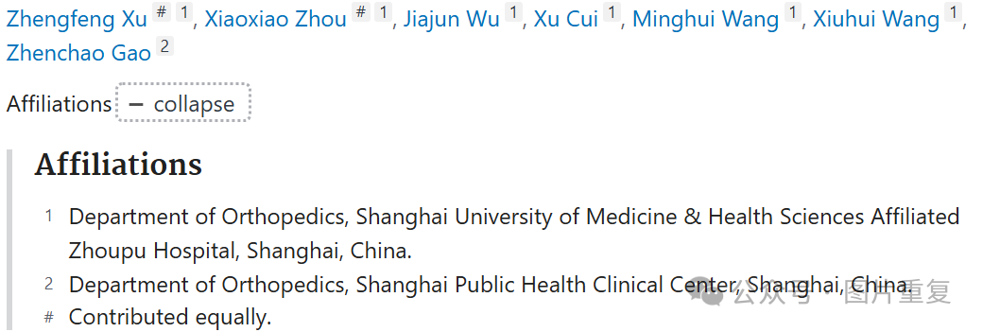

**#1René Aquarius 5 hours ago**

Dear authors,

We found unexpected overlap within one of your figures and between a figure presented in this study and a figure presented in another study (see enclosed image below).

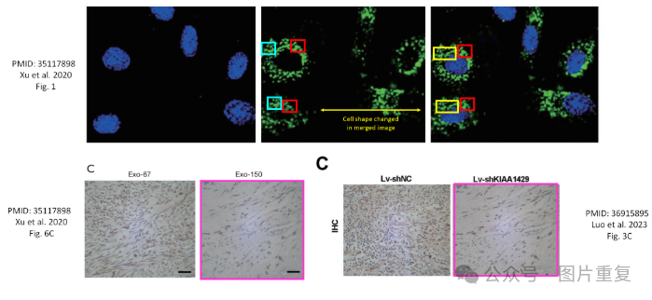

the following studies are affected.

Study 1: https://pubmed.ncbi.nlm.nih.gov/35117898/

Study 2: https://pubmed.ncbi.nlm.nih.gov/36915895/

We will contact the publishers to resolve these issues.

Kind regards,

Rene Aquarius