[南方医科大学知名附属医院论文图片重复](https://mp.weixin.qq.com/s?__biz=Mzg5MTg0MDc4NQ==&mid=2247493179&idx=1&sn=0db5f1be84f4acbdd8f019c73458a24e&chksm=cea03a4b74135e11cb650aaea7576b708578eaae7a2d8931c76da4713f243ae8cc8cf5d94fc0&scene=126&sessionid=1742490466)

原创  F[图片重复](javascript:void(0);)2025-03-12 11:26:28广东

**Deficiency of pseudogene UPAT leads to hepatocellular carcinoma progression and forms a positive feedback loop with ZEB1**

**Cancer science (2020)**

**PMID:**32808348

**DOI:**10.1111/cas.14620

**AUTHORS**

**Leyang Xiang12,Xiaoting Huang3,Siqi Wang4,Huohui Ou5,Zhanjun Chen16,Zhigang Hu1,Yu Huang7,Xianghong Li1,Yawei Yuan3,Dinghua Yang1**

**AFFILIATIONS**

1Unit of Hepatobiliary Surgery Department of General Surgery Nanfang Hospital Southern Medical University Guangzhou China

2Department of Oncology Surgery Affiliated Cancer Hospital & Institute of Guangzhou Medical University Guangzhou China

3Department of Radiation Oncology Affiliated Cancer Hospital & Institute of Guangzhou Medical University Guangzhou China

4Department of gastroenterology Nanfang Hospital Southern Medical University Guangzhou China

5Department of Hepatobiliary Surgery Shunde Hospital Southern Medical University (The First People's Hospital of Shunde) Foshan China

6Department of General Surgery Affiliated Baoan Hospital of Shenzhen Southern Medical University Shenzhen China

7Department of Laboratory Medicine Nanfang Hospital Southern Medical University Guangzhou China

**#1Sholto David 4 day ago**

An image previously appeared elsewhere where it was described as showing a different cell type. I've added the red rectangles to show where I mean. Would the authors please check and comment?

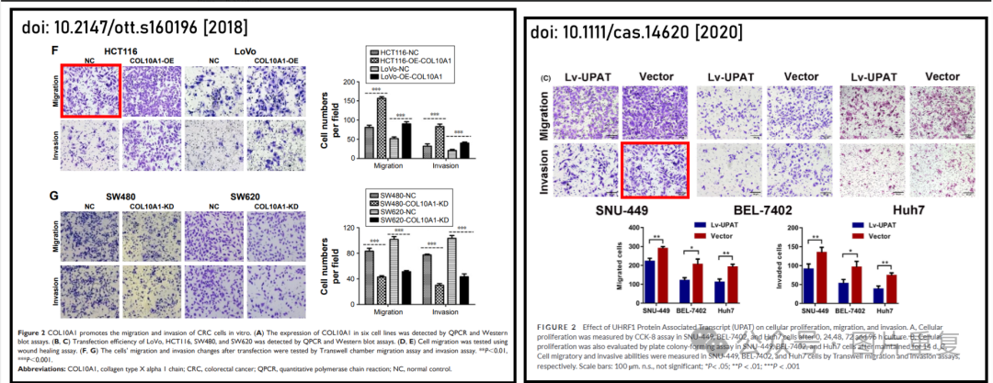

dentified by ImageTwin.ai