[上海中医药大学某研究团队所发文章被质疑发生图片重叠](https://mp.weixin.qq.com/s?__biz=Mzg4OTgzNzAyOA==&mid=2247566140&idx=4&sn=63f1a147c10d7acf63e0c6fe63bfd0b8&chksm=cef6d931ecba93fdb7c88787a3500fb8252cafc371d853794d18d52e91be1ded3dfb0016bde8&scene=126&sessionid=1742315685)

诚信君[iPubpeers](javascript:void(0);)2025-03-16 09:43:58河南



2025 年 1 月 20 日，上海中医药大学 Gu Donghao 研究团队，在***International journal of biological macromolecules***上发表的题为**“N-acetylcysteine and chitosan conjugate modified dexamethasone nanostructured lipid carriers: Enhanced permeability, precorneal retention and lower inflammation for the treatment of dry eye syndrome”**的研究论文，**被质疑文中出现图片重叠。**

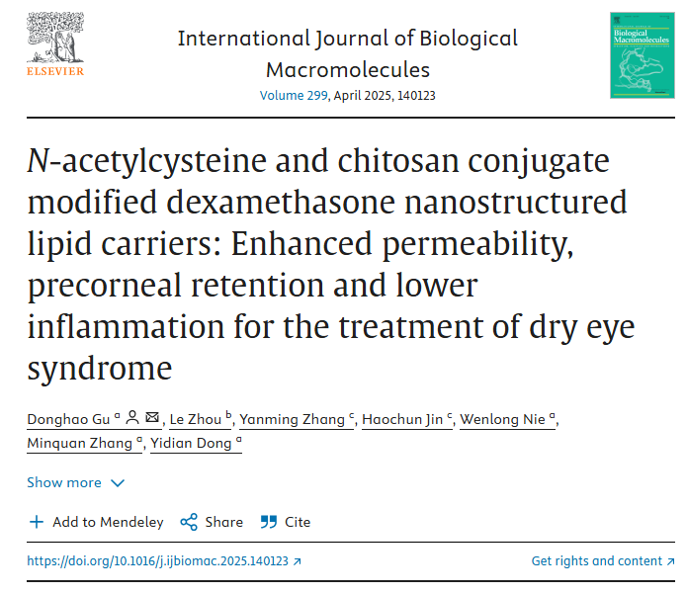

该文章于2025年3月在Pubpeer上被读者质疑：**文章出现图片重叠。**

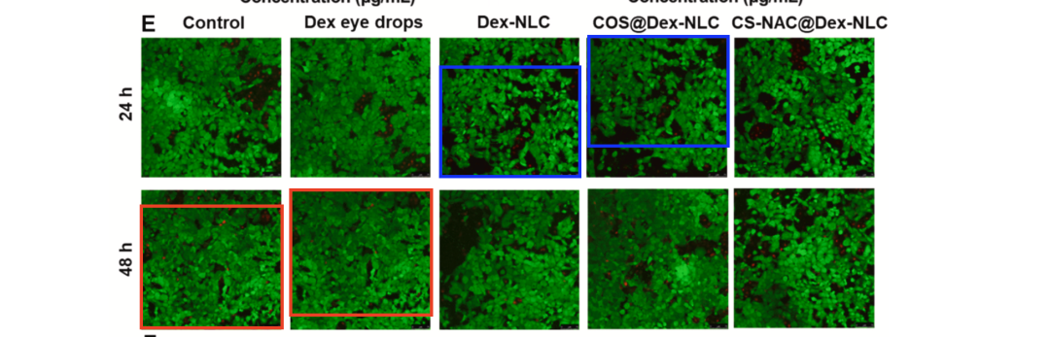

**相关消息**

https://pubpeer.com/publications/650C9515FAC66A4B0FFC8C6D3ABC37#1

图片



**iPubpeers，专注于图片重复报道。**

**投稿事宜：ilovehainan@foxmail.com**

**觉得本文好看，请点这里！**