[天津医科大学生理与病理生理学教研室刘志强团队论文涉嫌学术不端，现作者已诚恳道歉](https://mp.weixin.qq.com/s?__biz=MzkzMzc1Nzg1OQ==&mid=2247486122&idx=2&sn=682a62efec1bfb44fbf5e24ef4af7db6&chksm=c3d15db5c9ca54b30917b1dc7b3ce6c6fb0d75d0e7826ffc53df2c3b304ce8fb3714683e0fd1&scene=126&sessionid=1742315467)

Figure 查重[Figure查重](javascript:void(0);)2025-03-15 10:24:18上海

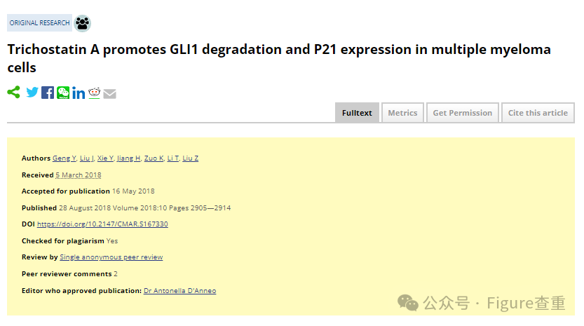

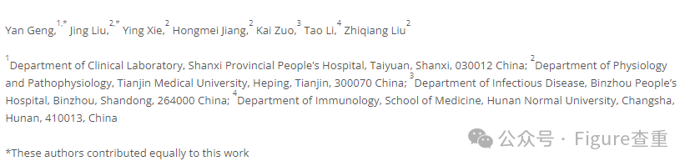

Trichostatin A promotes GLI1 degradation and P21 expression in multiple myeloma cells

Cancer management and research (2018) - 3 Comments  
pubmed: 30214285  doi: 10.2147/cmar.s167330  issn: 1179-1322

Yan Geng , Jing Liu , Ying Xie , Hongmei Jiang , Kai Zuo , Tao Li , Zhiqiang Liu

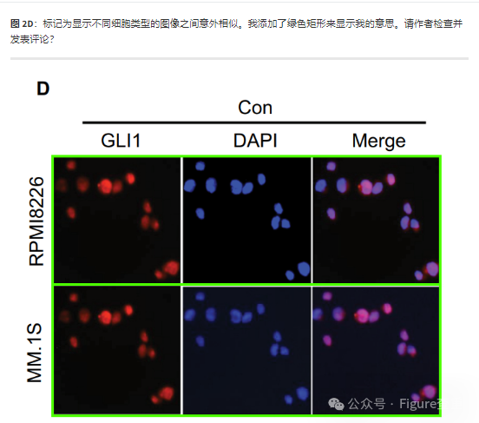

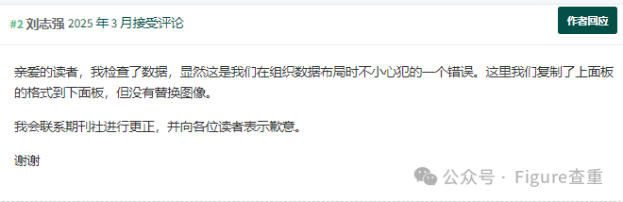

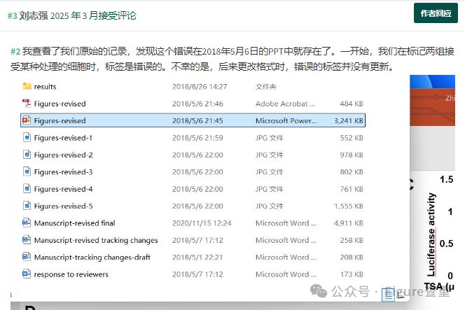

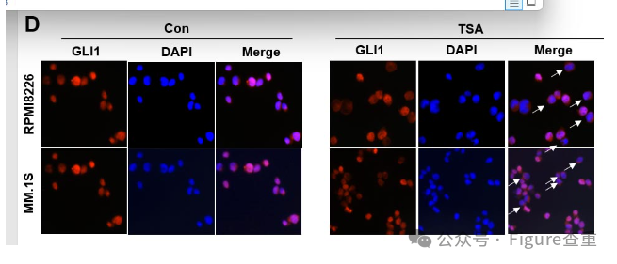

**参考链接：**

https://pubpeer.com/publications/048E963787987E8F12DE93D68D5953#3

**联系我们：**

如果您需要使用Figure查重服务，请扫描下方二维码，添加客服微信，了解更多详情。我们将竭诚为您服务，确保您的科研工作更加高效、可信。

