[大量图片重复——南京中医药大学第二附属医院针灸科论文引热议](https://mp.weixin.qq.com/s?__biz=MzkzMzc1Nzg1OQ==&mid=2247486077&idx=2&sn=f4e96d3382c2bc87bdbf1f8a1991b551&chksm=c34e5122107abf5e420049015abb6b439f3c0ebdda4836f47f70fbed358464569322b3adaee3&scene=126&sessionid=1742315467)

Figure 查重[Figure查重](javascript:void(0);)2025-03-12 12:03:35上海

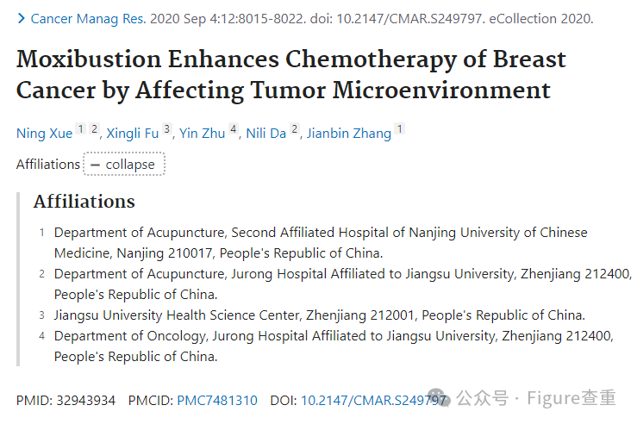

Moxibustion Enhances Chemotherapy of Breast Cancer by Affecting Tumor Microenvironment

Cancer management and research (2020) - 1 Comment  
pubmed: 32943934  doi: 10.2147/cmar.s249797  issn: 1179-1322

Ning Xue , Xingli Fu , Yin Zhu , Nili Da , Jianbin Zhang author has email

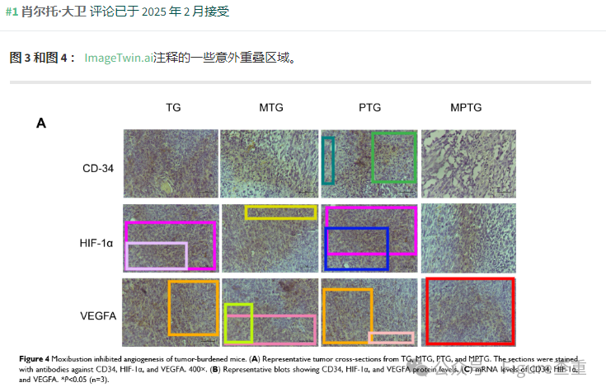

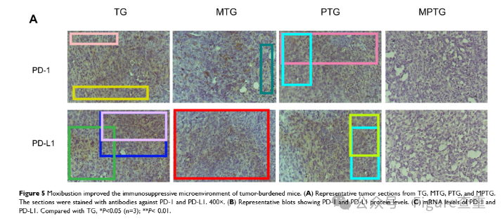

**参考链接：**

**https://pubpeer.com/publications/5843DD4C6223C99008BB4BCEAD814C#1**

**联系我们：**

如果您需要使用Figure查重服务，请扫描下方二维码，添加客服微信，了解更多详情。我们将竭诚为您服务，确保您的科研工作更加高效、可信。

