[南京大学医学院知名附属医院论文图片重复](https://mp.weixin.qq.com/s?__biz=Mzg5MTg0MDc4NQ==&mid=2247493272&idx=1&sn=0353b29a84907372986ac5bdca9a5532&chksm=ceaef8aabb207594683025ba3922519435c4ffa90aebf8a1964d219433ff1f1af4aae8140615&scene=126&sessionid=1742316491)

原创  F[图片重复](javascript:void(0);)2025-03-18 09:06:54广东

**MiR-200b regulates autophagy associated with chemoresistance in human lung adenocarcinoma**

**Oncotarget (2015)**

**PMID:**26416454

**DOI:**10.18632/oncotarget.5352

**AUTHORS**

**Banzhou Pan1,Bing Feng1,Yitian Chen1,Guichun Huang1,Rui Wang1,Longbang Chen1,Haizhu Song1**

**AFFILIATIONS**

1Department of Medical Oncology, Jinling Hospital, School of Medicine, Nanjing University, Nanjing 210002, China.

**#1Hoya Camphorifolia**

**2year ago**

* *[left]*

 Fig 8C from "HMGB1-mediated autophagy promotes docetaxel resistance in human lung adenocarcinoma" (Pan et al 2014).

* *[right]*

**Fig 6C**.

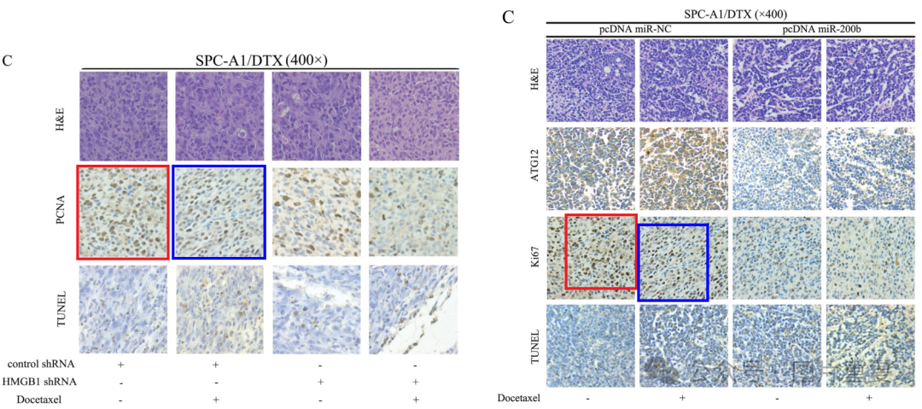Could the authors check whether the indicated panels were stained for Ki67 or for PCNA?

**#2Hoya Camphorifolia**

**2year ago**

Figs 1C, 2G. Elements repeat across panels.

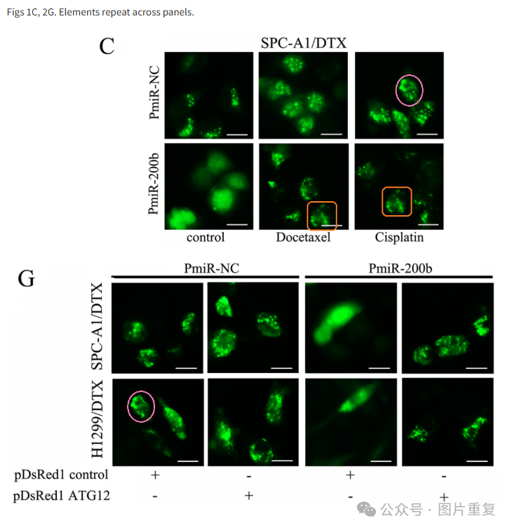

#3**Hoya Camphorifolia**

**2year ago**

* *[left]*

 Fig 4D from Pan et al (2014).

* *[right]*

**Fig 4B**.

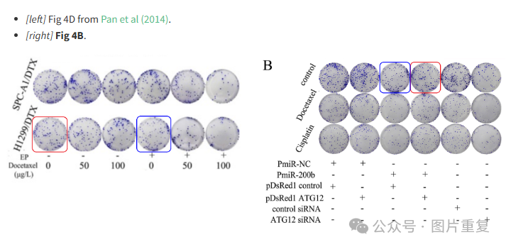

#4**Sholto David**

**2 month ago**

Extending the previous analysis with the pink rectangles.

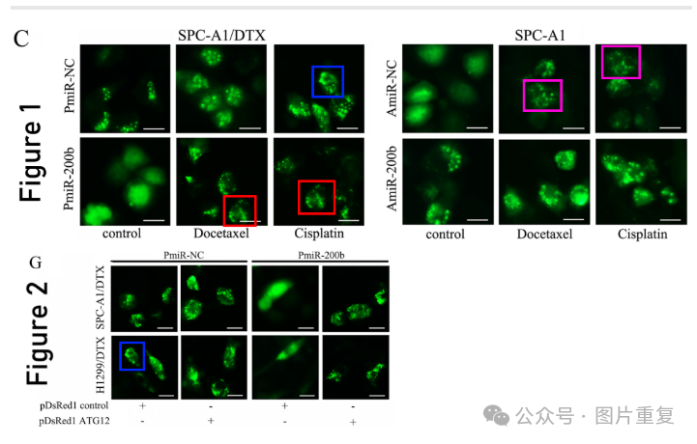

**#5Arceuthobium Divaricatum**

**1 hours ago**

Much more similar than expected. Similarities detected by ImageTwin.

