[郑州大学附属第一医院论文图片重复](https://mp.weixin.qq.com/s?__biz=Mzg5MTg0MDc4NQ==&mid=2247493179&idx=2&sn=7402e5eea614329ce46d6432088f23b7&chksm=cef15c3013a61f5655743bf18c06dee6887b896e1db1a25134acb517749ac8e991fdcfa0e056&scene=126&sessionid=1742316491)

原创  F[图片重复](javascript:void(0);)2025-03-12 11:26:28广东

**Circular RNA midline-1 (circMID1) promotes proliferation, migration, invasion and glycolysis in prostate cancer**

**Bioengineered (2022)**

**PMID:**35212614

**DOI:**10.1080/21655979.2022.2037367

**AUTHORS**

**Yafei Ding1,Mi Wang2,Jinjian Yang1**

**AFFILIATIONS**

1Department of Uropoiesis Surgical, The First Affiliated Hospital of Zhengzhou University, Zhengzhou City, Henan Province, China.

2Department of Anesthesiology, The First Affiliated Hospital of Zhengzhou University, Zhengzhou City, Henan Province, China.

#### Author response 11 day ago

**#1Elisabeth M Bik 19 day ago**

Concern about **Figure 7a**:

* Red boxes: The same ruler may be observed in two other papers. Note scratches at the top left of the "1", and white dots near the "3".
* Blue boxes: The same tumors may be observed in one paper, albeit more recent
* 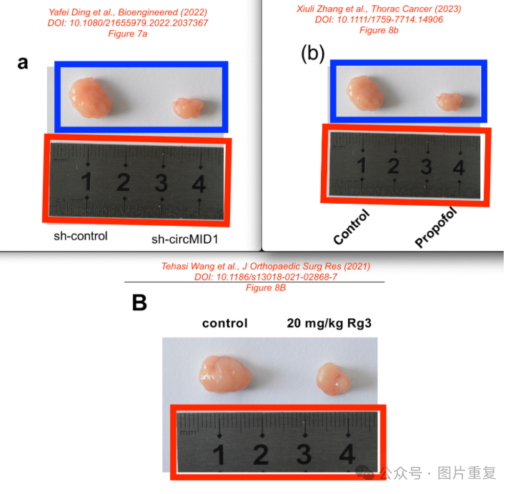

**#2 Jinjian Yang (author)11 day ago**

Dear Dr Elisabeth M Bik , We sincerely appreciate your meticulous review Figure. We have investigated the issues and carefully checked the records. The experiment was conducted in the public laboratory belonged to the First Affiliated Hospital of Zhengzhou University at that time, and the original images and rulers are as follows. I firmly believe that the Figure is accurate and this ruler belongs to our public laboratory. Regarding the issues in other articles, due to the passage of a long time and staff turnover, I'm not sure what caused it.

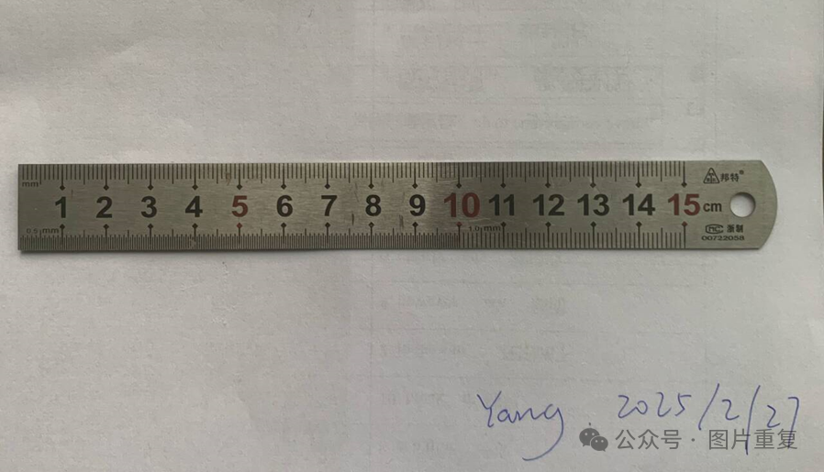

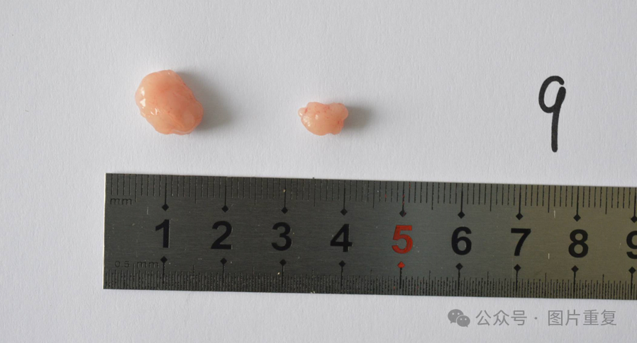

[#郑州大学](https://mp.weixin.qq.com/mp/appmsgalbum?__biz=Mzg5MTg0MDc4NQ==&action=getalbum&album_id=3266355464589295618#wechat_redirect)[#图片重复](https://mp.weixin.qq.com/mp/appmsgalbum?__biz=Mzg5MTg0MDc4NQ==&action=getalbum&album_id=2546994047780667392#wechat_redirect)