[撤稿！湖北医药学院知名学者论文图片重复](https://mp.weixin.qq.com/s?__biz=Mzg5MTg0MDc4NQ==&mid=2247493167&idx=1&sn=126293228e2864279362c2e1aa3321ae&chksm=ce4802646c1ac72621dae97dede01db55c3e12a455f47bcec5b3ebb4f24c5b15c84969c96262&scene=126&sessionid=1742316491)

Fu[图片重复](javascript:void(0);)2025-03-11 18:21:00广东

## LncRNA FEZF1-AS1 Modulates Cancer Stem Cel Properties of Human Gastric Cancer Through miR-363-3p/HMGA2

**Cell Transplantation (2020)**

**PMID:**32638620

**DOI:**10.1177/0963689720925059

**AUTHORS**

**Yuanjian Hui1,Yan Yang1,Deping Li2,Juan Wang3,Maojun Di1,Shichao Zhang4,Shasha Wang4**

**AFFILIATIONS**

1Department of General Surgery, Taihe Hospital, Hubei University of Medicine, Shiyan City, China

2Department of Gastroenterology, Taihe Hospital, Hubei University of Medicine, Shiyan City, China

3Department of Vasculocardiology, Taihe Hospital, Hubei University of Medicine, Shiyan City, China

4Department of Pediatrics, Taihe Hospital, Hubei University of Medicine, Shiyan City, China

**#1Hoya Camphorifolia 3 month ago**

Retracted, 27 November 2024, as part of a mass retraction.

At the request of the Journal Editor and Publisher, the following articles have been retracted

* Zhang T, Zhang L, Han D, Tursun K, Lu X. Circular RNA hsa_Circ_101141 as a competing endogenous RNA facilitates tumorigenesis of hepatocellular carcinoma by regulating miR-1297/ROCK1 pathway. Cell Transplantation. 2020;29. doi:10.1177/0963689720948016.
* Du C, Wang Y, Zhang Y, Zhang J, Zhang L, Li J. LncRNA DLX6-AS1 contributes to epithelial–mesenchymal transition and cisplatin resistance in triple-negative breast cancer via modulating miR-199b-5p/paxillin axis. Cell Transplantation. 2020;29. doi:10.1177/0963689720929983.
* Wan Q, Chen Q, Cai D, Zhao Y, Wu X. OTUB2 promotes homologous recombination repair through stimulating Rad51 expression in endometrial cancer. Cell Transplantation. 2020;29. doi:10.1177/0963689720931433.
* Li W, Yang X, Shi C, Zhou Z. Hsa_circ_002178 promotes the growth and migration of breast cancer cells and maintains cancer stem-like cell properties through regulating miR-1258/KDM7A axis. Cell Transplantation. 2020;29:. doi:10.1177/0963689720960174.
* Liu G, Guo W, Rao M, Qin J, Hu F, Li K. circRNA hsa_circ_104566 sponged miR-338-3p to promote hepatocellular carcinoma progression. Cell Transplantation. 2020;29. doi:10.1177/0963689720963948.
* Li J, Yu Z, Zhu Q, Tao C, Xu Q. hsa_circ_102559 acts as the sponge of miR-130a-5p to promote hepatocellular carcinoma progression through regulation of ANXA2. Cell Transplantation. 2020;29. doi:10.1177/0963689720968748.
* Li J, Yang Y, Xu D, Cao L. hsa_circ_0023409 accelerates gastric cancer cell growth and metastasis through regulating the IRS4/PI3K/AKT pathway. Cell Transplantation. 2021;30. doi:10.1177/0963689720975390.
* Wang Y, Yin L. LINC00461 promoted endometrial carcinoma growth and migration by targeting MicroRNA-219-5p/cyclooxygenase-2 signaling axis. Cell Transplantation. 2021;30. doi:10.1177/0963689721989616.
* Wu J, Wang X, Yuan X, et al. Kinesin family member C1 increases temozolomide resistance of glioblastoma through promoting DNA damage repair. Cell Transplantation. 2021;30. doi:10.1177/0963689721991466.
* Hui Y, Yang Y, Li D, et al. LncRNA FEZF1-AS1 modulates cancer stem cell properties of human gastric cancer through miR-363-3p/HMGA2. Cell Transplantation. 2020;29. doi:10.1177/0963689720925059.

After an internal investigation, Sage has become aware that the submissions contain indicators of third-party involvement. Due to concerns around author contributions to the articles, as well as concerns around the integrity of the research process, Sage and the Journal Editor retract the articles.

The authors have been informed of this decision using the email addresses provided at submission.

**#2René Aquarius 1 day ago**

Dear authors,

We found unexpected overlap between figures presented in this study and figures presented in other studies (see enclosed image below).

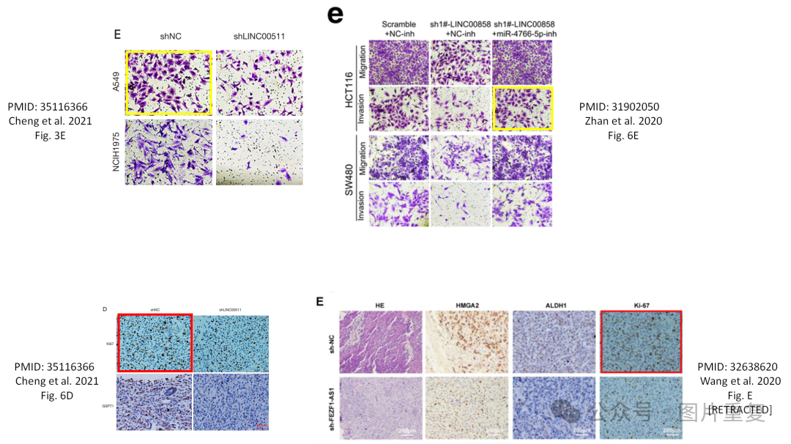The following papers are affected:

Paper 1: https://pubmed.ncbi.nlm.nih.gov/35116366/

Paper 2: https://pubmed.ncbi.nlm.nih.gov/31902050/

Paper 3: https://pubmed.ncbi.nlm.nih.gov/32638620/ [RETRACTED]

We will notify the publishers to resolve these issues.

Kind regards,

Rene Aquarius