[华中科技大学知名学者论文图片重复](https://mp.weixin.qq.com/s?__biz=Mzg5MTg0MDc4NQ==&mid=2247493156&idx=2&sn=a3bebf7f1cde47a4d5d0469c02e00385&chksm=ce7284ade0384c2f129980055386c55259b3e277844ff3d0e7927eb648a3dda32bd56b7a1580&scene=126&sessionid=1742316491)

原创  Fu[图片重复](javascript:void(0);)2025-03-10 09:19:00广东

**Hierarchical-structured bacterial cellulose/potato starch tubes as potential small-diameter vascular grafts**

**Carbohydrate Polymers (2022)**

**PMID:**35074114

**DOI:**10.1016/j.carbpol.2021.119034

**AUTHORS**

**Li Liu1,Xiongfa Ji2,Lin Mao3,Li Wang1,Kun Chen1,Zhijun Shi1,Abeer Ahmed Qaed Ahmed1,Sabu Thomas4,Revin Victor Vasilievich5,Lin Xiao6,Xiaohong Li7,Guang Yang8**

**AFFILIATIONS**

1Department of Biomedical Engineering, College of Life Science and Technology, Huazhong University of Science and Technology, Wuhan 430074, China.

2Department of Orthopedics, Guangdong Provincial People's Hospital, Guangdong Academy of Medical Sciences, Guangzhou 510080, China.

3Department of Biomedical Engineering, College of Life Science and Technology, Huazhong University of Science and Technology, Wuhan 430074, China; College of Life Sciences, Henan Agricultural University, Zhengzhou 450002, China.

4International and Inter University Centre for Nanoscience and Nanotechnology, Mahatma Gandhi University, Kottayam 686 560, Kerala, India.

5Department of Biotechnology, Bioengineering and Biochemistry, Faculty of Biotechnology and Biology, Federal State Budgetary Educational Institution of Higher Education "National Research Ogarev Mordovia State University", Saransk 430005, Russia.

6School of Biomedical Engineering, Sun Yat-sen University, Guangzhou 510006, China. Electronic address: .

7State Key Laboratory of High Performance Ceramics and Superfine Microstructure, Shanghai Institute of Ceramics, Chinese Academy of Sciences, Shanghai 200050, China. Electronic address: .

8Department of Biomedical Engineering, College of Life Science and Technology, Huazhong University of Science and Technology, Wuhan 430074, China. Electronic address: .

**#1Archasia Belfragei**

**2 hours ago**

Figure 2D seems to contain two largely identical panels:

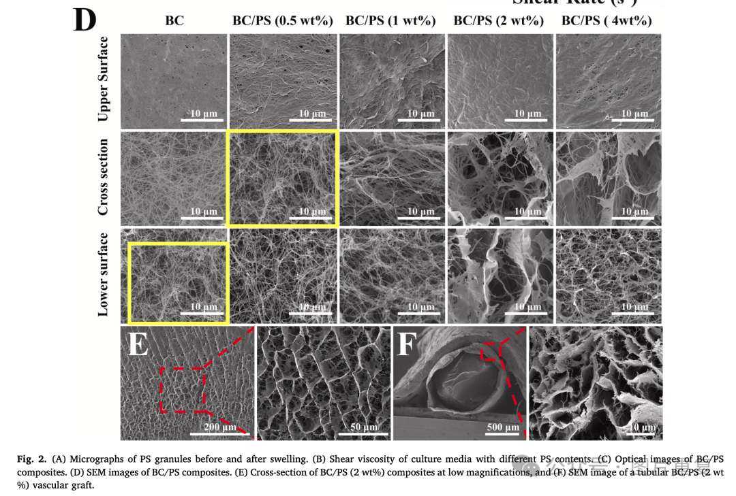

* Archasia Belfragei

[#华中科技大学](https://mp.weixin.qq.com/mp/appmsgalbum?__biz=Mzg5MTg0MDc4NQ==&action=getalbum&album_id=3891931461149999111#wechat_redirect)[#论文](https://mp.weixin.qq.com/mp/appmsgalbum?__biz=Mzg5MTg0MDc4NQ==&action=getalbum&album_id=2546994047612895232#wechat_redirect)[#图片重复](https://mp.weixin.qq.com/mp/appmsgalbum?__biz=Mzg5MTg0MDc4NQ==&action=getalbum&album_id=2546994047780667392#wechat_redirect)[#查重系统](https://mp.weixin.qq.com/mp/appmsgalbum?__biz=Mzg5MTg0MDc4NQ==&action=getalbum&album_id=3076605976766332935#wechat_redirect)