[上海中医药大学附属龙华医院陈磊/龚华论文多图与他文重复，科研成果面临质疑](https://mp.weixin.qq.com/s?__biz=Mzk3NTEwMTE3OA==&mid=2247484759&idx=1&sn=2ede3fcd0aa487bd3716cc0f01fac972&chksm=c50adf7fcb053c7b3dc543947d16eb58f6964a484ae84f13954870029c9a815e525bf4b65f6a&scene=126&sessionid=1742230534)

[学术荟萃](javascript:void(0);)2025-03-15 14:33:02山东

**Part.1**



**论文简介**

**标题：Cyclin-dependent kinase inhibitor 3 (CDKN3) plays a critical role in prostate cancer via regulating cell cycle and DNA replication signaling**

**日期：**2017年11月28日

**单位与作者：**上海中医药大学附属龙华医院 Chao Yu、Hongwen Cao、Lei Chen(通讯作者 音译 陈磊), Hua Gong(通讯作者 音译 龚华)

**期刊：*Biomedicine & Pharmacotherapy***

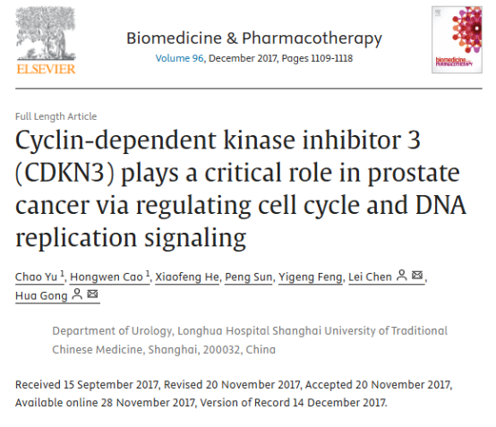

**Part.2**



**图像重复问题**

**#1 图8E与Qin et al 2016的图5D出现重复。**

[left] Fig 8E. -[right] Fig 5D from "Silencing of WWP2 inhibits adhesion, invasion, and migration in liver cancer cells" (Qin et al 2016).

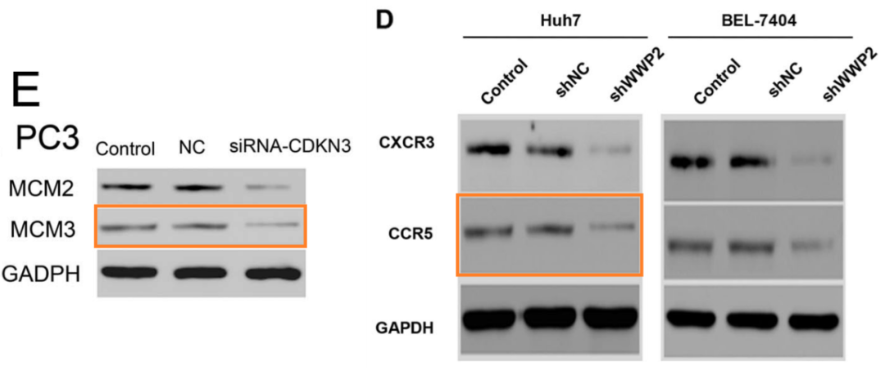

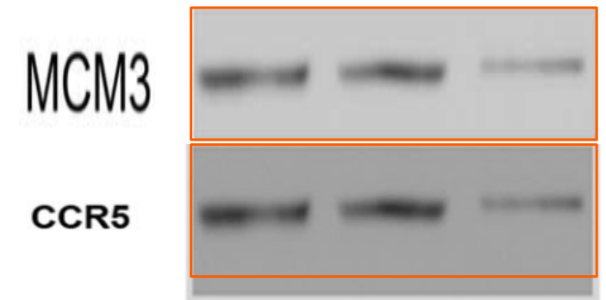

**#2 图7D与Tu et al 2019的图5B出现重复。**

[left] Fig 7D.

[right] Fig 5B from "CXCL16/CXCR6 is involved in LPS‐induced acute lung injury via P38 signalling" (Tu et al 2019).

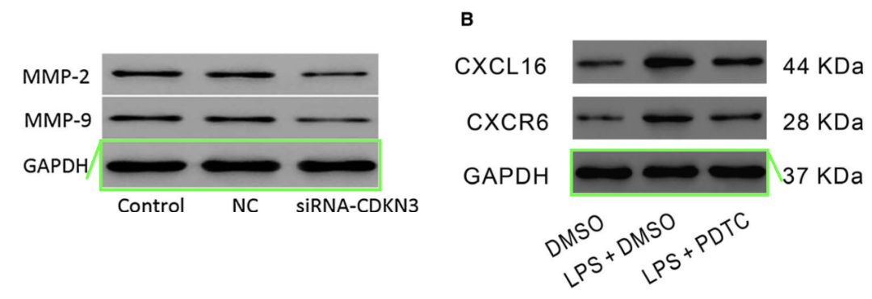

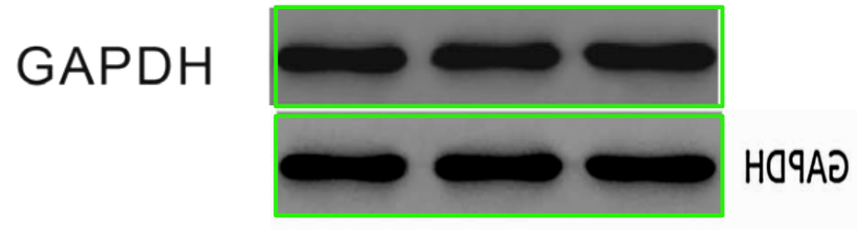

**参考信息：**

https://pubpeer.com/publications/E127A2F3021243EC062F90D59995AA#1

https://www.sciencedirect.com/science/article/abs/pii/S0753332217347819?via%3Dihub