[因存在多处图像重复，且作者主动请求，郑州大学第一附属医院的论文撤稿](https://mp.weixin.qq.com/s?__biz=MzkwMjY4ODQ5Mw==&mid=2247496290&idx=2&sn=94c54360f3dcc156eb71201a1eb18dec&chksm=c1cf5cca38dcac29d3ce3a781e776efd99a6e2605d1f4938a8639b116f573321cfa3979ad8cf&scene=126&sessionid=1742142163)

[Reviewer 2](javascript:void(0);)2025-02-19 14:35:20浙江



点击蓝字关注我们



**论文信息**

2017年5月16日，郑州大学第一附属医院临床医学研究所的Zhe Cheng(第一作者&通讯作者 音译 程哲)在Oncotarget期刊上在线发表题为"MicroRNA-145 down-regulates mucin 5AC to alleviate airway remodeling and targets EGFR to inhibit cytokine expression"(MicroRNA-145 下调粘蛋白 5AC 以缓解气道重塑，并靶向表皮生长因子受体抑制细胞因子的表达)的论文。

本研究得到了河南省教育厅自然科学研究项目（编号：13A320697）、河南省科学技术厅科技项目（编号：132300410273）以及河南省卫生科技创新人才项目（编号：2010-52）的支持。

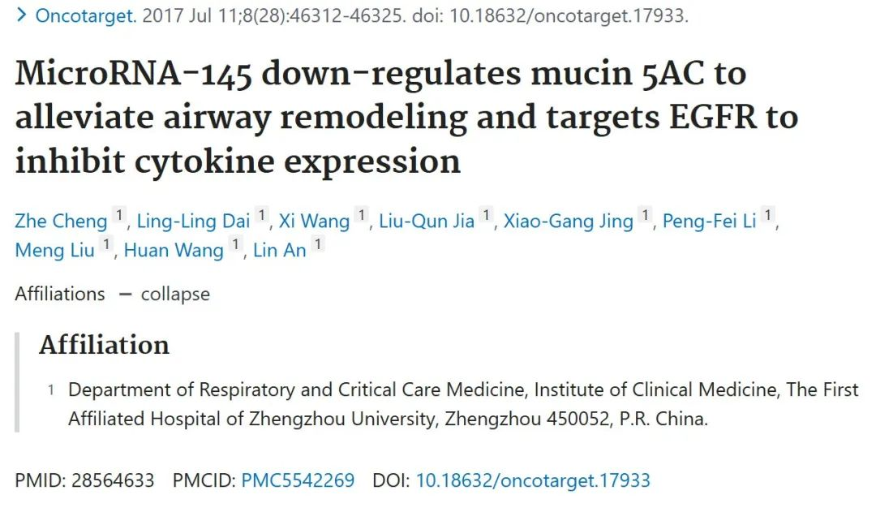

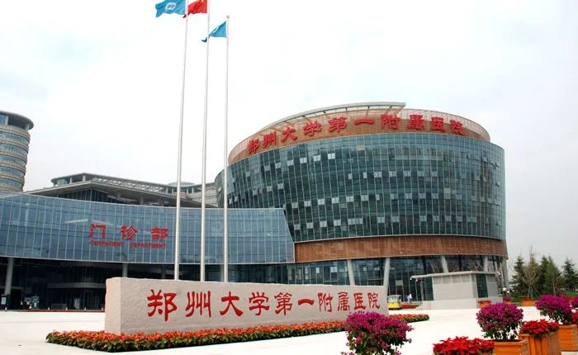



**质疑信息**

* **图4与多篇无关论文图像重复。**

Clockwise from upper left:

Fig 1 from "Tanshinone IIA alleviates lipopolysaccharide‐induced acute lung injury by downregulating TRPM7 and pro‐inflammatory factors" (Li et al 2018) [retracted].

Fig 4A-H from "Effects of microRNA-19b on airway remodeling, airway inflammation and degree of oxidative stress by targeting TSLP through the Stat3 signaling pathway in a mouse model of asthma" (Ye et al 2017).

Fig 3A from "Thymic Stromal Lymphopoietin Signaling Pathway Inhibition Attenuates Airway Inflammation and Remodeling in Rats with Asthma" (Cheng et al 2017) [retracted].

Fig 3A-D from "Effects of Zinc Finger Protein A20 on Lipopolysaccharide (LPS)-Induced Pulmonary Inflammation/Anti-Inflammatory Mediators in an Acute Lung Injury/Acute Respiratory Distress Syndrome Rat Model" (Wu et al 2017).

Fig 4 (HE staining).

Fig 1 from "Protective effect of autophagy on endoplasmic reticulum stress induced apoptosis of alveolar epithelial cells in rat models of COPD" (Tang et al 2017) [retracted].

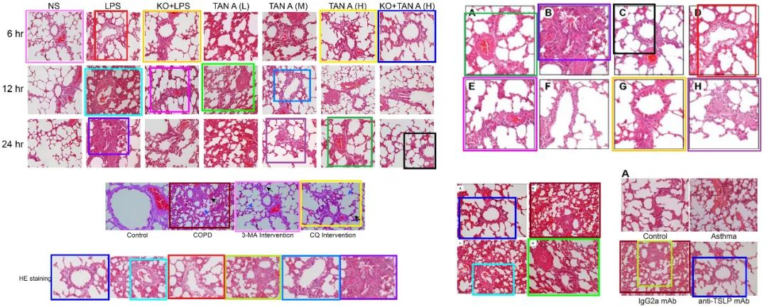

* **图2b和4c图像面板重叠，2c和图4d图像面板重叠。**

Fig 4 (Masson staining).

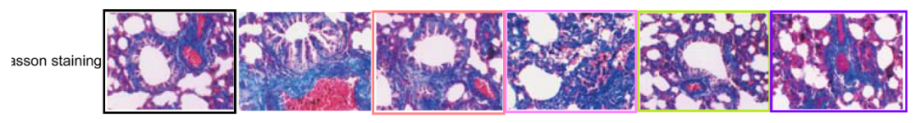

Fig 5 from "Effects of microRNA-19b on airway remodeling, airway inflammation and degree of oxidative stress by targeting TSLP through the Stat3 signaling pathway in a mouse model of asthma" (Ye et al 2017).

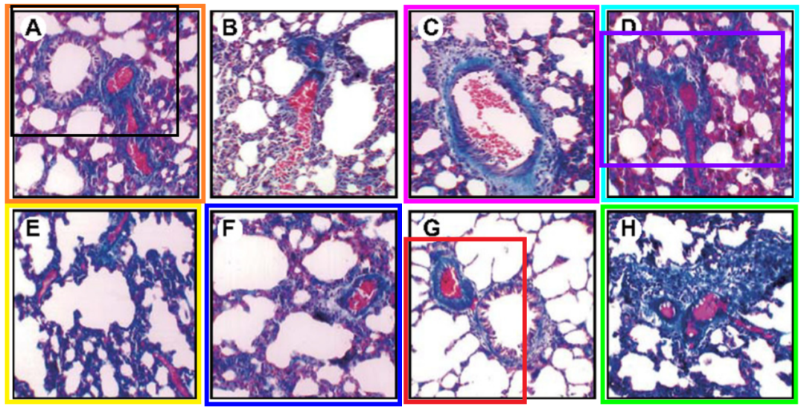

Fig 4 from "The involvement of the laminin-integrin α7β1 signaling pathway in mechanical ventilation-induced pulmonary fibrosis" (Liao et al 2017).

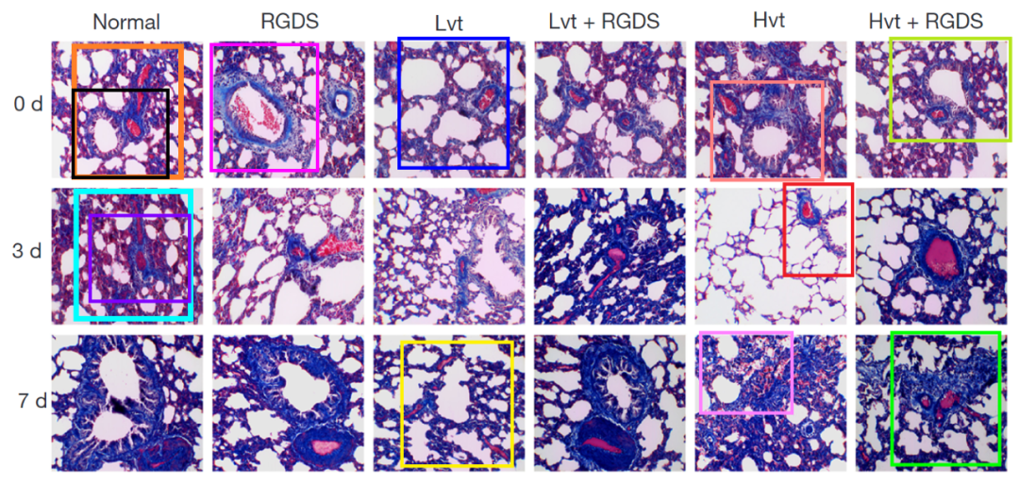

* **图2b和4c图像面板重叠，2c和图4d图像面板重叠。**

Fig 4 (PAS staining).

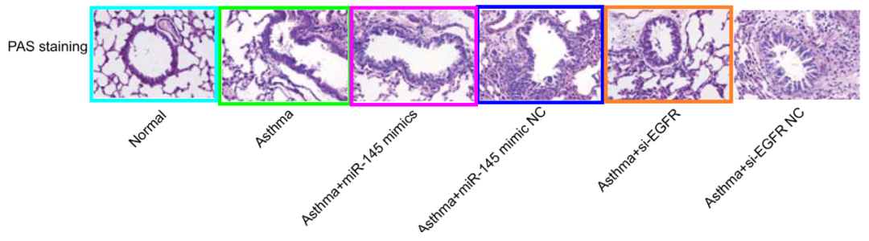

[left] Fig 6 from "Effects of microRNA-19b on airway remodeling, airway inflammation and degree of oxidative stress by targeting TSLP through the Stat3 signaling pathway in a mouse model of asthma" (Ye et al 2017).

[right] Fig 3B from "Thymic Stromal Lymphopoietin Signaling Pathway Inhibition Attenuates Airway Inflammation and Remodeling in Rats with Asthma" (Cheng et al 2018) [retracted].

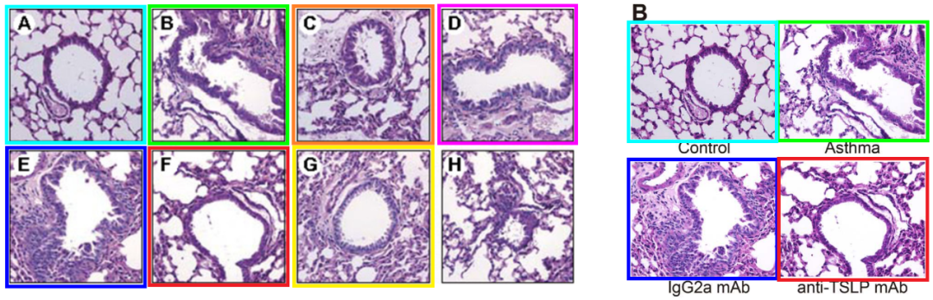

Fig 2B from "Role of the TSLP/DC/OX40L pathway in asthma pathogenesis and airway inflammation in mice" (Feng et al 2018) [retracted].

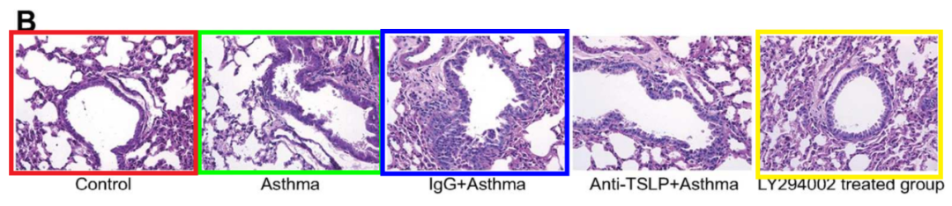



**撤稿原因**

**本文已于2025年2月5日被撤回：**在通讯作者程哲（Zhe Cheng）请求撤回本文后，Oncotarget对本文进行了调查。经调查，发现存在多处图像重复现象。特别是图4包含了之前一篇文章[1]中的图4（HE染色）、图5（Masson染色）和图6（PAS染色）中的图像。图4中的HE染色面板和Masson染色面板还包含了同期发表的一篇文章[2]中的图3A和图3C以及文章[3]中的图4中的图像。作者还在后续发表的一篇最近已被撤回的论文[4]中重复使用了部分HE染色和PAS染色图像。因此，编辑部决定撤回本文。Oncotarget已多次联系所有作者以确认此次撤回，但未收到任何回复。

涉及文章

1. Ye L, Mou Y, Wang J, Jin ML. Effects of microRNA-19b on airway remodeling, airway inflammation and degree of oxidative stress by targeting TSLP through the Stat3 signaling pathway in a mouse model of asthma. Oncotarget. 2017; 8:47533–46. https://doi.org/10.18632/oncotarget.17258.   
2. Wu DQ, Wu HB, Zhang M, Wang JA. Effects of Zinc Finger Protein A20 on Lipopolysaccharide (LPS)-Induced Pulmonary Inflammation/Anti-Inflammatory Mediators in an Acute Lung Injury/Acute Respiratory Distress Syndrome Rat Model. Med Sci Monit. 2017; 23:3536–45. https://doi.org/10.12659/msm.901700.   
3. Liao HD, Mao Y, Ying YG. The involvement of the laminin-integrin α7β1 signaling pathway in mechanical ventilation-induced pulmonary fibrosis. J Thorac Dis. 2017; 9:3961–72. https://doi.org/10.21037/jtd.2017.09.60.   
4. Cheng Z, Wang X, Dai LL, Jia LQ, Jing XG, Liu Y, Wang H, Li PF, An L, Liu M. Thymic Stromal Lymphopoietin Signaling Pathway Inhibition Attenuates Airway Inflammation and Remodeling in Rats with Asthma. Cell Physiol Biochem. 2018; 47:1482–96. https://doi.org/10.1159/000490865. [PubMed]. Retraction in: Cell Physiol Biochem. 2023; 57:543. https://doi.org/10.33594/000000678.



**参考信息**

https://pubpeer.com/publications/66D9F8A56FC44410FA2D6654F25E25#4

https://pubmed.ncbi.nlm.nih.gov/28564633/

https://www.oncotarget.com/article/28689/