[顶刊！中国农大和中山大学合作发表论文图片重复](https://mp.weixin.qq.com/s?__biz=Mzg5MTg0MDc4NQ==&mid=2247493192&idx=2&sn=bf9a75b84381c0781e997a7caef0c0c8&chksm=ce91595a1668e47a2bf727ac5e887752341be1b1fec9dab299522b2a417b4047256317e3162d&scene=126&sessionid=1742142450)

原创  F[图片重复](javascript:void(0);)2025-03-13 07:50:55广东

**sA novel ENTH domain-containing protein TgTEPSIN is essential for structural maintenance of the plant-like vacuolar compartment and bradyzoite differentiation in toxoplasma gondii**

**International Journal of Biological Macromolecules (2025)**

**PMID:**39864696

**DOI:**10.1016/j.ijbiomac.2025.140311

**AUTHORS**

**Kai He1,Ruibin Wu1,An Yan1,Xianyong Liu2,Shaojun Long3**

**AFFILIATIONS**

1National Animal Protozoa Laboratory and School of Veterinary Medicine, China Agricultural University, Beijing 100193, China; Key Laboratory of Animal Epidemiology and Zoonosis of Ministry of Agriculture, China Agricultural University, Beijing 100193, China.

2National Animal Protozoa Laboratory and School of Veterinary Medicine, China Agricultural University, Beijing 100193, China; Key Laboratory of Animal Epidemiology and Zoonosis of Ministry of Agriculture, China Agricultural University, Beijing 100193, China. Electronic address: .

3National Animal Protozoa Laboratory and School of Veterinary Medicine, China Agricultural University, Beijing 100193, China; Shenzhen Key Laboratory of Pathogenic Microbes and Biosafety, and Laboratory of Zoonotic Diseases, School of Public Health (Shenzhen), Sun Yat-Sen University, Shenzhen Campus, Shenzhen 518107, China. Electronic address: .

**#1Archasia Belfragei 9 hours ago**

More or less every single panel in Figure 4B seems duplicated or overlaps with another panel:

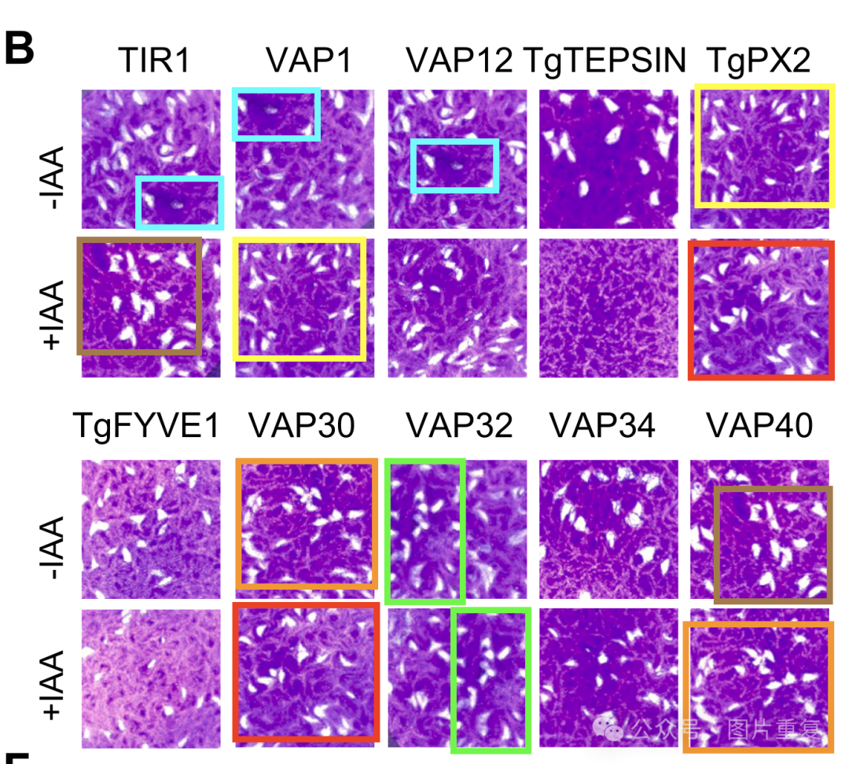

Archasia Belfragei