[知名团队！第四军医大学知名附属医院发表的论文图片重复](https://mp.weixin.qq.com/s?__biz=Mzg5MTg0MDc4NQ==&mid=2247493192&idx=1&sn=d19beb1230ae356754f61e457e356631&chksm=ce157534823c3b2d8e154a8ae6e200cc14f5a1b8439b3dcd2865d76cf028c1d36bfff89f6773&scene=126&sessionid=1742142450)

原创  F[图片重复](javascript:void(0);)2025-03-13 07:50:55广东

**Long Noncoding RNA UCA1 Targets miR-122 to Promote Proliferation, Migration, and Invasion of Glioma Cells**

**Oncology research (2018)**

**PMID:**28548636

**DOI:**10.3727/096504017x14934860122864

**AUTHORS**

**Yang Sun1,Jun-Gong Jin1,Wei-Yang Mi2, Hao-Wu1,Shi-Rong Zhang3,Qiang Meng1,Shi-Tao Zhang3**

**AFFILIATIONS**

1Department of Neurosurgery, Tangdu Hospital, Fourth Military Medical University, Xi’an, P.R. China

2Department of Neurosurgery, Xi’an Children’s Hospital, Xi’an, P.R. China

3Department of Neurosurgery, Xi’an No. 3 Hospital, Xi’an, P.R. China

#### Erratum

#### 2year ago

#### Author response

#### 4 hours ago

**#1Hoya Camphorifolia**

**4year ago**

Figs 2I, "UCA1 knockdown effectively suppressed the proliferation, migration, and invasion of glioma cell lines... (H) Invasion capacity detected by Transwell assay", and 4E, "UCA1 facilitated glioma proliferation, migration, and invasion partially targeting miR-122 in U87 cell lines. ... (E) Transwell assay showed the migrative and invasive capabilities"

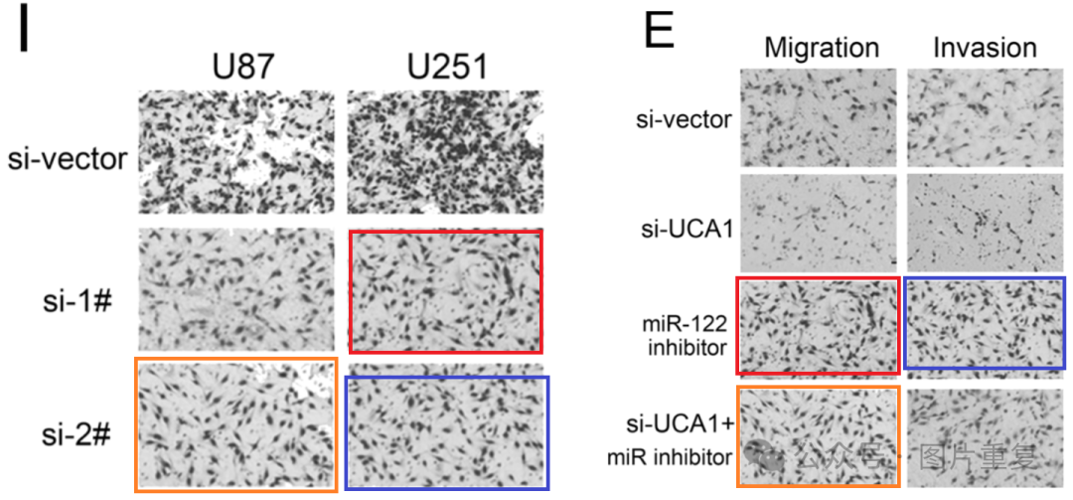

Could the authors check the identification of the panels?

**#2Qiang Meng (author)**

**4year ago**

Dear Hoya Camphorifolia PhD:

Thank you very much for your comments. As you indicate, we check these figures and find that these errors are caused by our careless and Inadequate verification. In our time-pressured data collation process, we ignored this images confusion, thereby causing this error. We are sorry for these mistake and sincerely thanks for your criticism. We will contact with the journal for corrigendum and solve the problem properly. Thanks again.

**#3Hoya Camphorifolia**

**3year ago**

Undated correction: https://www.ingentaconnect.com/contentone/cog/or/2021/00000028/00000006/art00011

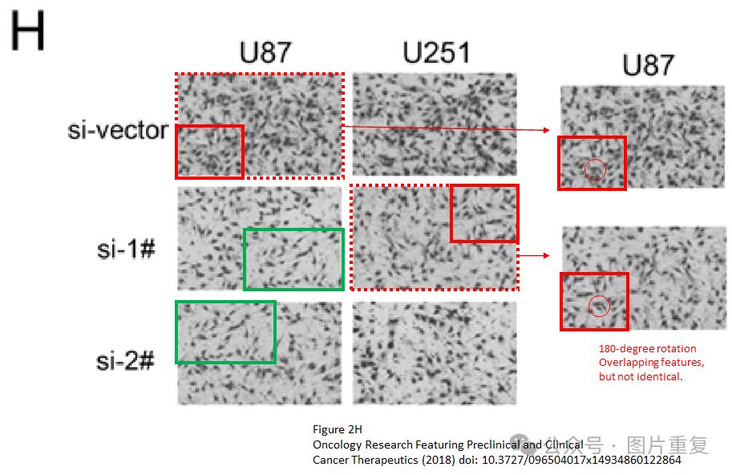"The following was originally published in Volume 26, No. 1, pages 103–110, 2018 (doi: https://doi.org/10.3727/096504017X14934860122864). There was an error in Figure 4E in the Transwell assay. A corrected version of the figure is shown here and the figure has been replaced with the corrected version in the original published article in the online site (https:// www.ingentaconnect.com/contentone/cog/or/2018/00000026/00000001/art00011). The original version of the figure did not affect the results or conclusion of the article."

**#4Actinopolyspora Biskrensis  3year ago**

If I'm understanding the stealth correction, the current paper should be the corrected version. If so, there appears to be issues with Figure 2H, including difficult to explain differences between the overlapping images marked with red dashed box.

**#5Prorhynchus Putealis**

**18 day ago**

Much more similar than expected.

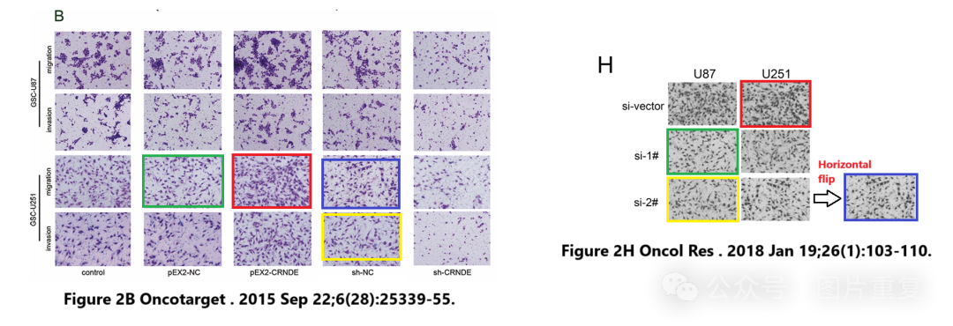

**#6Shi-Tao Zhang (author)**

**4 hours ago**

Dear Prorhynchus putealis PhD:

Thank you for your comments. We will check the records and find where cause these errors. The assays were supported by biotech company, and we will contact them to verify the reasons.

Thanks again sincerely

[#中山大学](https://mp.weixin.qq.com/mp/appmsgalbum?__biz=Mzg5MTg0MDc4NQ==&action=getalbum&album_id=3879421011573506062#wechat_redirect)[#中国农业大学](https://mp.weixin.qq.com/mp/appmsgalbum?__biz=Mzg5MTg0MDc4NQ==&action=getalbum&album_id=3895608666036060167#wechat_redirect)