[质疑一年终勘误，来自南京医科大学知名学者](https://mp.weixin.qq.com/s?__biz=Mzg5MTg0MDc4NQ==&mid=2247493142&idx=2&sn=2213ea295a34df40a32ad5ffc3e8391b&chksm=ce3c7232a07cc45bc2520611cf394f9c120038186247ecf0cb4e8a6aef03a8201e39356e32cd&scene=126&sessionid=1742142450)

原创  F[图片重复](javascript:void(0);)2025-03-09 16:56:26广东

**Epstein-Barr virus-encoded latent membrane protein 2A promotes the epithelial-mesenchymal transition in nasopharyngeal carcinoma via metastatic tumor antigen 1 and mechanistic target of rapamycin signaling induction**

**Journal of Virology (2014)**

**PMID:**25100829

**DOI:**10.1128/jvi.01867-14

**AUTHORS**

**Zhe Lin1,Xin Wan1,Runqiu Jiang2,Lei Deng2,Yun Gao2,Junwei Tang2,Yu Yang2,Wei Zhao1,Xin Yan1,Kun Yao1,Beicheng Sun3,Yun Chen4**

**AFFILIATIONS**

1Department of Microbiology and Immunology, Nanjing Medical University, Nanjing, Jiangsu Province, China.

2Liver Transplantation Center, The First Affiliated Hospital of Nanjing Medical University, Nanjing, Jiangsu Province, China.

3Liver Transplantation Center, The First Affiliated Hospital of Nanjing Medical University, Nanjing, Jiangsu Province, China .

4Department of Microbiology and Immunology, Nanjing Medical University, Nanjing, Jiangsu Province, China .

**#1Elisabeth M Bik 1year ago**

Concern about **Figures 6F and 6G**:

* Red boxes and arrows: Three lanes in the MTA1 panel of Figure 6F look remarkably similar to the mirror image of three lanes in the MTA1 panel of Figure 6G.

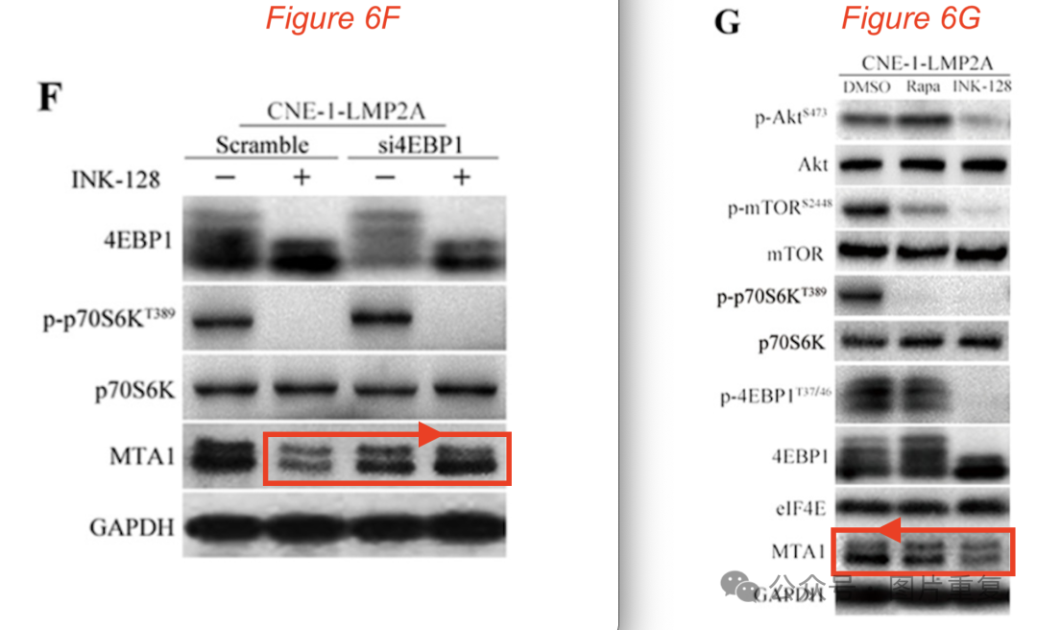

**#2Elisabeth M Bik 1 day ago**

Correction, 3 May 2024, found here: https://journals.asm.org/doi/abs/10.1128/jvi.00399-24

It reads:

"Page 11875, Fig. 2B: Due to an error in rearranging the figure in the final version, the Vimentin panel of Fig. 2B is an inadvertent duplicate of the E-cadherin panel of Fig. 5B. The Vimentin panel of Fig. 2B should appear as shown in this correction."

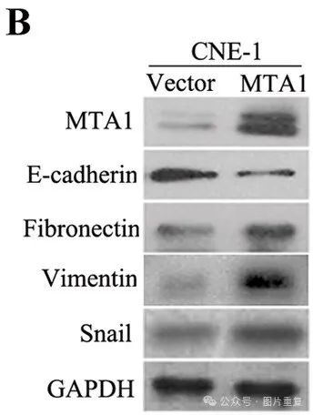

"Page 11880, Fig. 6F: Due to an error in rearranging the figure in the final version, the MTA1 panel of Fig. 6F is an inadvertent duplicate of the MTA1 panel of Fig. 6G. The MTA1 panel of Fig. 6F should appear as shown in this correction."

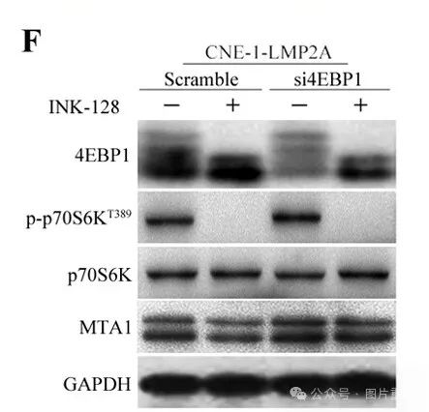

"We apologize for any confusion caused by these errors. This correction does not affect any of the conclusions of the paper."

**#3Illex Illecebrosus  9 hours ago**

#1

**Click here to see animation video based on issues reported above.**



Other animations available **here**. Link to the relevant PubPeer post is in the description. Please note that we are not making any judgements but simply visualising observations by others.

[#南京医科大学](https://mp.weixin.qq.com/mp/appmsgalbum?__biz=Mzg5MTg0MDc4NQ==&action=getalbum&album_id=3890809439615402004#wechat_redirect)[#查重系统](https://mp.weixin.qq.com/mp/appmsgalbum?__biz=Mzg5MTg0MDc4NQ==&action=getalbum&album_id=3076605976766332935#wechat_redirect)[#图片重复](https://mp.weixin.qq.com/mp/appmsgalbum?__biz=Mzg5MTg0MDc4NQ==&action=getalbum&album_id=2546994047780667392#wechat_redirect)