[浙江大学医学院知名团队论文图片重复](https://mp.weixin.qq.com/s?__biz=Mzg5MTg0MDc4NQ==&mid=2247493142&idx=1&sn=28ecf72b2494457b0fba827c19e64659&chksm=cee1c5405fe29828c765e1bda700d0f7f052ecc569c1dff7422cdd6abae03685a5e8f57743ed&scene=126&sessionid=1742142450)

原创  F[图片重复](javascript:void(0);)2025-03-09 16:56:26广东

## Fistin inhibits proliferation of pancreatic adenocarcinoma by inducing DNA damage via RFXAP/KDM4A-dependent histone H3K36 demethylation

**Cell Death & Disease (2020)**

**PMID:**33093461

**DOI:**10.1038/s41419-020-03019-2

**AUTHORS**

**Guoping Ding1,Xiaodong Xu1,Dan Li12,Yuhao Chen13,Weimin Wang14,Dongnan Ping1,Shengnan Jia5,Liping Cao56**

**AFFILIATIONS**

1Department of General Surgery, Sir Run Run Shaw Hospital, School of Medicine, Zhejiang University, Hangzhou, 310000, China.

2Department of General Surgery, School of Medicine, Affiliated Hospital of Hangzhou Normal University, Hangzhou, 310000, China.

3Emergency Department, Sir Run Run Shaw Hospital, School of Medicine, Zhejiang University, Hangzhou, 310000, China.

4Department of General Surgery, Huzhou Hospital, Zhejiang University School of Medicine, Huzhou, 313003, Zhejiang, China.

5Department of General Surgery, Sir Run Run Shaw Hospital, School of Medicine, Zhejiang University, Hangzhou, 310000, China. .

6Innovation Center for Minimally Invasive Technique and Device, Zhejiang University, Hangzhou, 310000, Zhejiang, China. .

**#1Clusia Sipapoana 12 hours ago**

Much more similar than expected. Similarities detected by ImageTwin.

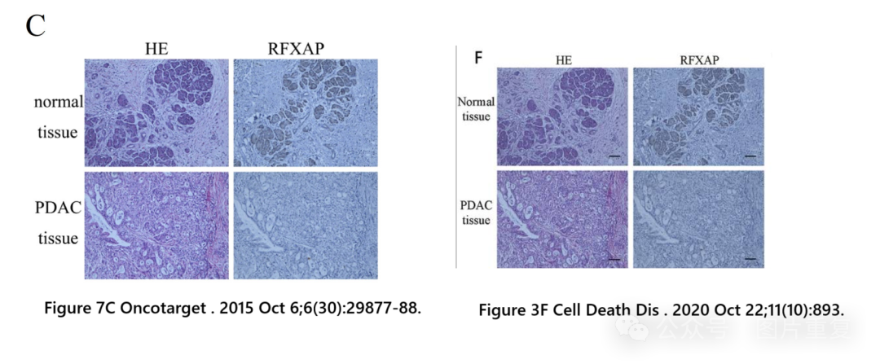

**#2Clusia Sipapoana 12 hours ago**

Much more similar than expected for 2 different cell lines. Similarities detected by ImageTwin.

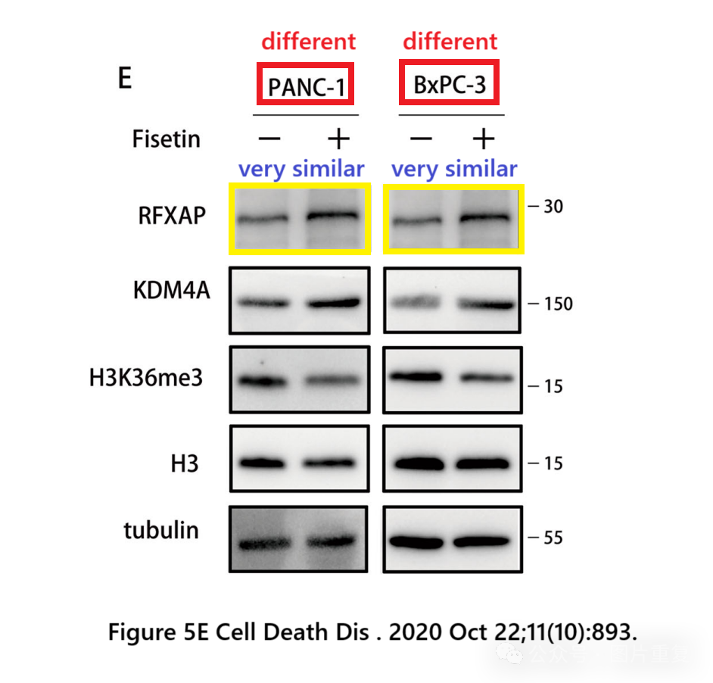

[#浙江大学医学院](https://mp.weixin.qq.com/mp/appmsgalbum?__biz=Mzg5MTg0MDc4NQ==&action=getalbum&album_id=3890805573423415298#wechat_redirect)[#论文](https://mp.weixin.qq.com/mp/appmsgalbum?__biz=Mzg5MTg0MDc4NQ==&action=getalbum&album_id=2546994047612895232#wechat_redirect)[#图片重复](https://mp.weixin.qq.com/mp/appmsgalbum?__biz=Mzg5MTg0MDc4NQ==&action=getalbum&album_id=2546994047780667392#wechat_redirect)