[Fudan researcher expelled for academic misconduct](https://mp.weixin.qq.com/s?__biz=Mzk0OTY1MDkwOQ==&mid=2247486071&idx=4&sn=ccff66cf1b28f4c876ada897afbe3579&chksm=c2e33236f48860dc9a9d7e6ac44c04b849e78213063a6f7b7721107a380bad7c409ed3a66930&scene=126&sessionid=1741971673)

[Research Integrity](javascript:void(0);)2025-03-02 21:26:27新加坡



Research Integrity

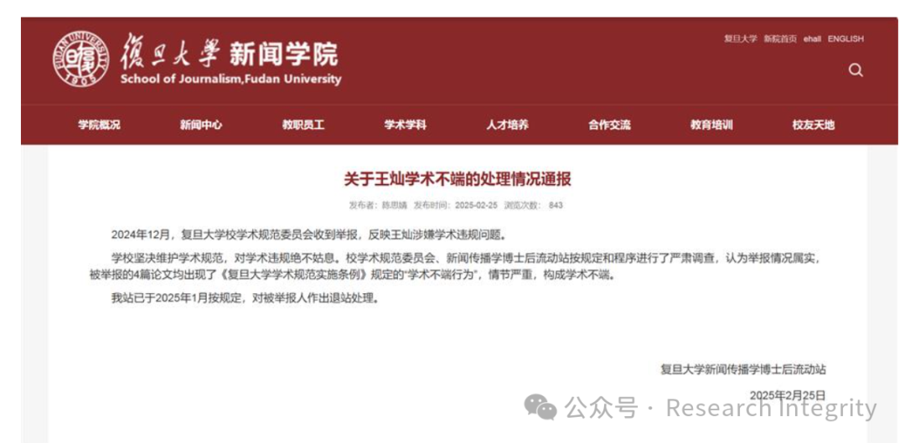

A screenshot of the notification on the website of the School of Journalism, Fudan University

A researcher has been expelled from a postdoctoral research center at Fudan University for academic misconduct, according to a notification released by the university's School of Journalism on Tuesday.

It said that in December the university's academic committee had received allegations of misconduct by Wang Can, a researcher affiliated with the university's postdoctoral research center at its School of Journalism.

It said an investigation found the allegations to be true and misconduct as defined in the university's academic norms was discovered in all four theses mentioned in the allegations.

It added that the violation was very serious and Wang was removed from the postdoctoral center in January.

Fudan's academic norms, released in 2017, stipulate that misconduct refers to deeds such as counterfeiting, falsifying and plagiarism in doing research, writing papers, or applying for projects or awards.

According to HBTV, Taiwan literature doctoral candidate Ye Zhan had alleged Wang had plagiarized his paper and those of others between 2022 and 2024. He claimed that Wang copied the entire texts of the four theses and published them in top academic journals.

**来源：公众号Research Integrity，转载请注明出处，若没注明学术诚信公众号出处，构成侵权。后台联系客服微信：BikElisabeth**

免责声明：

质疑信息来源于Pubpeer，提及人名均为音译

对于文章内容的真实性、完整性、及时性

本公众号不做任何保证或承诺，仅供读者参考

未经授权禁止转载！

转载请勿更改原文内容及格式！

如有转载需求或合作事宜

可添加下方客服微信或推送邮件到researchintegrity@qq.com

