[浙江大学医学院附属第二医院肝胆胰外科涉嫌诚信科研问题引发热议](https://mp.weixin.qq.com/s?__biz=MzkzMzc1Nzg1OQ==&mid=2247486086&idx=1&sn=7e8e48d13709e5b46200da3ce312dd1b&chksm=c3bb669a825f29fd0666e5aab97dd420b084ba766742e481352df20fdfdcf722107d15c7ce27&scene=126&sessionid=1741971005)

Figure 查重[Figure查重](javascript:void(0);)2025-03-13 11:14:55上海

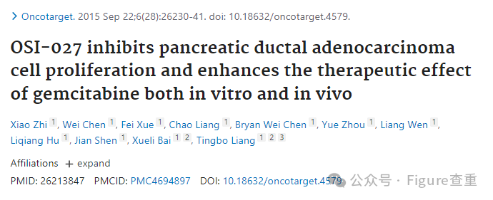

OSI-027 inhibits pancreatic ductal adenocarcinoma cell proliferation and enhances the therapeutic effect of gemcitabine both in vitro and in vivo

Oncotarget (2015) - 4 Comments  
pubmed: 26213847  doi: 10.18632/oncotarget.4579  issn: 1949-2553

Xiao Zhi , Wei Chen , Fei Xue , Chao Liang , Bryan Wei Chen , Yue Zhou , Liang Wen , Liqiang Hu , Jian Shen , Xueli Bai , Tingbo Liang

# OSI-027 inhibits pancreatic ductal adenocarcinoma cell proliferation and enhances the therapeutic effect of gemcitabine both *in vitro* and *in vivo*

Xiao Zhi 1,#,Wei Chen1,#,Fei Xue1,Chao Liang1,Bryan Wei Chen1,Yue Zhou1,Liang Wen1,Liqiang Hu1,Jian Shen1,Xueli Bai1,2,Tingbo Liang1,2,3

Author informationArticle notesCopyright and License information

1 Department of Hepatobiliary and Pancreatic Surgery, The Second Affiliated Hospital, School of Medicine, Zhejiang University, Hangzhou, P.R.China

2 Key Laboratory of Cancer Prevention and Intervention, The Second Affiliated Hospital, Zhejiang University School of Medicine, Hangzhou, P.R.China

3 Collaborative Innovation Center for Cancer Medicine, Zhejiang University, Hangzhou, P.R.China

?

**Correspondence to:** Tingbo Liang, liangtingbo@zju.edu.cn

?

Xueli Bai, shirleybai57@hotmail.com

#

Contributed equally.

PMCID: PMC4694897  PMID: 26213847

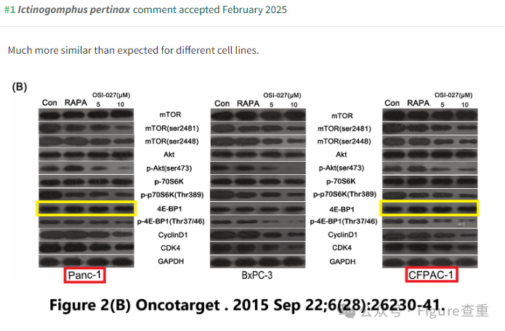

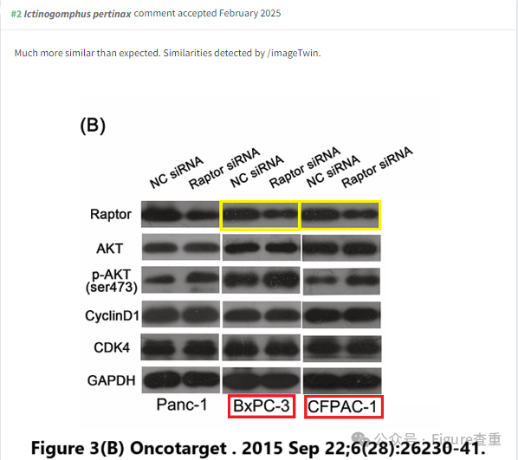

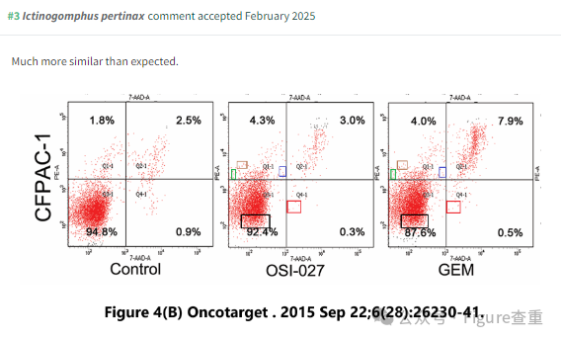

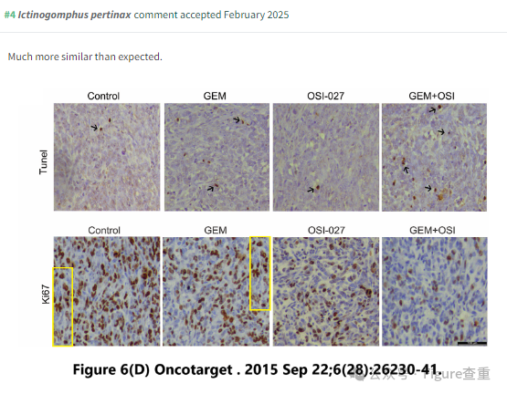

**参考消息：**

**https://pubpeer.com/publications/70BA8699AAA84B5CE521E961C852C0**

**联系我们：**

如果您需要使用Figure查重服务，请扫描下方二维码，添加客服微信，了解更多详情。我们将竭诚为您服务，确保您的科研工作更加高效、可信。

