[杰出学者邹明辉被撤回25篇文章](https://mp.weixin.qq.com/s?__biz=Mzk0ODg4MTYxMw==&mid=2247504343&idx=1&sn=9287db088415462695e6fc336da08506&chksm=c2d4871f44180ba65f410ee0d199ff802c54b86cd93bd63c4017de3de93e5490275d3dee4358&scene=126&sessionid=1741976768)

[诚信学者](javascript:void(0);)2025-03-06 14:01:43上海

吲哚胺 2,3 双加氧酶-1 （IDO1） 在许多炎症和癌症疾病中催化色氨酸-犬尿氨酸代谢。值得注意的是，心脏损伤后立即发生的急性炎症对于新生儿心肌细胞增殖和心脏再生至关重要。

2022 年 10 月 26 日，佐治亚州立大学分子与转化医学中心的Donghong Zhang等人在***Nature communications***（IF=14.7）杂志在线发表题为**“Kynurenine promotes neonatal heart regeneration by stimulating cardiomyocyte proliferation and cardiac angiogenesis”**的研究论文**，该研究结果表明，增加吲哚胺 2,3 双加氧酶衍生的犬尿氨酸水平通过作为心肌细胞增殖和心脏血管生成的内源性调节剂来促进心脏再生。**

但是，在2025 年 3 月 3 日，该文章被撤回，**主要原因是文章内涉嫌图像的重复使用。**

**另外，**2024年3月30日，诚信科研公众号报道了邹明辉被撤回24篇文章（[点击阅读](https://mp.weixin.qq.com/s?__biz=Mzg2Mzc2NzUxMQ==&mid=2247502110&idx=1&sn=59403558237547e3cca85d78b59f4c36&scene=21#wechat_redirect)）。

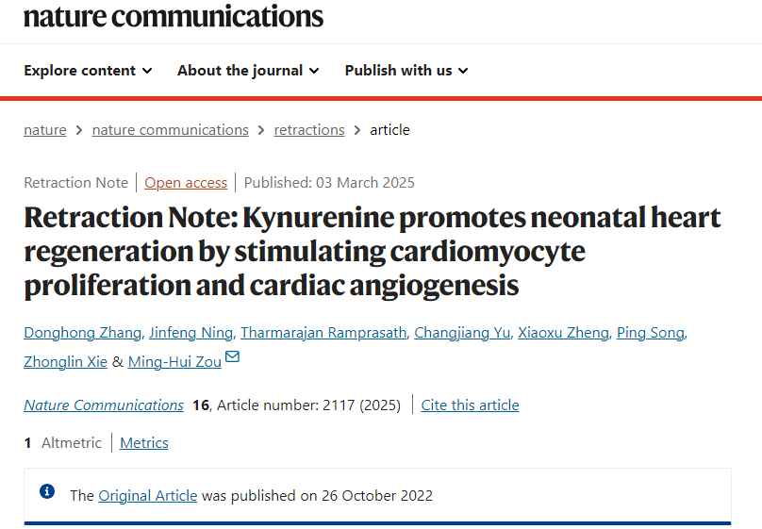

在提出以下问题后，编辑们撤回了这篇文章：

图 2e 的左上面板与图 5e 的右下面板重叠

图 2l 的左上面板与图 5e 的左下面板重叠

佐治亚州立大学的一项调查得出结论，这些部分重叠的图像来自显微镜下的两个不同领域，在一个切片中。因此，编辑们对所呈现的结果和结论不再有信心。Donghong Zhang不同意这种撤回。 Zhonglin Xie和Ming-Hui Zou同意这一撤稿。Tharmarajan Ramprasath 和 Ping Song 尚未回复编辑关于此次撤回的信件。编辑们无法找到 Jinfeng Ning、Changjiang Yu和Xiaoxu Zheng的当前电子邮件地址。

**参考消息：**

https://www.nature.com/articles/s41467-025-57248-0

已被撤回的25篇论文分别是：

1.Ablation of Adenosine Monophosphate-Activated Protein Kinase α1 in Vascular Smooth Muscle Cells Promotes Diet-Induced Atherosclerotic Calcification In Vivo,Circulation Research;

2.Adenosine monophosphate-activated protein kinase-α2 deficiency promotes vascular smooth muscle cell migration via S-phase kinase-associated protein 2 upregulation and E-cadherin downregulation,Arteriosclerosis, Thrombosis, and Vascular Biology;

3.Uncoupling of endothelial nitric oxidase synthase by hypochlorous acid: role of NAD(P)H oxidase-derived superoxide and peroxynitrite,Arteriosclerosis, Thrombosis, and Vascular Biology;

4.Suppression of the mTORC1/STAT3/Notch1 pathway by activated AMPK prevents hepatic insulin resistance induced by excess amino acid,American Journal of Physiology- Endocrinology and Metabolism;

5.AMPKα2 Deletion Exacerbates Neointima Formation by Upregulating Skp2 in Vascular Smooth Muscle Cells,Circulation Research;

6.Reactive nitrogen species induced by hyperglycemia suppresses Akt signaling and triggers apoptosis by upregulating phosphatase PTEN (phosphatase and tensin homologue deleted on chromosome 10) in an LKB1-dependent manner,Circulation;

7.Myeloperoxidase deletion prevents high-fat diet-induced obesity and insulin resistance，Diabetes；

8.Activation of AMP-activated protein kinase α1 alleviates endothelial cell apoptosis by increasing the expression of anti-apoptotic proteins Bcl-2 and Survivin，Journal of Biological Chemistry；

9.Activation of 5'-AMP-activated kinase is mediated through c-Src and phosphoinositide 3-kinase activity during hypoxia-reoxygenation of bovine aortic endothelial cells: Role of peroxynitrite，Journal of Biological Chemistry；

10.Activation of the AMP-activated protein kinase by the anti-diabetic drug metformin in vivo : Role of mitochondrial reactive nitrogen species，Journal of Biological Chemistry；

11.Activation of protein phosphatase 2A by palmitate inhibits AMP-activated protein kinase，Journal of Biological Chemistry；

12.Identification of nitric oxide as an endogenous activator of the AMP-activated protein kinase in vascular endothelial cells，Journal of Biological Chemistry；

13.Nicotine-induced activation of AMP-activated protein kinase inhibits fatty acid synthase in 3T3L1 adipocytes: A role for oxidant stress，Journal of Biological Chemistry；

14.Protein kinase Cζ-dependent LKB1 serine 428 phosphorylation increases LKB1 nucleus export and apoptosis in endothelial cells，Journal of Biological Chemistry；

15.Reactive nitrogen species is required for the activation of the AMP-activated protein kinase by statin in vivo，Journal of Biological Chemistry；

16.Thromboxane A2 receptor activates a Rho-associated kinase/LKB1/PTEN pathway to attenuate endothelium insulin signaling，Journal of Biological Chemistry；

17.Hypochlorous acid via peroxynitrite activates protein kinase Cθ and insulin resistance in adipocytes，Journal of Molecular Endocrinology；

18.Activation of the AMP-activated protein kinase (AMPK) by nitrated lipids in endothelial cells，PLOS ONE；

19.Peroxynitrite-Dependent Zinc Release and Inactivation of Guanosine 5'-Triphosphate Cyclohydrolase 1 Instigate Its Ubiquitination in Diabetes，Diabetes；

20.Liver Kinase B1 Is Required for White Adipose Tissue Growth and Differentiation，Diabetes；

21.Upregulation of Mitochondrial Uncoupling Protein-2 by the AMP-Activated Protein Kinase in Endothelial Cells Attenuates Oxidative Stress in Diabetes，Diabetes；

22.Regulation of the proteasome by AMPK in endothelial cells: the role of O-GlcNAc transferase (OGT)，PLOS ONE；

23.Tyrosine Nitration of PA700 Links Proteasome Activation to Endothelial Dysfunction in Mouse Models with Cardiovascular Risk Factors，PLOS ONE；

24.Transcription factor Krüppel-like factor 2 plays a vital role in endothelial colony forming cells differentiation，Cardiovascular Research；

25.Kynurenine promotes neonatal heart regeneration by stimulating cardiomyocyte proliferation and cardiac angiogenesis，Nature communications；