[大理大学药学与化学学院张兰胜论文图像与他文重复，大理大学研究可信度受挑战](https://mp.weixin.qq.com/s?__biz=Mzk3NTEwMTE3OA==&mid=2247484752&idx=1&sn=3e422df06b923d3530f067c0b6db63da&chksm=c56f4b69f2dd23eaeec7701688f71c7028cc928870afe6a6e2070e431ff508cf9a1cb67f5718&scene=126&sessionid=1741972985)

[学术荟萃](javascript:void(0);)2025-03-14 20:19:00山东

**Part.1**



**论文简介**

**标题：Rhein-8-O-β-D-glucopyranoside inhibited high glucose-induced apoptosis of human mesangial cells by regulating the lincRNA ANRIL/let-7a/TGF-β1/Smad signaling pathway**

**日期：**2020年2月24日

**单位与作者：**大理大学药学与化学学院 Lan-Sheng Zhang(音译 张兰胜)

**期刊：*Experimental and Therapeutic Medicine***

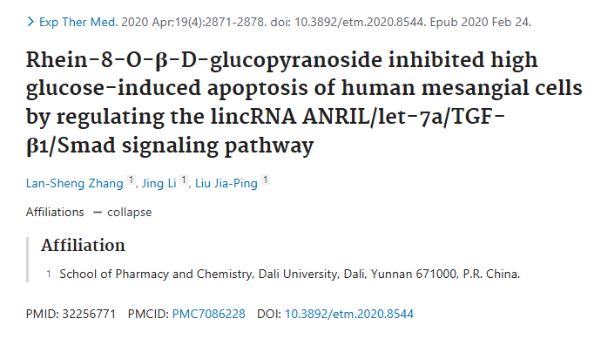

**Part.2**



**图像重复问题**

**#1 图1A与Wang et al 2021的图4i出现重复。**

[above] Fig 4i from "Long non-coding RNA LINC00649 regulates YES-associated protein 1 (YAP1)/Hippo pathway to accelerate gastric cancer (GC) progression via sequestering miR-16-5p" (Wang et al 2021).

[below] Fig 1A.

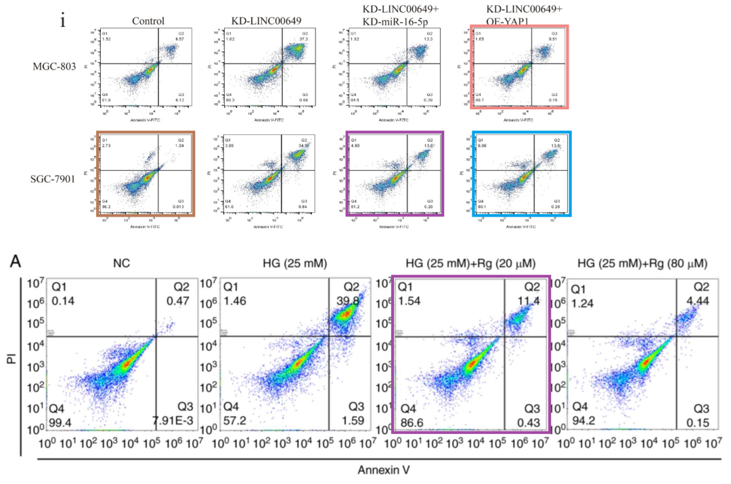

**#2 图4B与Xue et al 2020的图3A出现重复。**

[left] Fig 3A from "Circular RNA circ-LDLRAD3 serves as an oncogene to promote non-small cell lung cancer progression by upregulating SLC1A5 through sponging miR-137" (Xue et al 2020).

[right] Fig 4B.

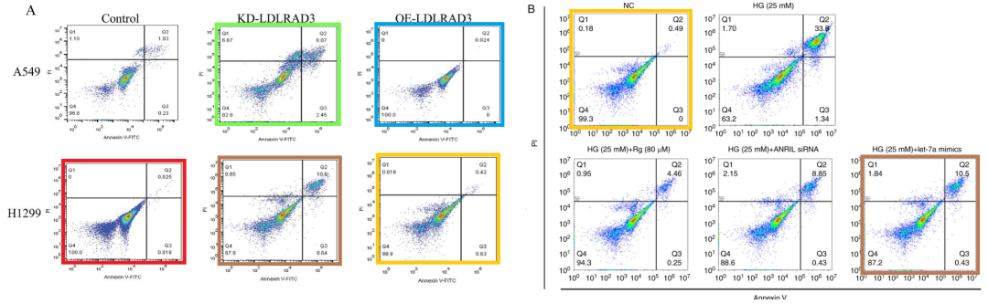

**参考信息：**

https://pubpeer.com/publications/8FFC42C6554B95E437BBB4C916C73B#1

https://pubmed.ncbi.nlm.nih.gov/32256771/