[论文多图严重重复，昆明医科大学附属第二医院董昭兴团队学术严谨性受质疑](https://mp.weixin.qq.com/s?__biz=Mzk3NTEwMTE3OA==&mid=2247484661&idx=1&sn=622c25a01c39b86da570260b0d3af510&chksm=c539610cf498144ac7ddfb7dbf05980ac172cd685ca0a0090b7f9ee7cb184cfcce6cdbafbdf1&scene=126&sessionid=1741972985)

[学术荟萃](javascript:void(0);)2025-03-13 16:30:06山东

**Part.1**



**论文简介**

**标题：High-Dose Paraquat Induces Human Bronchial 16HBE Cell Death and Aggravates Acute Lung Intoxication in Mice by Regulating Keap1/p65/Nrf2 Signal Pathway**

**日期：**2019年2月8日

**单位与作者：**

昆明医科大学附属第二医院Wenlin Tai、Shuhao Deng、Zhaoxing Dong(通讯作者 音译 董昭兴)

玉溪市人民医院Jihua Zhang

武警广东省总队医院Jiexiong Yao

**期刊：*Inflammation***

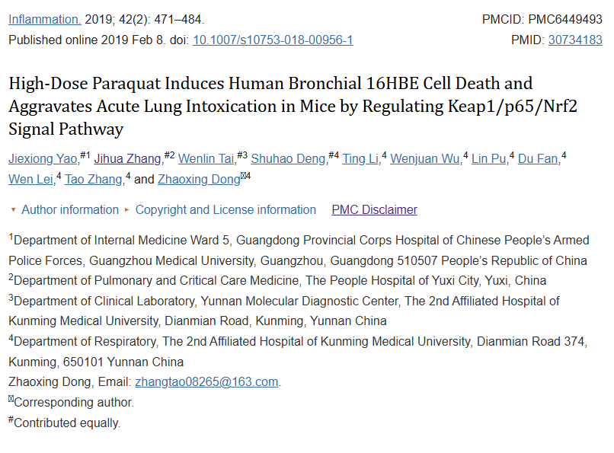

**Part.2**



**图像重复问题**

**#1 图2c出现重复。**

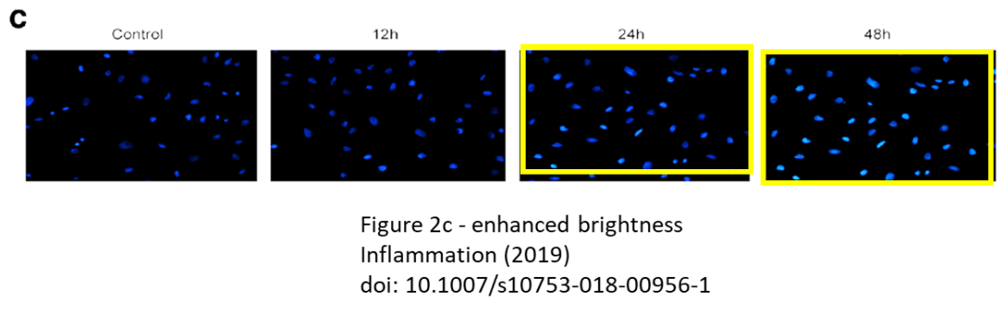

**#2 图1c, i 与 Zhao et al 2020、Hong et al 2020 论文出现重复。**

Fig 1c, i.

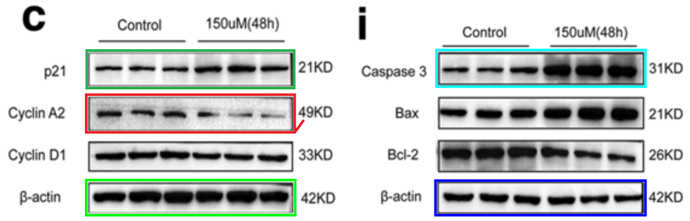

[left] Fig 1f from "CircRNA CDR1as/miR-641/HOXA9 pathway regulated stemness contributes to cisplatin resistance in non-small cell lung cancer (NSCLC)" (Zhao et al 2020).

[right] Fig 5A from "Circular RNA circ-CPA4/ let-7 miRNA/PD-L1 axis regulates cell growth, stemness, drug resistance and immune evasion in nonsmall cell lung cancer (NSCLC)" (Hong et al 2020).

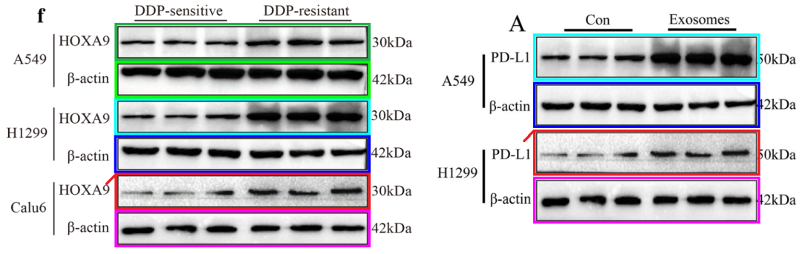

**#3 图2c出现重复。**

Left to right:

* Fig 2j from Zhao et al (2019).
* Fig 4f...
* and Fig 4j.

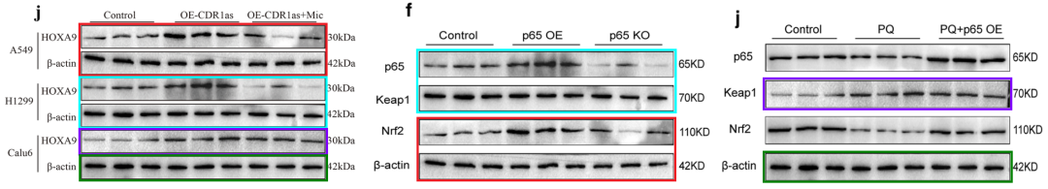

**#4 图3a 与 Yu et al 2021、Zhang et al 2018 论文出现重复。**

[above] Fig 2G,H from "Blockage of AMPK-ULK1 pathway mediated autophagy promotes cell apoptosis to increase doxorubicin sensitivity in breast cancer (BC) cells: an in vitro study" (Yu et al 2021).

[below] Fig 3a.

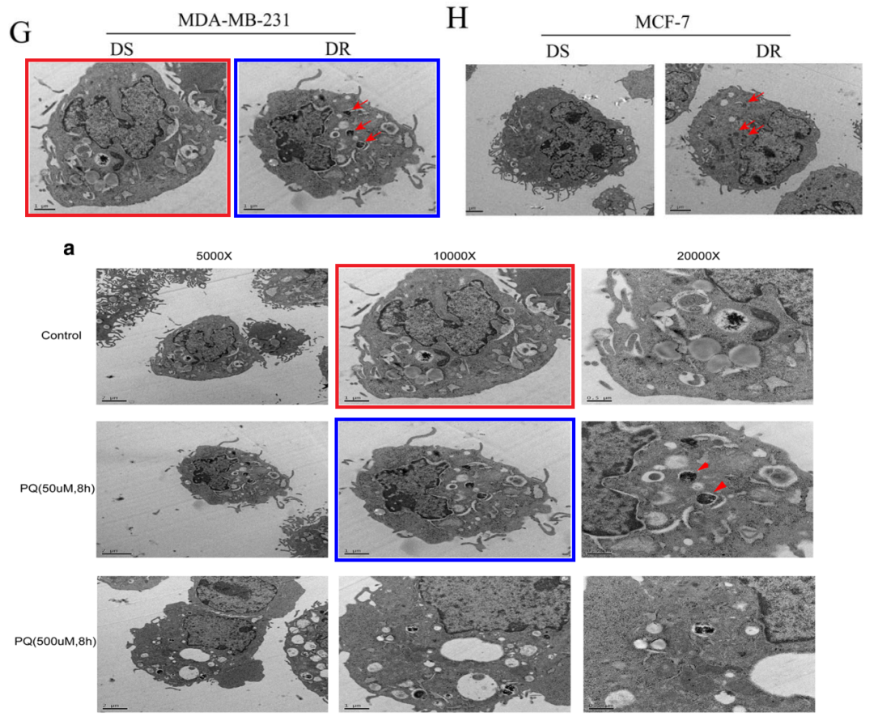

The source appears to be Fig 2a from "High-glucose Induces Retinal Pigment Epithelium Mitochondrial Pathways of Apoptosis and Inhibits Mitophagy by Regulating ROS/PINK1/Parkin Signal Pathway" (Zhang et al 2018).

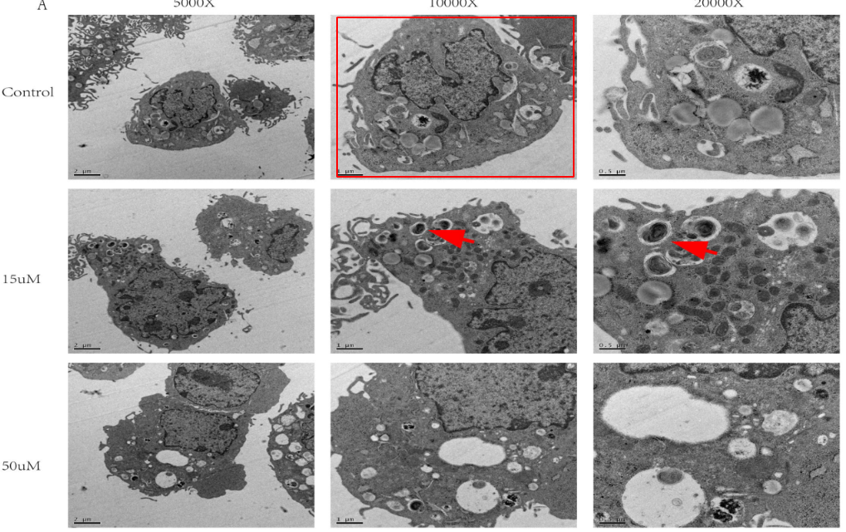

**#5 图5e与Sun et al 2021论文出现重复。**

[left] Fig 1E,G from "Midazolam increases cisplatin-sensitivity in non-small cell lung cancer (NSCLC) via the miR-194-5p/HOOK3 axis" (Sun et al 2021).

[right] Fig 5e.

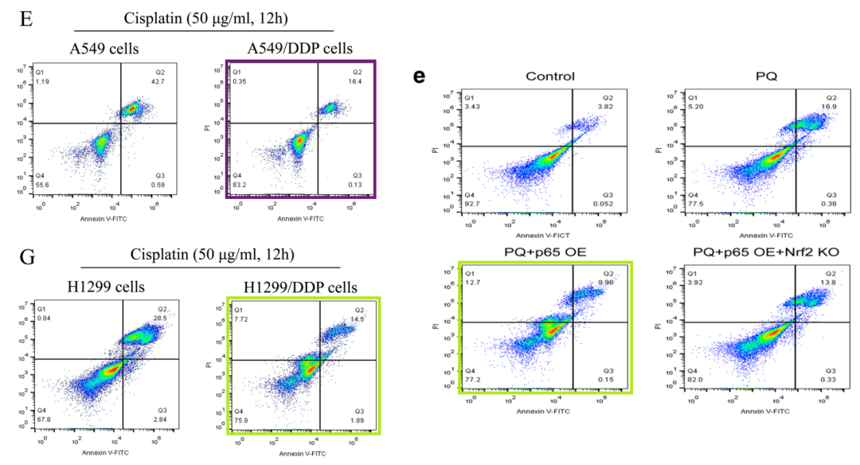

**#6 图2c,d,e 再次与两篇 Liu et al 2019 的论文出现重复。**

[left] Fig 2c,d,e.

[right] Fig 4E,F,G from "Downregulation of LncRNA-XIST inhibited development of non-small cell lung cancer by activating miR-335/SOD2/ROS signal pathway mediated pyroptotic cell death" (Liu et al 2019).

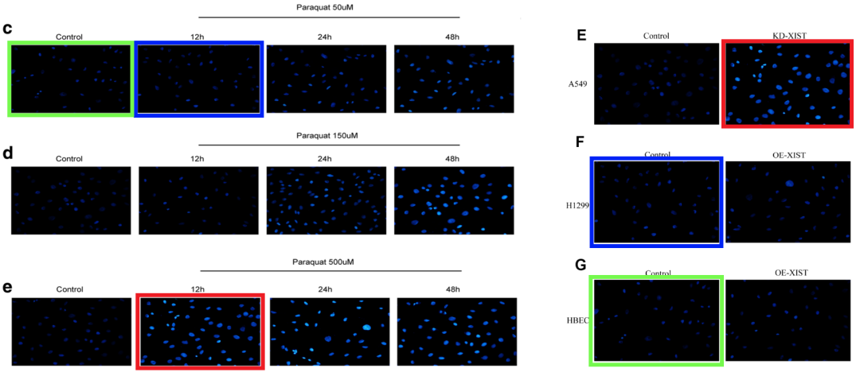

Three panels also appear in Fig 5l of "Downregulation of LncRNA-XIST inhibited development of non-small cell lung cancer by activating miR-335/SOD2/ROS signal pathway mediated pyroptotic cell death" (Liu et al 2019).

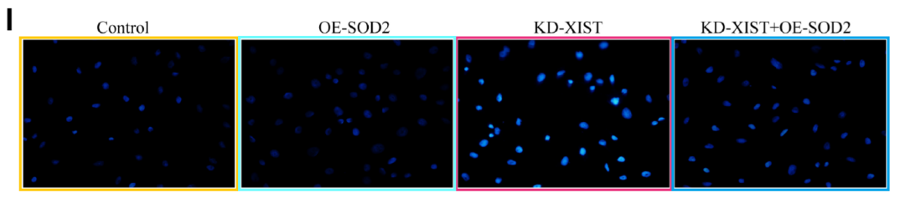

**基金支持：**

* 国家自然科学基金研究81560015
* 云南省应用基础研究项目-联合专项研究资助

2017FE468（-210），2017FB468（-005）

**参考信息：**

https://pubpeer.com/publications/DF0A4893DE8654A4974BE81D338288#6

https://pubmed.ncbi.nlm.nih.gov/30734183/