[局部重复？来自河南大学知名附属医院](https://mp.weixin.qq.com/s?__biz=Mzg5MTg0MDc4NQ==&mid=2247493215&idx=1&sn=8b178ff4029790591d5f0a83ee79cfde&chksm=ce18ae9bb1b57ea4e0252c595017657ea88b374741b87e08c474180938cd560fac84f4e8b143&scene=126&sessionid=1741972085)

原创  F[图片重复](javascript:void(0);)2025-03-14 12:50:56广东

**UCA1 promotes cell proliferation and invasion and inhibits apoptosis through regulation of the miR129–SOX4 pathway in renal cell carcinoma**

**OncoTargets and Therapy (2018)**

**PMID:**29760557

**DOI:**10.2147/ott.s160192

**AUTHORS**

**Qian Liu1,Yang Li1,Weiling Lv2,Guangwei Zhang1,Xin Tian1,Xiaodong Li1,Hepeng Cheng1,Chaoyang Zhu1**

**AFFILIATIONS**

1Department of Urology, Huaihe Hospital of Henan University, Kaifeng, Henan.

2Department of Pharmacy, Huaihe Hospital of Henan University, Kaifeng, Henan, China.

**#1Sholto David 3 hours ago**

**Figure 2C**: Unexpected duplicated areas. I've added the coloured rectangles to show where I mean. There are some rotations. Would the authors please check and comment?

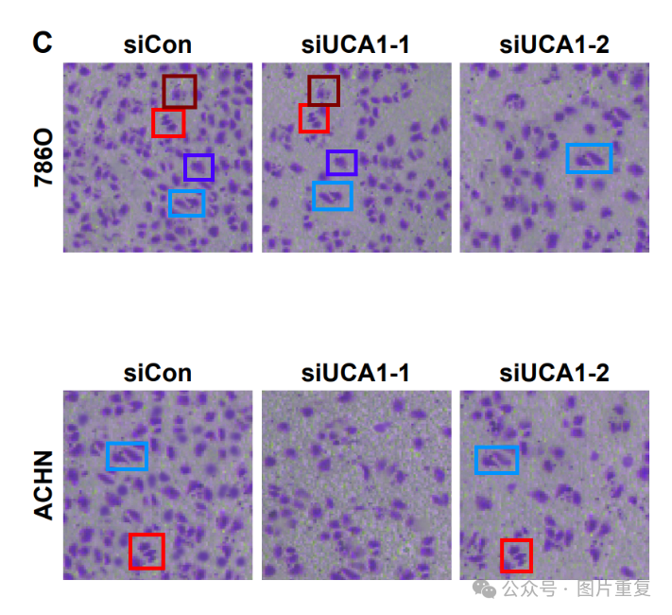

[#图片重复](https://mp.weixin.qq.com/mp/appmsgalbum?__biz=Mzg5MTg0MDc4NQ==&action=getalbum&album_id=2546994047780667392#wechat_redirect)[#河南大学](https://mp.weixin.qq.com/mp/appmsgalbum?__biz=Mzg5MTg0MDc4NQ==&action=getalbum&album_id=3897935528523415559#wechat_redirect)